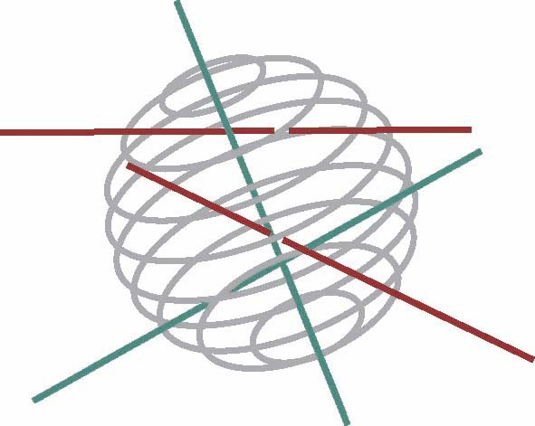
Scientific Support Plan for a Sustainable Development Policy (SPSD II)

Part 2:
Global change, Ecosystems and Biodiversity

FINAL REPORT

INTEGRATED MANAGEMENT TOOLS FOR WATER BODIES IN AGRICULTURAL LANDSCPAES (MANSCAPE)

Edited by H. Hampel and K. Martens

Koen Martens – Royal Belgian Institute of Natural Sciences, coordinator
Bertrand Losson – University of Liege, P.I.
Patrick Kestemont – University of Namur, P.I.
Wim Vyverman – University of Ghent, P.I.
Luc De Meester – Catholic University of Leuven , P.I.

EV/36/29A; EV/12/29B; EV/13/29C; EV/02/29D; EV/01/29E

April 2008







D/2005/XXXX/XX [Field reserved to the Belgian Science Policy]

Published in 2005 by the Belgian Science Policy
Rue de la Science 8
Wetenschapsstraat 8
B-1000 Brussels
Belgium
Tel: +32 (0)2 238 34 11 – Fax: +32 (0)2 230 59 12
http://www.belspo.be

Contact person:
Ms. Aline Van Der Werf
Secretariat: +32 (0)2 238 36 13

Neither the Belgian Science Policy nor any person acting on behalf of the Belgian Science Policy is responsible for the use which might be made of the following information. The authors are responsible for the content.
No part of this publication may be reproduced, stored in a retrieval system, or transmitted in any form or by any means, electronic, mechanical, photocopying, recording, or otherwise, without indicating the reference.

ABSTRACT

Ponds are still present in large numbers in various landscapes. They hold an important fraction of aquatic biodiversity, and include more rare species than any other non-marine aquatic habitat. The loss of small freshwater bodies will reduce connectivity among remaining populations, as well as reduce numbers of organisms (Gibbs, 1993; Semlitsch & Bodie, 1998). The Belspo project MANSCAPE, with partners in the Royal Belgian Institute of natural Sciences (Brussels) and the Universities of Ghent, Leuven, Liege and Namur, set out to develop integrated management tools for pools in various types of landscapes, namely: pristine, intermediate and extensive landuse (agricultural). Many groups of living organisms where monitored in 126 ponds, divided in clusters of three, each cluster representing the 3 types of land use. Both local and regional potential drivers of biodiversity were monitored.
Presence/ absence of fish and macrophyte cover turned out to be sledgehammer drivers of aquatic biodiversity in ponds. Turbidity and sediment quality (sludge) are also important. The latter two are highly affected by presence of cattle (trampling). Regional drivers of biodiversity include land use. Effects are sometimes visible up to hundreds of meters. However, in general, local factors are more important drivers than regional ones. This will facilitate management in highly fragmented landscapes such as agricultural areas in Belgium.
MANSCAPE confirms earlier results on high beta- and gamma-diversity amongst ponds.
Older ponds might have higher biodiversity levels than new ponds. Therefore, optimal source allocation between creation of new ponds and maintenance of old ponds will be necessary. Also, old ponds might be source populations for new ponds.
Incidence of parasites potentially harmful for cattle (example: liver fluke Fasciola hepatica) in the studied ponds in Belgium is very low, and farmers can thus be motivated to use ponds to water cattle, rather than use tapwater. Pesticide load is very low in the Belgian ponds, regardless of the land use, but heavy metals in areas under intensive anthropogenic activities should continue to be monitored.

Key words: pond, biodiversity, integrated management, environmental quality

TABLE OF CONTENTS

Abstract ….. 3

Keywords ….. 3

Introduction, by K. Martens, S. Declerck and H. Hampel …..6

Chapter 1. Standardization of research methodologies among partners and selection of the model systems (WP 1), by H. Hampel, S. Declerck, T. De Bie, D. Ercken, B. Goddeeris, L. De Meester and K. Martens ….. 8

Chapter 2. Quantifying local conditions: morphometric and abiotic characteristics of the study sites (WP 2) by T. De Bie, S. Declerck, D. Ercken and B. Goddeeris ….. 15

Chapter 3. Assessment of biodiversity at the taxon level (WP 3) ….. 19

3.1 Bacterioplankton, by K. Van Der Gucht and W. Vyverman ….. 19
3.2. Phytoplankton , by J. Van Wichelen, S. Denayer, R. Durinck, P. Vanormelingen and W. Vyverman ….. 23
3.3 Phytobenthos , by J. Van Wichelen, R. Dasseville, M. Lionard and W. Vyverman ….. 27
3.4 Diatoms, by L. Denys ….. 28
3.5 Zooplankton, by T. De Bie, S. Declerck, L. De Meester and L. Brendonck ….. 32
3.6 Zoobenthos, by B. Goddeeris ….. 36
3.7 Macroinvertebrates, by H. Hampel, F. van De Meutter, D. Ercken, B. Goddeeris and K. Martens ….. 41
3.8 Amphibia, by D. Bauwens, T. De Bie, H. Hampel and D. Ercken …..45
3.9 Fish, by S.N.M. Mandiki, V. Gillardin, T. De Bie, D. Ercken, H. Hampel and P. Kestemont ….. 47
3.10 Macrophytes, by L. Van Hecke …..49

Chapter 4. Assessment of genetic diversity of selected model groups (WP 4) …..50
4.1 Cladocera, by G. Louette, A. Hulsmans, K. De Gelas, and L. De Meester ….. 50
4.2 Anostraca, by G. Louette, A. Hulsmans, K. De Gelas and L. Brendonck ….. 56
4.3 Amphibians, by I. Schon, H. Vrijders, A. Maes, D. Bauwens, B. Goddeeris and K. Martens …..57

Chapter 5. Assessment of taxon diversity using resting propagule banks (wp 5), by T. De Bie, S. Declerck, L. De Meester and Luc Brendonck …..59

Chapter 6. Quantifying the regional context (WP 7), by T. De Bie, S. Declerck, L. De Meester, S. Keyers and L. Brendonck ….. 64

Chapter 7. Assessment of trematode parasite loads (WP 8), by S. Larsi and B. Losson ….. 70

Chapter 8. Assessing anthropogenic stress: pollution loads (WP 9), by S.N.M. Mandiki, V. Gillardin, L. André, J.-P. Thomé, T. De Bie, D. Ercken, H. Hampel and Patrick Kestemont ….. 72

Chapter 9. Assessment of ecosystem architecture and trophic structure typology for small water bodies – integrated data analyses (WP 6 - WP 10), by S. Declerck, T. De Bie, H. Hampel, L. De Meester, W. Vyverman, J. Van Wichelen, K. Vandergucht, B. Goddeeris, , D. Ercken, L. Denis, L. Vanhecke, L. Brendonck, K. Van Der Gucht, W. Vyverman and K. Martens ….. 78

Chapter 10. Ecological assays of impact of selected pollutants on model organisms (WP 11), by S.N.M. Mandiki, V. Gillardin, L. Spano, S. Flamant, F. Masroor and P. Kestemont ….. 85

Chapter 11. External dispersal and colonization processes of model organisms (WP 12), by G. Louette, S. Declerck and L. De Meester ….. 94

Chapter 12. Internal colonization processes: assessment of egg bank dynamics (WP 13), by G. Louette and J. Vandekerckhove ….. 100

Chapter 13. Guidelines for sustainable and integrated management of ponds and pools in Belgium (WP 14): executive management summary, by K. Martens, T. De Bie, H. Hampel, L. De Meester, W. Vyverman, J. Van Wichelen, K. Vandergucht, B. Goddeeris, D. Bauwens, D. Ercken, L. Denis, L. Vanhecke, G. Louette, I. Schon, L. Brendonck, K. Van Der Gucht, W. Vyverman, S. Larsi, B. Losson, S.N.M. Mandiki, V. Gillardin, P. Kestemont and S. Declerck …..103

References ….. 107

List of authors and their affiliations ….. 120

INTRODUCTION

by

K. Martens, S. Declerck and H. Hampel

Small water bodies constitute the majority of stagnant surface waters in Belgium. Ponds and small lakes are largely ignored and only in the last 10 years that research focus on the ecology and conservation value of these ecosystems. Ponds also not yet used as sentinel habitats for environmental quality and biodiversity levels, and this is spite of the remarkable potential of such habitats. Decision makers dealing with conservation of biodiversity in various types of landscapes are faced with an equal paucity of information on required number of source habitats, optimal distance to satellite habitats, etc. when small water bodies are concerned. It is difficult to implement scientifically underpinned management plans when elementary data are missing. The number of pools integrated in agricultural landscapes is dwindling, because farmers are less and less inclined to use such natural waters for cattle. This is partly due to the lack of information on health hazards for commercial stock, related to water quality, parasite loads, etc. This lack of hard data makes that farmers prefer to install expensive tap water systems, rather than use natural waters.
The EU WFD distinguishes four groups of organisms of prime importance to determine biodiversity levels in inland waters: phytoplankton, phytobenthos, macroinvertebrates and fish. However, these conclusions were largely based on surveys of running waters and only partially on expertise gathered on standing waters. In aquatic ecosystems, bacteria play a key role in the break-down of organic matter and the remineralization of nutrients. They are grazed upon by protozoa and some metazoans and, as such, form the base of a heterotrophic aquatic food chain. Bottom-up (resources) as well as top-down (predation) factors have been shown to regulate bacterial populations in aquatic habitats (Van der Gucht et al. 2001). Diatoms (Bacillariophyceae) are important unicellular primary producers in most freshwater habitats, combining high diversity, good dispersal capacity, short generation times and often distinct relationships to physical-chemical conditions. Surface sediments integrate living cells of extant diatom communities as well as the siliceous frustules of preceding generations from the different micro- and mesohabitats represented in a pool. Phytoplankton as primary producers build up carbon biomass, which functions as food for many other aquatic organisms. Its species composition and diversity is linked with many aspects from the aquatic environment they live in, i.e. nutrients, grazing and water clarity. In turn, since they are important prey items, their diversity affects the diversity of the higher trophic levels as well. Zooplankton has been studied in many different habitats and a large database on ecological characteristics of different groups exists. Branchiopoda are actually an underestimated indicator group for habitat integrity and ecosystem health. Zoobenthos (Ostracoda, Chironomidae) are vital parts of any trophic cascade system in aquatic habitats. Chironomidae larvae are important in nearly all aquatic ecosystems. Macro invertebrates are a third group selected by the EU Water Frame Directive as indicator groups of water quality. A survey of UK ponds by Nicolet (2001) has show that Coleoptera are by far the most species-rich group, with a high potential to function as bio-indicators. Macrophytes have a strong structuring effect of a habitat and considered together with abiotic and other biotic variables to be one of the one of the prime drivers of ecosystem architecture.
To assess the dynamic aspects of biodiversity the analysis of resting egg banks is attractive due to the integration of variation in space and time. Yet, this approach has hardly been explored (Havel et al. 2000). Studies on the colonization of newly created habitats and the build-up of resting egg banks in aquatic habitats are nearly absent. This approach has the potential to understand the assemblage of communities in this type of habitat as well as to yield practical information on the value of nature in newly created pools and on how to improve it.
An often overlooked component of biodiversity, but one with generally large economic impact, is parasite load. The control options for fasciolosis aim at the reduction of pasture contamination which may be accomplished through the use of anthelmintics (strategic anthelmintic control), management regimes (draining or fencing-off wet areas), molluscicides and biological competition (snail control) as components of an integrated control programme (Torgerson and Claxton 1999).
Studies integrating diversity across trophic levels and overall trophic structure with pollutant stress in a wide range of natural habitats are rare. Several methods using aquatic vertebrates (mainly fish and amphibians) as bioindicators have been developed and are currently being used (Cabana and Rasmussen 1996). Several studies deal with the toxicity of xenobiotics and underline the potential effect of the endocrine disruptor atrazine on different species (Hayes et al. 2002).
The present project aimed to develop tools for integrated management, using small stagnant water bodies as an important element of landscape infrastructure. MANSCAPE had the following objectives: (1) assessment of extant patterns of biodiversity and of ecosystem and trophic structure in pools and small lakes; (2) development of cost-effective methods for reliable monitoring of biodiversity, in order to reflect ecosystem health in small water bodies; (3) assessment of natural dynamic processes (colonisation, egg bank recruitment) leading to extant biodiversity patterns in small water bodies; (4) assessment of mutual interactions between extant aquatic ecosystems in small water bodies and sectorial activities (nutrient levels and biodiversity, effects of pollution levels on biodiversity, parasite loads in pools).

Chapter 1. STANDARDIZATION OF RESEARCH METHODOLOGIES AMONG PARTNERS AND SELECTION OF THE MODEL SYSTEMS (WP 1)

by

H. Hampel, S. Declerck, T. De Bie, D. Ercken, B. Goddeeris, L. De Meester and K. Martens

Sampling locations and period
The studied pools cover a major part of Belgium (Fig. 1.1) and have an average size of 250 m² and a maximum depth of 170 cm. The age of the pools ranged from 3 to more than 100 years old. Within of the 42 clusters, three pools with different use of the surrounding land were chosen: one pool in an area with intensive agriculture, one pool in an area with extensive land use (pristine) and one pool in a relatively natural (intermediate) environment. The selection was also designed to allow the independent evaluation of land use effects and geographic patterns.
Sampling period started on the 15th of July and ended on the 17th of September in 2003. The second sampling campaign in 2004 was conducted during the spring from 26th of April till 30th of June (the second sampling period of zoobenthos was done during winter, i.e. from the 6th of January till the 10th of February 2004, in order to avoid the spring emergence period of the chironomids). Due to the extremely dry summer in 2003, 27 ponds out of 126 were dry and such as not sampled.

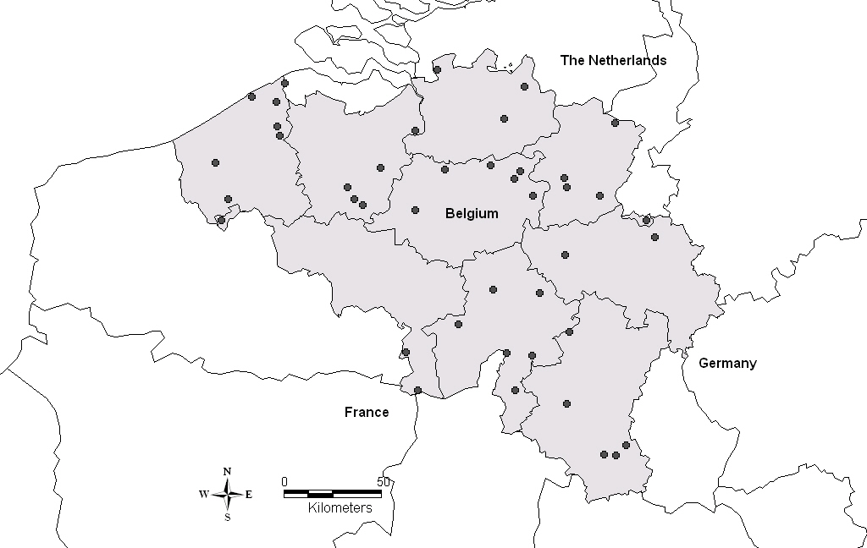
Figure 1.1. Location of the 42 clusters of three pools

1.2 Sampling methods on the field
Name of the pools was marked as follows: Province (An- Atwerpen, Wv- West Vlanderen, Ov- Oost Vlanderen, Vb- Vlaams Brabant, Lg- Liege, Na- Namur, Li- Limburg) nearest community, land use (In-intensive, Ex-extensive, Na-natural). Example: VbBegIn.
Sampling of the ponds followed a strict protocol starting with making a summarized description of the entire pool: shape, width and variation in depth of the border of the pool, global coverage by macrophytes. Land use (crop, forest, pasture, urban area) in 10, 20 m from the pond was visually assessed. Degree of trampling, presence of manure and fence were noted. Type of sediment (sand, clay, rock, mud) and the thickness of silt were recorded during the benthic sampling.

1.2.1 Water samples
First water sample was taken and physical measurements of the ponds carried out. From the water sample, physical, chemical as well as biological variables were assessed (Table 1.1). For suspended matter, chlorophyll a, pigments, chemical variables, bacterio- and phytoplankton, depth integrated water samples were taken with a tube sampler. Conductivity, pH, temperature and oxygen concentrations were measured in the water column of the pond. Water transparency was measured with a Sneller’s tube.

Table 1.1. Physical, chemical and biological variables assessed from water sample
Physical |  | Chemical |  |  | Biological
water temperature |  | NO₃⁻ | alcalinity : total CO₃⁻⁻ |  | Chlorophyll a
oxygen level |  | NO₂⁻ | hardness : Mg^{++,} Ca⁺⁺ |  | Pigments
conductivity |  | NH₄⁺ | SO₄⁻⁻ |  | Bacteria (quantitative)
pH |  | Kjeldahl N | Cl⁻ |  | Bacteria (qualitative)
suspended matter |  | Ortho-P | heavy metals
Sneller-depth |  | Total P | PCB's

1.2.2 Sampling the group of organisms
Zooplankton was sampled with a tube sampler. The sampling locations were located according to a predefined grid. This grid assures that different subhabitats were represented to a similar extent. The water taken at the different locations was pooled in a big recipient and subsamples for taxon richness were taken for: Rotifera, Crustacean zooplankton. Additional zooplankton samples were taken with sweep net for genetics and taxon diversity analyses. The sample for taxon richness analysis was fixed with sugar+ lugol (2ml in 48ml of sample). The sample for genetic analyses was fixed with alcohol (minimum 70%).
Phytobenthos was sampled with a plexiglass core, which was pushed into the substratum on one location in the littoral zone at a depth of 20 cm and volume of 5 ml was collected. Samples were stocked in the deep freezer.
The zoobenthos was sampled quantitatively by means of a handcorer. In each pond eight sample units were taken according to a predefined grid, and the upper 10cm of the soil and the water layer of these sample units were pooled in a bucket. The samples were fixated with paraformaldehyde powder (6% minimum) and sodium carbonate was added.
Macroinvertebrate samples were taken with sweep-net (mesh size: 250µm) in all habitats of the pond. The sampling time spent in each habitat was adapted to the percentage covered in the pool. Macroinvertebrates were fixated in 1 liter of water containing paraformaldehyde powder (6% minimum) and sodium carbonate.
The presence of Amphibia was assessed using visual (and auditory) observations of adult animals, larvae and egg clumps or strings during the spring reproductive period and using dip-netting of larvae during the summer period. Dip-netting was performed using dip-nets with an effective surface of ca. 10 dm² and a mesh-width of 4 mm.
The Point Abundance Sampling (PAS), an electrical fishing technique sampled fish in the ponds. Number of sampling points depended on surface area of the ponds. A subsample of fish was deep-froze which was preserved for PCB-analysis.
Snails were collected manually during a 15 minutes time period. Originally two species were collected: Lymnaea truncatula (for parasitic load determination) and L. stagnalis (for PCB’s detection and as internal negative control for trematode infection). Although first sampling showed the necessity to include further species: Radix peregra and R. ovata. The snails collected from the different plots were frozen at –80°C until their use for the molecular biology assay.
A broad estimation of coverage by macrophytes was done using Tansley-estimations (Tansley 1946). The assessment of macrophyte cover was separately done for three types of macrophytes: submerged, floating and emergent. All water plants and plants on the borders of the ponds were collected and preserved for later identification.

1.2.3 Assessment of morphometrics
Measurement of water depth along two perpendicular transects at every 2m was carried out. Near the borders the distance of measurement was shorter. The profile of the pond border was also measured (Fig. 1.2).
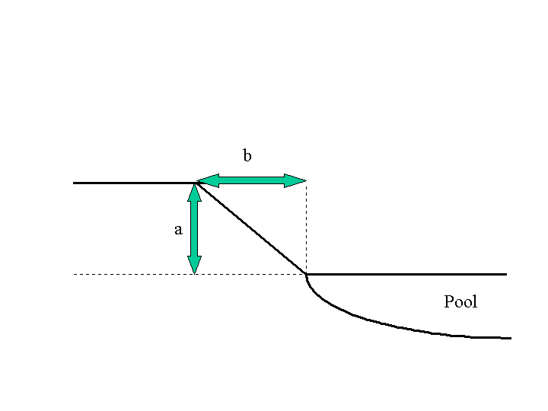
Figure 1.2. Measurement of the profile of the pond

Processing of the samples in the laboratory and methodologies to analyse the samples of biodiversity and community

1.3.1 Bacterioplankton,
From the water sample two volumes of 250ml were filtered over a 0.2 µm MF-Millipore MCE filter using a syringe. Diversity and community composition in bacterioplankton was studied using denaturing gradient gel electrophoresis (DGGE). Genomic DNA from the natural bacterial community was extracted following the protocol described by Zwart et al. (1998), which includes the bead-beating method concomitant with phenol extraction and ethanol precipitation. PCR products obtained with primers 357FGC and 518R were analyzed on a 35 to 70% denaturant DGGE gel as described by Van der Gucht et al. (2001). Phylogenetic information on the most dominant members of the bacterial communities was obtained by sequencing DGGE bands following the protocol described by Van der Gucht et al. (2001). The software performs a density profile through each lane, detects the bands and calculates the relative contribution of each band to the total band signal in the lane after applying a rolling disk as background substraction. A matrix was compiled based upon the relative contribution of individual bands to the total band signal in each lane. The analysis was based on DGGE patterns of 51 pools (17 clusters).

1.3.2 Phytoplankton
Water sample was filtered in the laboratory for pigment analysis using HPLC (High Pressure Liquid Chromatography). Later a more detailed taxon specific analysis was carried out using Zeiss Axiovert microscope. At a magnification of 400X along several longitudinal transects phytoplankton was counted and identified. Some rare, larger taxa were quantified by scanning half the counting chamber at higher magnification (200X). When possible, at least 200 individuals were counted and identified up to genus level (e.g. Tikkanen and Willén 1992; John et al. 2002).

1.3.3 Phytobenthos
Phytobenthic samples were kept cold in the dark during transportation and stocked in the deep freeze (- 20 °C) until pigment analysis. Lyophilised sub-samples (5 ml) were extracted in 5 ml acetone (90 %) and chl a was analysed with HPLC (Wright et al. 1991).

1.3.4 Diatoms
Diatoms were identified from the phytobenthic samples. Permanent slides were examined by interference light microscopy (Olympus BX50). Identification was based mainly on standard floras and recent monographs (Lange-Bertalot and Moser 1994; Krammer 1997a, 1997b, 2000, 2002, 2003; Lange-Bertalot 2001; Lange-Bertalot et al. 2003; Werum and Lange-Bertalot 2004). Relative abundance of taxa was calculated from 500 random-selected valves. Additional taxa were detected by scanning one or more slides using a stopping rule to standardize relative effort.

1.3.5 Zooplankton
Cladocerans from the pond samples were counted and identified to species level, following Flössner (2000). Rotifers were counted in the samples of 2003 and identified to genus level, following Ruttner-Kolisko (1974).

1.3.6 Zoobenthos
Zoobenthic samples were washed on 250 and 500 µm sieve and specimens were picked out from the later sample and identified to the possible lowest taxonomic level. Identification of chironomid larvae were mainly done with the general keys of Moller Pillot (1984a, 1984b) and Wiederholm (1983).

1.3.7 Macroinvertebrates
Samples were sorted on 0.5 and 1 mm sieve and individuals were identified from the later sample to the possible lowest taxonomic level. Various identification keys were used for different taxa (Elliott et al. 1988; Savage 1989; Wallace et al. 1990; Glöer and Meier-Brook 1994; Edington and Hildrew 1995; Klausnitzer 1996; Drost et al. 1992).

1.3.8 Fish
Fish collected with the PAS technique were identified using identification of Keith and Allardi (2001).

1.3.9 Amphibians
Species, number of individuals, life stages and gender were recorded. Species identification was performed using standard keys. As the on situ identification of the larvae of some species was impossible, a sample of larvae was collected and identified in the laboratory. As it was impossible to distinguish between the larvae of Triturus vulgaris and T. helveticus on external characteristics, these two species were considered together in the analyses. Data for the 2003 and 2004 was lumped and only presence/absence data for the different species was considered.

1.3.10 Macrophytes
All herbarium macrophytes (including vascular hydrophytes and helophytes and charophytes) were identified from the collected and dried specimens using several identification keys (e.g. Haslam at al. 1975; Casper and Kraus 1980; Jermy et al. 1980).

Statistical data analyses of biodiversity and community data
For several organism groups, data of two seasons were available (except bacteria, rotifers and diatom). For each group of organisms, two types of analyses were done: (1) analyses on multivariate community data (abundance matrices species/samples), and (2) analyses on diversity variables as dependent variables (three diversity variables were taken into account: taxon richness, rarity based index and Shannon-Wiener). Diversity calculations were carried out on standard number of individuals (except macroinvertebrates). Rarity based index: i = log10 (N/n_{i})+1, N = total number of pools, n_{i} = number of pools in which species i occurs. To estimate the 'conservation value' of a pond for a group of organisms, the weights of all the species were summed. To avoid aberrations due to seasonality the analysis using rarity index were carried out on the entire species list (spring + summer).
The first analyses (1) were done with CCA or RDA; the latter (2) with multiple regression. Each of these analyses was repeated for two different sets of explanatory variables: (1) pool characteristic variables and (2) land use variables. Both the multivariate and multiple regression analyses aimed to explain the dependent datasets with the respective explanatory datasets. This was done by running a forward selection on each set of explanatory variables. Multicollinearity in the explanatory variable datasets was taken into consideration.
Multivariate community analyses were performed in the program CANOCO. All analyses were done on density data, fourth root transformed. Species that occurred in less than 5% of the samples and that have a contribution to total abundance in these samples lower than 5% were omitted. Multiple regression analyses were performed in STATISTICA program.
Any deviation from the above mentioned procedure is mentioned in WP3 where the results for the assessment of biodiversity is presented for the different group of organisms.

Chapter 2. Quantifying local conditions: morphometric and abiotic characteristics of the study sites (WP 2)

by

T. De Bie, S. Declerck, D. Ercken and B. Goddeeris

2.1 Methods
This chapter focuses on two types of pond variables: (1) variables that are related to the clear water/turbid state (“CT-variables”), and (2) variables related to vegetation complexity. The CT-variables were water transparency, concentration of phytoplankton chlorophyll a, total phosphorus, thickness of the silt layer on the pond sediments, and the percentage of pond surface covered by aquatic vegetation.
Vegetation complexity was quantified within each pond using three characteristics of the aquatic vegetation: (1) the richness of observed plant taxa (NOT); (2) the number of different growth forms present (e.g., submerged, floating, emergent vegetation; NGF), and (3) the Shannon-Wiener diversity calculated from the cover fractions of eight different biotope types, i.e. seven vegetation types and the open water zone (SWBT).
Land use cover variables were assessed at seven different spatial scales, i.e. for circular areas around the ponds with radii ranging from 50 m over 100, 200, 400, 800, and 1600 m to 3200 m. The land use types discerned were (1) crop land, (2) meadows and pastures, (3) forest and (4) urban areas. Coverage data were obtained through the application of the GIS software package ArcView GIS 3.2a (ESRI, Inc.). In addition, we made a visual assessment of nearby crop land presence independently from the GIS-dataset. Trampling by cattle was assessed using a simple score system (none, low, intermediate, high or very high degree of trampling of the pond edges; TRAMPLING).
During the summer of 2003, 27 of the 126 ponds dried out. Data analysis was therefore confined to the 99 permanent ponds. All analyses were done on spring/summer averaged values. We first identified the spatial scales at which different land use variables show the strongest association with the CT-variables. For each of the seven spatial scales, we assessed the contribution of the percentage cover of each land use type to the variation in the CT-dataset with separate RDA-analyses. The contribution of crop presence in the immediate vicinity of ponds as determined from visual observations was also evaluated. TRAMPLING and the variables of the spatial model were specified as co-variables in all these analyses to partial out their effects.
Second, the subset of land use variables best explaining the CT-dataset was identified. For this a forward selection procedure was performed on the entire set of land use variables corresponding with all spatial scales (10 to 3200 m radii, including TRAMPLING). For each of the variables retained, both the marginal and conditional effects on the CT-variables were estimated.
In analogy to the RDA-models, the association between the three vegetation complexity variables and the land use variables were analyzed with multiple regression analysis upon forward variable selection. Significance levels were defined at the 5% level.

Results
The studied ponds were generally very small and shallow. The surface area of the 99 permanent ponds ranged between 12 and 3,674 m² (Table 2.1) and 90 % of the ponds were smaller than 400 m². Maximum depth averages ranged between 0.18 and 1.6 m. The set of ponds displayed a large variability for the studied variables (Table 2.1) and represented both turbid hypertrophic ponds devoid of water plants and with high amounts of phosphorus, chlorophyll a and silt, as well as vegetated ponds with clear water.

Table 2.1. Summary statistics and variable abbreviations for morphometric variables and clear water/turbid state related variables (CT-variables) assessed for 99 Belgian farmland ponds.
 |  |  | Median | Minimum | 25 % | 75 % | Maximum
Morphometric variables
 | Surface area (m²) | AREA | 147 | 12 | 62 | 265 | 3674
 | Depth maximum (m) | DEPTH | 0.71 | 0.18 | 0.46 | 0.92 | 1.6
CT-variables
 | Transparency (m) | TRANSP | 0.21 | 0.4 | 0.15 | 0.28 | 0.56
 | Total phosphorus (mg P L⁻¹) | PTOT | 0.83 | 0.07 | 0.44 | 2.08 | 19.07
 | Chlorophyll a (µg L⁻¹) | CHLa | 21 | 1 | 6 | 109 | 1455
 | Silt (m) | SILT | 0.28 | 0 | 0.13 | 0.50 | 1
 | Vegetation cover (%) | VEGCOV | 55 | 0 | 15 | 90 | 100

A significant portion of the variation in the CT-variables was explained by the cover of forest and crop land. The level of statistical significance of this association strongly depended on the spatial scale considered. The effect of forest cover was significant when estimated for circular areas with surfaces of 0.008, 0.03, 0.125, and 0.5 km² around the ponds (radii of 50, 100, 200, and 400 m, respectively) but not for larger areas. The effect of percentage cover of crop lands was significant for surface areas with radii of 50 and 100 m. Both land use variables explained most variation for areas with a radius of 100 m.
Application of a forward selection retained four variables: TRAMPLING, percentage forest cover in a 200 m-circular area, crop presence/absence in a 20 m-circular area, and the spatial variable Y³. TRAMPLING and crop presence/absence were significantly negatively associated with clear water conditions (Fig. 2.1a, b) whereas forest cover showed a significant positive association with clear water conditions (Fig. 2.1c). The CT-variables also showed a significant association with latitude: ponds tended to become increasingly turbid towards the north of the study area (Fig. 2.1d).
Of all land use variables, TRAMPLING had the highest impact on vegetation complexity and showed significant, negative correlations with all three vegetation complexity variables.

Figure 2.1. - Effects of land use variables and latitude on CT-variables. The Y-axes of the graphs represent the sample scores of the first principal axis of a partial standardized PCA performed on the CT-variables. Positive PCA-scores indicate turbid conditions. TRAMPLING: degree of trampling by cattle (a); CROP P/A (20 m): presence or absence of crop land in the immediate vicinity of the pond (radius of circular area: 20 m; b); FOREST (200 m): percentage of land covered by forest in a 200 m radius circular area around the pond (c); Y³: spatial variable, with Y being latitude (d). Error bars equal twice the standard error of the mean.

Discussion
Results indicate significant associations between surrounding land use and variables related to turbidity or vegetation complexity. Ponds frequently visited by cattle or located near cropland were characterized by relatively high values of turbidity related variables (e.g., total phosphorus, chlorophyll a concentrations, silt on the sediments), lower water transparency and sparser aquatic vegetation. Conversely, ponds at locations with high forest cover showed the opposite pattern. Ponds with high disturbance by cattle also contained a lower number of abundant water plant taxa, a lower number of water plant growth forms and a lower diversity of biotope types.
The negative association between the proportion of crop land and the ecological quality of ponds is in line with the results of former studies on rivers, lakes and man-made reservoirs. Crop agriculture, especially row-crop farming with frequent tillage and the intense application of fertilizers, leads to high soil erosion and high nutrient and sediment export rates. This may ultimately result in increased nutrient loads adversely affecting water plant cover and richness in favour of phytoplankton.
The contribution of crop land and forest to CT-variables and vegetation complexity decreased strongly with increasing spatial scale. This indicates that the most important land use effects on ponds operate at relatively small spatial scales, and that inputs of nutrients and possibly also pesticides mainly originate from local surface water run-off rather than from atmospheric deposition or major ground water flows.
The strong negative effect of cattle trampling on water clarity and vegetation indicated that the access of cattle to ponds is an important factor that should be well taken into account in.

Chapter 3. Assessment of biodiversity at the taxon level (WP 3)
This chapter focuses to characterize community structure on all trophic level in the sampled ponds. Screening focused on bactria, phytoplankton, phytobenthos, zooplankton, macrobenthos, macroinvertebates in water column, macrophytes, amphibia and fish. As taxon richness is accepted as a low cost measure of biodiversity, biodiversity on taxon level was also assessed. Both community structure and biodiversity indices were related to land use and pond characteristics to identify the main variables affecting the communities.

3.1 Bacterioplankton, by K. Van Der Gucht and W. Vyverman

3.1.1 Methods
A non-standardised PCA-analysis was performed on the fourth root transformed DGGE data of bacterioplankton. Only taxa (DGGE-bandclasses) that occurred in 5% of the lakes and that had an average abundance of at least 5% of the minimum profiling were included in the analysis (bandclasses that have no bands exceeding 5% of the minimum profiling were removed). Actinobacterium genus in the analyses represents three different taxa and could not be specified further due to the small DNA fragment sequenced.

3.1.2 Results

3.1.2.1 Community structure
The eigenvalues of the first four principal PCA-axes were: PCA1: 0.15; PCA2: 0.10; PCA3: 0.08; PCA4: 0.06 (Fig. 3.1). The cumulative amount of variation explained by these axes amounted to 39%. The first axis extracted by the PCA is positively related to the abundance of a member of the Bacteroidetes and a member of the Actinomycetales. The second axis is positively related to the abundance of a member of the gamma- (Chlorobium sp.) and epsilon-Proteobacteria (Arcobacter sp.) and negatively related to members of the beta-Proteobacteria and Actinomycetales (Fig. 3.1).
Figure 3.1. PCA ordination plot for the DGGE data of bacterioplankton.

3.1.2.2 Land use and bacterial community composition
RDA was used to quantify the amount of variation in community composition explained by a single variable or sets of explanatory variables. Only ‘crop 200m’ was significant (p = 0.012) explaining 3% of the species variation (Fig. 3.2a).

3.1.2.3 Land use and bacterial diversity
No significant correlations between any diversity measure and land use data was found.

3.1.2.4 Pool characteristics and bacterial community composition
Forward selection included NO₃ mg/l (5%, p=0.002), surface (3%, p=0.012) and sneller depth (3%, p=0.016) into a minimum set of explanatory variables. These explain 11% of the species variance. Figure 3.2b shows that axis 2 separates pools according to their NO₃ mg/l content and turbidity.

a) b)
Figure 3.2. PCA ordination plot for the DGGE data of bacterioplankton showing explanatory variables of land use (a) and pool characteristics (b) significantly explaining the variation in the community composition.

Mantel tests were performed to investigate the relation between BCC (bacterial community composition) and abiotic/biotic characteristics of the ponds (Bonnet & Van de Peer (2002). A significant relation was observed between BCC and resources (bottom up control), turbidity and zooplankton community composition (top down control) (Table 3.1). There was no correlation with land-use variables, physical constraints and spatial distribution of the ponds.

Table 3.1. Results of Mantel tests relating BCC to abiotic/biotic characteristics of the pools.
Matrix type | r | p
Bottom up (resources: TP, TN and chl a) | -0.239 | 0.002
Spatial distribution (distance between pairs of pools) | 0.06 | 0.103
Physical constraints (lake area, depth, soil texture) | 0.08 | 0.101
Condition of the pool (clear versus turbid; snell, %vegeration cover, silt) | -0.167 | 0.005
Top down control (zooplankton abundance + composition) | 0.256 | 0.0003
Land use | 0.05 | 0.258

As all variables that were significantly related to BCC were also related among each other, partial Mantel tests were used to check whether these controlling factors work independently. These partial Mantel tests show that the three factors (Top down, Bottom up control and Turbidity) independently influence the BCC (Table 3.2).

Table 3.2. Results of Mantel tests relating BCC to abiotic/biotic characteristics of the pools. Results of standard Mantel tests are shown above the diagonal, results of the partial Mantel tests below the diagonal.
 | BCC | Top down | Bottom up | Turbidity
BCC | - | 0.256 (< 0.001) | -0.239 (0.001) | -0.167 (< 0.05)
Top down | 0.224 (< 0.001) controlled for turbidity | - | -0.108 (< 0.05) | -0.246 (< 0.001)
Bottom up | -0.15 (< 0.001) controlled for turbidity | -0.064 (0.113) | - | 0.192 (< 0.001)
Turbidity | -0.14 (< 0.05)  controlled for bottom up  -0.11 (< 0.05)  controlled for top down | -0.231 (< 0.001) | 0.172 (< 0.001) | -

3.1.2.5 Pool characteristics and bacterial diversity
A significant negative correlation was found with metal PCA for taxon richness (-0.56, p= 0.03) and Shannon-Wiener index (-0.62, p=0.01).

3.1.3 Discussion
BCC in the pools was structured by factors related to water clarity, bottom-up control and top-down control. These findings have also been observed in shallow lakes (Muylaert et al. 2002, Van der Gucht et al. 2005). The strong relationship with turbidity indicates that clear water and turbid pools not only harbour different fish, zooplankton and phytoplankton communities but also harbour different bacterial communities. Although our results suggest that BCC shows no strong direct association with land use patterns, BCC is found to be strongly related to water turbidity, which itself has been shown to be influenced by the presence of cropland and trampling by cattle (Declerck et al. 2006).

3.2. Phytoplankton, by J. Van Wichelen, S. Denayer, R. Durinck, P. Vanormelingen and W. Vyverman

3.2.1 Methods
For the estimated taxon richness, a rare faction was carried out on the count data to a standard number of individuals (n = 100).

3.2.2 Results

3.2.2.1 Phytoplankton species composition in relation to pool characteristics and land use
Two summer samples (LxNobEx and NaSorIn) with a high abundance of otherwise rare taxa (Tetradesmus and small, unidentified coccal green algae respectively) were outliers. A model including Sneller depth, cyclopoid copepods density (NCYCCOP), temperature, alkalinity, macrophyte coverage (COVER) and cattle presence explained 18 % of the variation in species data from the summer samples (Fig. 3.3a). The first axis represents a gradient in turbidity and related variables. The presence of cattle was negatively correlated with clear water characteristics. The second axis represents a gradient in zooplankton grazing. Euglenophytes (Trachelomonas, Phacus, Euglena) and several coccal chlorophytes (Monoraphidium, Desmodesmus, Pediastrum, Staurastrum) tend to dominate the community in turbid ponds. Dinoflagellates (Glenodinium, Glenodiniopsis), cryptophytes (Chroomonas, Rhodomonas), flagellated green algae (Volvox, Pandorina) and cyanobacteria (Anabaena, Pseudoanabaena) were more linked with clear water ponds. Cryptophytes (Cryptomonas) and pennate diatoms showed a positive correlation with the density of cyclopoid copepods while small green algae (Chlamydomonas, Tetraedron) showed a negative trend.

a) b)
Figure 3.3. RDA triplot of phytoplankton data and forward-selected pool characteristics for a) summer 2003 (axes 1: eigenvalue 0.096 and 2: eigenvalue 0.033) b) spring 2004 (axes 1: eigenvalue 0.100 and axes 2: eigenvalue 0.015). The squares represent non-permanent pools (dry in summer 2003).

One sample (VbTwIn) was excluded from the analysis of the spring 2004 dataset due to the presence of a bloom that mainly consisted of coccal green algae. A model including the forward-selected pool characteristics water transparency (Sneller depth), cladoceran biomass (BIOCLADO), cyclopoid copepod density (NCYCCOP), presence of fish and cattle explained 14 % of the variation in species data. Again, the first axis represented a gradient in turbidity related variables. The second axis was related to the presence of cyclopoid copepods and cattle, which were negative related towards each other (Fig. 3.3b). Cryptophytes (Cryptomonas) and cyanobacteria (Anabaena, Planktothrix) were added to the list of species more typical for the turbid pools, together with the species that dominated the community in the turbid ponds already in summer (euglenophytes and green algae). Flagellated (Volvox, Chlamydomonas) and filamentous green algae (Spirogyra), dinoflagellates (Gymnodinium), diatoms (Tabellaria) and colonial picocyanobacteria were more linked to the clear water conditions. Cryptomonas and the dinoflagellate Peridinium were positively correlated with the density of cyclopoid copepods. The species composition is less variable in non-permanent pools, which were slightly more situated at the clear water side of the turbidity gradient.
There were no land use data significantly explaining the variation in phytoplankton species data for any season.

3.2.2.2 Phytoplankton diversity in relation to pool characteristics and land use data
Alkalinity showed the strongest correlation with the phytoplankton diversity in the summer samples of 2003 (Table 3.3). In general, more taxa and a higher contribution of rare taxa to the total assemblage were present at lower alkalinities. Water volume and Sneller depth positively influenced the diversity, while the sulphate concentration and the presence of fences had a negative impact. The correlations for the spring samples of 2004 were weaker. Shading and the presence of mud on the bottom had a slightly negative influence on taxon richness and H’.

There were no significant correlations between phytoplankton diversity and land use variables.

Table 3.3. Multiple regression of diversity metrics and forward-selected pool characteristics (number between brackets are ß coefficients). TR (taxon richness), H’ (Shannon Wiener index), RBI (rarity based index)
 | 2003 (N = 71) | 2004 (N = 119)
TR | alkalinity (-0.54), volume (0.35), SO₄ (-0.30) | shade (-0.22), mud (-0.19)
 | r²adj. = 0.37, df = 7.63, F = 6.83, p <0,0001 | r²adj. = 0.1, df = 3.12, F = 5.2, p = 0.0021
H' | fenced (-0.25) | shade (-0.20), mud (-0.19)
 | r²adj. = 0.28, df = 7.63, F = 4.80, p = 0.0002 | r²adj. = 0.08, df = 3.12, F = 4.5, p = 0.005
RBI | alkalinity (-0.34), sneller depth (0.25) | Not significant
 | r²adj. = 0.21, df = 3.67, F = 7.33, p = 0.0003

3.2.3 Discussion
The multivariate analysis showed the clear/turbid gradient the most important determinant for the phytoplankton community structure for both seasons. The presence or absence of submerged vegetation plays a critical role in structuring phytoplankton communities. By stabilizing both the sediment layer and the water column, macrophytes can create high water clarity (Scheffer 1993). But by reducing internal loading and taking up dissolved nutrients from the water column they can out-compete phytoplankton. Small and/or actively moving phytoplankton is best adapted to this rather stabile environment (Reynolds 1984). Small cryptophytes, dinoflagellates, chrysophytes but also the large, flagellated Volvox-colonies and floating cyanobacteria are characteristic for these habitats. The absence of macrophytes makes the sediment layer and the water column more prone to (wind-induced) sediment re-suspension. In these turbid and nutrient-rich environments, phytoplankton dominates the production. Due to the higher turbulence, larger phytoplankton taxa like many euglonoids and/or immobile taxa like many coenobial green algae can become dominant (Reynolds 1984). Surprisingly cyanobacteria dominated only rarely in the turbid pools in comparison with many turbid lakes were these organisms can form massive blooms at the end of summer (Scheffer et al. 1997).
For both seasons, the presence of cattle showed a negative impact on the water clarity in the pools they have access to. Increased trampling disrupts the sediment layer and the submerged vegetation. Furthermore, droppings supply plenty of nutrients and organic matter. Especially euglenoids enjoy these organically polluted waters. Also grazing can have an impact on the structure of phytoplankton communities. At high grazer abundance, grazing resistant taxa will tend to dominate. Large cell sizes (Peridinium, Closterium), colony-forming (Spirogyra, Tabellaria, Aulacoseira) or high growth rates (Cryptomonas) are advantageous in the presence of grazers (Reynolds 1984; Sarnelle 2005).
Alkalinity shows the strongest correlation with phytoplankton diversity. Clear/turbid variables (Sneller depth, presence of mud) although significant, were less determent. Alkalinity is strongly correlated with conductivity, hardness and ion concentration, all predominantly associated with soil conditions. The tendency that phytoplankton diversity is higher in low alkalinity pools can be confirmative for the resource-competition theory which state that highest diversity occurs when many resources are limiting species growth at the same time (Hambright and Zohary 2000; Interlandi and Kilham 2001).
No land use data significantly explain variance in the phytoplankton community structure or diversity, except for the presence of cattle in the close vicinity of the pools. Most probably, the measured land use data had no strong ‘direct’ effect on the aquatic systems in contrast to trampling by cattle for instance. Present day features are the result of long-lasting effects of historical land use and aquatic systems show a certain amount of resilience towards increasing pressures (e.g. eutrophication).

3.3 Phytobenthos, by J. Van Wichelen, R. Dasseville, M. Lionard and W. Vyverman

3.3.1 Methods
In total, 162 samples were analysed, 61 from summer and 101 from spring. Phytobenthos biomass (mg chla/m²) data were logarithmic transformed prior to multiple regression analysis where phytobenthos biomass was related to two sets of explanatory variables (pool characteristics and land use variables).

Results
Only the amount of forest in a radius of 200 m around the pond showed a weak, although significant negative correlation with the phytobenthic biomass in the summer samples of 2003 (Table 3.4). The phytobenthos biomass showed a positive correlation with hardness and chlorinity and a negative with the water volume in spring 2004.

Table 3.4. Multiple regression of phytobenthos biomass and forward-selected pool characteristics (PC) and land-use data (LU) (number between brackets are ß coefficients).
 | 2003 (N = 61) | 2004 (N = 101)
PC | not significant | hardness (0.40), cl (0.30), volume (-0.23)
r²adj. = 0.17, df = 5.95, F = 5.15,
p = 0.0003
LU | Forest 200m (-0.26) | not significant
 | r²adj. =0.05, df =1.57, F = 4.12, p = 0.047

3.3.3 Discussion
No clear effects of surrounding land-use on the abundance of phytobenthos in the ponds could be extracted from these analyses. The presence of trees around a pond can limit the amount of irradiance that reach the bottom and thus limit phytobenthos growth, especially in summer when trees have dense foliage. Pool characteristics seemed to have a somewhat larger structural role in the development of the phytobenthos community. The latter is favoured by the ion concentration (mainly carbonates, and chlorides), in line with the results of the analysis of the diatom assemblages (see 3.4). The phytobenthos biomass seemed to decrease with lake volume. Since lake volume is positively correlated with maximal depth (r²=0.67, p < 0.001) this can again be an effect of light limitation, since the amount of irradiance that reach the bottom decreases with depth.

3.4 Diatoms, by L. Denys

3.4.1 Methods
Only environmental data for 2004 were considered; no land-use data were available for OvTem pools. Species data were square-root transformed. Taxa never exceeding 1% were excluded and a marginal weight (0.02%) was given to all occurrences outside the count. Species-gradient lengths were long enough (axis 1: 4.27 SD, axis 2: 2.42 SD; DCA) to warrant CCA (rare taxa always down-weighted).

3.4.2 Results

3.4.2.1 Land use and diatom assemblage composition
Of the 690 taxa inventoried, 287 pass the analysis threshold. In a CCA of 113 samples, only ‘forest 50 m’ was marginally significant (extra fit 0.1, p=0.05, F=1.5), explaining 1.3% of the species variation. Three samples from low-pH pools (AnHerNa, AnKalNa and WvBeeNa) with a particular species composition (Craticula riparia, Eunotia exigua, Pinnularia subcapitata var. elongata) were outliers. Without these samples, a model including ‘cropland 100 m’ (extra fit 0.09, p=0.005, F=1.5) and ‘pastures 200 m’ (extra fit 0.08, p=0.047, F=1.3) explained 2.6% of the variance. Figure 3.4 shows the distribution of selected taxa in relation to land use.

Figure 3.4. CCA ordination of selected land-use variables and taxa (axes 1 and 2; outliers excluded; only taxa with fit of at least 5% are shown).

3.4.2.2 Land use and diversity
Multiple regression with land-use variables might suggest that pastures can have a slightly positive influence on Shannon Wiener index (H’) and taxonomic richness (TR), but this was not the case if the outlier pools were ignored (Table 3.5). Adjacent forest may result in a somewhat higher rarity-based index (RBI), but this relation was very poor also.

Table 3.5. Multiple regression of diversity metrics and forward-selected land-use variables (numbers between brackets are β coefficients). Shannon Wiener index (H’), taxonomic richness (TR) and rarity-based index (RBI)
 | all sites (n=113) | outliers excluded (n=110)
H’ | Pasture 200 m (0.29), Crop 50 m (0.20)  r²_{adj.}=0.06, df=2.1, F=4.5, p=0.013 | not significant
TR | Pasture 200 m (0.19)  r²_{adj.} = 0.03, df=1.1, F=4.2, p=0.042 | not significant
RBI | Forest 50 m (0.19)  r²_{adj.}=0.03, df=1.1, F=4.1, p=0.045 | Forest 50 m (0.24)  r²_{adj.}=0.05, df=1.1, F=6.6, p=0.01

3.4.2.3 Pool characteristics and assemblage composition
Forward selection included alkalinity (extra fit 0.16, p <0.001, F=5.0), Sneller depth (extra fit 0.08, p <0.001, F=2.5), chloride (extra fit 0.07, p <0.001, F=2.2), pH (extra fit 0.06, p <0.001, F=2.0), temperature (extra fit 0.05, p=0.003, F=1.8), hardness (extra fit 0.04, p=0.038, F=1.4) and floating vegetation (extra fit 0.04, p=0.032, F=1.4) into a minimum set of explanatory variables. These explained 13.3% of the species variance; the low amount was mainly due to the sparse and heterogeneous species matrix. Species-environment relations were explained rather well (60.5% by axes 1 and 2). Removing the three outliers hardly altered the results; a minimal model with PCA ion (extra fit 0.14, p <0.001, F=4.6), Sneller depth (extra fit 0.08, p <0.001, F=2.7), temperature (extra fit 0.06, p <0.001, F=1.9), alkalinity (extra fit 0.05, p <0.001, F=1.9), chloride (extra fit 0.04, p=0.014, F=1.5), pH (extra fit 0.04, p=0.027, F=1.3) and submerged vegetation (extra fit 0.04, p=0.035, F=1.3) now explained 12.9% of the species variation. Figure 3.5 shows that CCA axis 1 separated pools according to alkalinity, pH and PCA ion, while the second axis was mainly turbidity-related.

Figure 3.5. CCA triplot of diatom data and forward-selected pool characteristics for axes 1 and 2 (scaled on inter-species distances); outliers excluded. Only taxa with a fit of at least 10% are shown. Symbol indicates land-use category: ■ intensive, □ extensive, •nature.

The opposed vectors for temperature vs. submerged vegetation and Sneller depth suggested improved transparency with increasing vegetation cover and better heat absorption with higher turbidity. Chloride set apart some samples from the coastal area (WvKnoIn, WvUitIn), but elevated values also occurred elsewhere. Assemblage composition largely overlapped for the three land-use categories, but pools within nature areas tended to be less turbid. Diatoms such as Amphora veneta, Eolimna subminuscula, Hippodonta hungarica, Nitzschia palea var. tenuirostris and the soil diatoms Hantzschia amphioxys, Mayamaea atomus and Pinnularia schimanski were associated with turbid, alkaline conditions, whereas epiphytes, e.g., Achnanthidium spp., Cocconeis placentula var. lineata and Epithemia turgida, as well as Navicula cryptotenella and N. radiosa were most abundant in alkaline clear pools with substantial macrophyte cover. Encyonema minutum, Eunotia bilunaris, Gomphonema exilissimum, Navicula rhynchocephala and Tabellaria floculosa characterized lower alkalinities. A biplot for axes 1 and 3 (Fig. 3.6a) points out that less permanent pools often present relatively low pH, chloride and temperature values, suggesting a relation to soil conditions. Turbidity was not related to permanency. Pinnularia and Stauroneis species, as wel as Eolimna minima, Eunotia bilunaris, Mayamaea atomus var. permitis and Nitzschia acidoclinata were common in non-permanent pools, but the reverse applied to, e.g., Amphora veneta and Hippodonta hungarica (Fig. 3.6b).

a) b)
Figure 3.6. a) CCA biplot of sample locations and forward-selected pond characteristics for axes 1 and 3. Symbols and envelopes indicate permanent (solid) and non-permanent pools (dashed). b) same as ‘a’ but indicating taxa and environmental variables.

3.4.2.4 Pool characteristics and diversity
Diatom diversity was poorly explained by multiple regression of pool variables (Table 3.6). The highest adjusted r² (0.23) was noted for H’, but the predominant effect of pH largely waned with exclusion of the three acid outliers. Alkalinity, submerged vegetation and pool size (R2) may have exerted a slightly positive influence on taxonomic richness and the prevalence of less common taxa.

Table 3.6. Multiple regression of diversity metrics and forward-selected pool characteristics (numbers between brackets are coefficients). Shannon Wiener index (H’), taxonomic richness (TR) and rarity-based index (RBI)
 | all sites (n = 116) | outliers excluded (n= 113)
H’ | pH (0.46), R1 (0.16)  r²_{adj.}=0.23, df=2.1, F=17.9, p<0.001 | pH (0.24)  r²_{adj.}=0.05, df=1.1, F=6.9, p=0.01
TR | alkalinity (0.26), R2 (0.25)  r²_{adj.}=0.07, df=2.1, F=5.6, p=0.005 | R2 (0.45), surface (-0.31), submerged (0.20)  r²_{adj.}=0.11, df=3.1, F=5.5, p=0.002
RBI | R2 (0.27), nitrate-N (0.18)  r²_{adj.}=0.09, df=2.1, F=7.0, p=0.001 | R2 (0.32)  r²_{adj.}=0.09, df=1.1, F=12.4, p <0.001

3.4.3 Discussion
The composition of diatom assemblages in Belgian pools was heterogeneous and governed primarily by the concentration of base cations and pH. This is in line with littoral assemblages of standing waters in lower Belgium (Denys 2006), and elsewhere in Europe (e.g. Schönfelder et al. 2002). The large-scale association of these gradients with soil conditions and land use (viz. the occurrence of carbonate-poor cover sands in the Kempen region) largely obscured the effects of habitat characteristics operating on a more local scale. Both natural and impact-related chlorinity gradients affected species distributions but measured nutrient concentrations were not significantly related to species turnover. Development of aquatic vegetation and associated differences in water transparency were the most important secondary features structuring pool-diatom assemblages. The former determined the habitat availability for epiphytes, whereas mineral turbidity from inwashed soil particles, associated to the representation of diatoms from surrounding wet soils (e.g., Hantzshia amphioxys, Mayamaea atomus). Low transparency and high sedimentation rates also favoured the development of motile epipelon (e.g. Amphora veneta, Hippodonta hungarica, certain Navicula spp.), characterizing pools on fine-textured disturbed soils. As planktonic productivity increases, centrics and other more planktonic diatoms, e.g., Cyclotella meneghiniana, Nitzschia palea var. tenuirostris and Stephanodiscus parvus, may become important. Concomitantly, intensification of heterotrophic processes was marked by species indicating profusion of biodegradable organic substances (e.g. Eolimna subminuscula). Although temperature may influence pool metabolism and productivity, it appeared likely that its apparent relation to pool diatom assemblages was due to covariance with vegetation, transparency and soil characteristics. Loss of vegetation and increased turbidity were linked to agricultural activities through eutrophication and soil disturbance, but the intensity of these pressures, and their legacy, were reflected poorly by actual surrounding land use. Possibly, smaller pools supported more catholic and less species-rich diatom populations, which could relate to levels of environmental stress and habitat heterogeneity, but this conclusion remains highly tentative.

3.5 Zooplankton, by T. De Bie, S. Declerck, L. De Meester and L. Brendonck

3.5.1 Results

3.5.1.1 Land use and assemblage composition
In a canonical correspondence analysis (CCA) performed on the landscape related variables and the cladoceran dataset of 2003 a forward selection procedure included Urban 50m (extra fit 0.31, p<0.05, F=2.8), Trampling (extra fit 0.2, p=0.01, F=1.83), Crop 20m (extra fit 0.18, p=0.01, F=1.63) and Pasture 400m (extra fit 0.17, p=0.03, F=1.63) into a set of explanatory variables. These variables explained 9,3% of the species variance. Forward selection on the cladoceran dataset of 2004 included Urban 50m (extra fit 0.22, p=0.01, F=3.4), Trampling (extra fit 0.17, p=0.006, F=2.5), Forest 3200m (extra fit 0.15, p=0.004, F=2.38) and Crop 10m (extra fit 0.12, p= 0.04, F=1.98). These land use variables explained 8,3% of the species variance.
In a redundancy analysis (RDA) performed on the landscape related variables and the rotifer dataset a forward selection included Trampling (extra fit 0.04, p= 0.004, F=3.4) and Crop 20m (extra fit 0.03, p= 0.03, F=2.3). This model explained 7% of the species variance.

3.5.1.2 Land use and diversity
The results of multiple regression analysis (Table 3.7) demonstrated for the cladoceran dataset of both years a negative effect of trampling on species richness, Shannon Wiener index (H’) and on the rarity based index (RBI).
The genus richness, H’ and RBI of the rotifer dataset were negatively impacted by the presence of crop inside a radius of 20m.

Table 3.7. Multiple regression of diversity metrics and forward-selected land use variables (numbers between brackets are β coefficients).
Response variable | Explanatory variables
Cladoceran  species richness 2003 | Trampling (-0.26; p=0.01), Crop 400m (-0.23; p=0.02):  r²_{adj.}=0.09, df=2.93, F=5.6, p=0.005
Cladoceran  species richness 2004 | Trampling (-0.22; p=0.01), Urban1600m (0.22; p=0.01),  Forest 3200m (0.21; p=0.02): r²_{adj.}=0.12, df=3.11, F=6.2, p=0.0001
Cladoceran  H’ 2003 | Trampling (-0.32; p=0.002), Urban 800m (0.22; p=0.03):  r²_{adj.}=0.12, df=2.93, F=7.19, p=0.002
Cladoceran  H’ 2004 | Trampling (-0.24; p=0.008), Urban 1600m (0.21; p=0.02),  Pasture 200m (0.22; p=0.02): r²_{adj.}=0.08, df=3.1, F=4.7, p=0.003
Cladoceran  RBI (2003+2004) | Urban 1600m (0.26; p=0.01), Pasture 400m (0.26; p=0.01),  Trampling (-0.22; p=0.03): r²_{adj.}=0.11, df=3.91, F=4.7, p=0.004
Rotifer  genus richness | P/A Crop 20m (-0.35; p=0.001), Pasture 50m (-0.3; p=0.004),  Urban 200m (-0.27; p=0.008), Forest 3200m (0.2; p=0.04)  r²_{adj.}=0.24, df=4.7, F=7.0, p<0.0001
Rotifer  H’ | P/A Crop 20m (-0.37; p<0.001), Pasture 50m (-0.3; p=0.007),  Urban 200m (-0.26; p=0.01): r²_{adj.}=0.18, df=3.7, F=6.7, p<0.001
Rotifer  RBI | Forest 3200m (0.26; p=0.01), Urban 200m (-0.27; p=0.01),  Pasture 50m (-0.29; p<0.01), P/A Crop20m (-0.28; p=0.01):  r²_{adj.}=0.21, df=4.7, F=6.4, p=0.01

3.5.1.2 Pond characteristics and assemblage composition
In a CCA performed on the pond characteristics variables and the cladoceran dataset a forward selection included into a set of explanatory variables mainly some turbidity related variables, the presence of predators like fish or Chaoborus and the volume of the ponds (Table 3.8). The cover with aquatic vegetation explained most of the variation of cladoceran community. The result of Chaoborus was not an artefact resulting from the negative correlation between Chaoborus and fish because Chaoborus remained significant upon inclusion of fish as co-variable in the CCA-model. Figure 3.7a shows that axis 1 separated the ponds mainly according to turbidity-related variables, while the second axis mainly related to the presence of fish and the volume of the ponds.
In a RDA performed on the pond characteristics and the rotifer dataset of 2003 a forward selection included % vegetation cover (extra fit 0.09, p=0.002, F=7.9), Fish (extra fit 0.05, p=0.002, F=3.9) and pH (extra fit 0.03, p= 0.02, F=2.84). This model explained 16% of variation (F 5.1, p=0.002). Figure 3.7b shows the distribution of selected rotifer genera in relation with local pond characteristics.

Table 3.8. Variation partitioning on a CCA-model relating the cladoceran dataset and forward-selected environmental variables of 2003 and 2004. The contribution of each variable to the total explained variance is calculated considering the other selected variables as co-variable. * Percentage of total variation, ** percentage of explained variation
Summer 2003 | % (*) | % (**) | F | p | Spring 2004 | % (*) | % (**) | F | p
Entire model | 15.5 |  |  |  | Entire model | 11.25
% veg | 3.2 | 21 | 3.0 | 0.002 | % veg | 2.71 | 24.3 | 3.35 | 0.002
chlorophyll a | 2.5 | 16 | 2.3 | 0.01 | volume | 1.9 | 16.8 | 2.3 | 0.002
water transparency | 2.2 | 14 | 2.0 | 0.002 | fish | 1.6 | 14.2 | 1.99 | 0.004
ion-PCA | 2.0 | 13 | 1.8 | 0.008 | Nitrate | 1.6 | 14.2 | 1.99 | 0.004
fish | 2.0 | 13 | 1.9 | 0.004 | Tot P | 1.4 | 12.4 | 1.73 | 0.03
volume | 2.0 | 13 | 1.8 | 0.002 | Chaoborus | 1.32 | 11.7 | 1.6 | 0.002
explained in common | 1.6 | 10 |  |  | explained in  common | 0.72 | 6.4

a)
b)
Figure 3.7. Triplot of zooplankton data and forward selected pond characteristics for axes 1 and 2 (scaled on inter-species distances). Only species with a fit of at least 5% are shown. Isoclines indicate species richness of the ponds. a) CCA cladocerans (2003); b) RDA rotifers (2003).

3.5.1.3 Pond characteristics and diversity
Cladoceran and rotifer species richness and H’ were positively influenced by the cover of vegetation (Table 3.9). Despite the limited variation in size of the ponds, surface was positively associated with species richness of cladocerans and with all the diversity indices of the rotifers.

Table 3.9. Multiple regression of diversity metrics and forward-selected pond characteristics (numbers between brackets are β coefficients).
Response variable | Explanatory variables
Cladoceran  species richness 2003 | % Veg (0.31; p=0.007), Surface (0.24; p=0.02), Ion PCA (-0.22; p=0.05) :  r²_{adj.}=0.21, df=3.6, F=6.8, p<0.001
Cladoceran  species richness 2004 | % Veg (0.24 ; p=0.006), P/A Chaoborus (0.23; p=0.007),  pH (-0.18; p=0.04): r²_{adj.}=0.16, df=3.1, F=7.1, p=0.002
Cladoceran  H’ 2003 | % Veg (0.29; p=0.01), Tot P (-0.17; p=0.14), Ion PCA (-0.16, p=0.15) :  r²_{adj.}=0.19, df=3.6, F=6.2, p=0.001
Cladoceran  H’ 2004 | Ion PCA (-0.22; p=0.02), % Veg (0.19; p=0.04),  Chaoborus (0.18; p=0.06), NO₃⁻: r²_{adj.}=0.10, df=4.9, F=3.6, p=0.008
Cladoceran  RBI (2003+2004) | Tot P (-2.9; p=0.02), Surface (0.19, p=0.15):  (-0.22; p=0.03) : r²_{adj.}=0.11, df=3.91, F=4.7, p=0.004
Rotifer  genus richness | % Veg (0.42; p=0.0001), Surface (0.22; p=0.02),  pH (-0.19; p=0.07) : r²_{adj.}=0.27, df=3.7, F=10.6, p<0.0001
Rotifer  H’ | % Veg (0.39; p=0.0006), Surface (0.16; p=0.1),  pH (-0.15; p=0.16) : r²_{adj.}=0.20, df=3.7, F=7.7, p<0.0001
Rotifer  RBI | % Veg (0.37; p=0.001), Surface (0.22; p=0.03),  pH (-0.29; p=0.02), Chlorophyll a (0.21; p=0.08) :  r²_{adj.}=0.20, df=4.7, F=5.7, p<0.001

3.5.2 Discussion
The results showed that cladoceran and rotifer composition and diversity of small ponds were governed to a great extent by the presence of aquatic vegetation. It is known that an increase in structural complexity or heterogeneity of the habitat can create extra niches, act as refuge or offer breeding places for a variety of zooplankton species and thus enhance or alter zooplankton diversity and composition (Crowder & Cooper, 1982). Declerck et al. (in press) also showed that land use practices like the degree of trampling by cattle and tillage of farmland can affect the vegetation cover and turbidity status of ponds. Hence presence of crop land in the close surrounding of the pond most likely affected negatively the diversity of zooplankton (both cladoceran and rotifers) through its impact on pond characteristics. We can however not exclude direct effects that can be caused by for example the use of pesticides. Likewise we can explain the negative association between disturbance caused by trampling by cattle and the diversity indices of the cladoceran group. The effects of trampling by cattle resemble those exerted by large benthic fish on shallow lakes: enhance dominance of phytoplankton and adversely affect water plant vegetation through a variety of direct and indirect mechanisms (Scheffer 1998). Also here the direct effects of trampling on the zooplankton composition can not be excluded. Mixing or re-suspension of the sediment layer can alter the zooplankton resting egg bank and prevent resting eggs temporary or permanent from hatching and taking part of the active community.

3.6 Zoobenthos, by B. Goddeeris

3.6.1. Methods
Sediments samples were taken according to the protocol described in Chapter 1 cf. “zoobenthos”. The purpose of a separate processing of sediment organisms was to get information on the sediment quality of pools. This study has been limited to the Chironomidae. The species richness of the non-biting midges Chironomidae is well known and the larvae of most species live in close connection with the sediment. The fixed samples were processed over 500 µm sieves; all larvae were picked out, but only third and fourth instar larvae have been taken into account as the identification of second and first instars need microscopic preparation in slides and was, therefore, too time consuming. Moreover, the majority of the larvae were fourth and third instars, the second and first instars not exceeding 5% of the total amount of larvae.
The same analyses as for macroinvertebrates (see 3.7, below) were applied on benthic chironomids.

3.6.2. Results
An overview of the larval densities, all taxa lumped together, is given in Table 3.10. In 2003, nearly 20% of the ponds had no benthic chironomids at all, and 40% were below 500 larvae/m². In winter 2004, nearly 30% of the ponds had no chironomids, while 40% were below 500 larvae/m². The dry summer of 2003 had an important impact on 2004 as 50% of the dry ponds of 2003 still had no larvae during winter 2004, and 30% of them had less than 500 larvae/m².

Table 3.10. Densities of benthic chironomid larvae in the 99 ponds of 2003 and the 123 ponds of 2004. The number of ponds for each density class is indicated in the corresponding case.

N/m² class | 0/m² | 1 –  500/m² | 501 –  1000/m² | 1001 –  2000/m² | 2001 –  4000/m² | 4001 –  8000/m² | 8001 –  16000/m²
2003 | 18 | 40 | 19 | 11 | 6 | 4 | 1
2004 | 36 | 48 | 14 | 9 | 8 | 7 | 1

In order to check density differences between the two sampling periods, the 2003 and 2004 densities of each pond are compared in Table 3.11. Only 97 ponds were sampled in both periods. When neighbouring values in Table 3.11 are considered as similar, density differences between summer and winter are observed for 35% of the ponds.

A total of 68 chironomid taxa were found in the sediment samples. Following taxa were the commonest in summer 2003 (the total number of larvae between brackets):

Table 3.11. Comparison of the density classes of the 97 ponds sampled in 2003 (columns) and 2004 (rows). The number of ponds for each summer/winter density couple is indicated in the corresponding case. Dark grey indicate density couples of the same value and light grey of neighbouring value.

 |  | 2003
 |  | 0/m² | 1 –  500/m² | 501 –  1000/m² | 1001 –  2000/m² | 2001 –  4000/m² | 4001 –  8000/m² | 8001 –  16000/m²
2  0  0  4 | 0/m² | 4 | 13 | 3 | 3 | 1 | 1
2  0  0  4 | 1 –  500/m² | 10 | 14 | 10 | 2 | 2 | 1
2  0  0  4 | 501 –  1000/m² | 2 | 3 | 1 | 3 | 1 | 1 | 1
2  0  0  4 | 1001 –  2000/m² |  | 5 | 2 |  | 2
2  0  0  4 | 2001 –  4000/m² | 2 | 1 | 1 | 2
2  0  0  4 | 4001 –  8000/m² |  | 3 | 2
2  0  0  4 | 8001 –  16000/m² |  |  |  | 1

Psectrotanypus varius (602), Chironomus gr. plumosus (294), Procladius sp. (113), Cricotopus gr. sylvestris (49), Anatopynia plumipes (45), Tanypus punctipennis (39), Clinotanypus nervosus (20), Chironomus f.l. reductus (18), Xenopelopia sp. (17), Polypedilum gr. nubeculosum (17), Zavreliella marmorata (17). These 11 taxa constitute 85% of all larvae found in 2003. Following taxa were the commonest in winter 2004: Psectrotanypus varius (738), Chironomus gr. plumosus (633), Procladius sp. (127), Chironomus gr. thummi (108), Einfeldia gr. insolita (31), Glyptotendipes gr. caulicola (24), Polypedilum albicorne (19), Anatopynia plumipes (18), Tanytarsus sp. (14), Clinotanypus nervosus (12), Kiefferulus tendipediformis (12). These 11 taxa constitute 94% of all larvae found in 2004. The three commonest taxa of 2003, i.e. Ps. varius, Ch. gr. plumosus and Procladius sp., were also the three commonest in 2004, and in the same sequence. These three species(-groups) are members of the Chironomus combination sensu Moller Pillot (1983), to which Tanypus kraatzi, Tanypus punctipennis and Chironomus gr. thummi also belong. As this combination is an indicator of unfavourable sediment conditions, the percentage of the larvae of this combination has been calculated (Table 3.12). The majority of pools is dominated by the Chironomus combination, indeed; this trend is, however, less obvious when the larval densities are low.
No correlation could be found between benthic chironomid assemblages and land use or pool characteristics.

Table 3.12. Percentage of larvae belonging to the Chironomus combination in each pond in the summer samples of 2003 and the winter samples of 2004. The number of ponds is indicated in the corresponding case.
2003 | 0% | 1-  10% | 11-20% | 21-30% | 31-40% | 41-50% | 51-60% | 61-70% | 71-80% | 81-90% | 91-99% | 100%
1-500/m² | 16 |  | 2 | 1 | 3 | 1 |  | 2 | 3 | 1 |  | 11
501-1000/m² | 1 | 3 |  | 1 | 1 | 1 |  |  | 2 | 3 | 3 | 4
1001-2000/m² |  |  |  | 1 | 1 |  |  | 2 |  | 1 | 3 | 3
2001-4000/m² |  |  |  |  | 1 | 1 |  | 2 |  |  | 1 | 1
4001-8000/m² |  |  |  |  |  | 1 |  |  | 1 |  |  | 2
80001-16000/m² |  |  |  |  |  |  |  |  |  |  |  | 1
2004 | 0% | 1-10% | 11-20% | 21-30% | 31-40% | 41-50% | 51-60% | 61-70% | 71-80% | 81-90% | 91-99% | 100%
1-500/m² | 12 |  | 2 | 1 | 4 | 3 |  | 4 | 1 | 3 |  | 18
501-1000/m² | 1 |  |  |  |  |  |  | 1 | 1 | 4 | 2 | 4
1001-2000/m² |  | 1 |  |  | 1 |  |  |  |  | 2 | 2 | 3
2001-4000/m² |  |  |  |  |  | 2 |  |  | 1 | 1 | 2 | 2
4001-8000/m² |  |  |  |  |  |  |  |  |  | 1 | 3 | 3
80001-16000/m² |  |  |  |  |  |  |  |  |  |  |  | 1

3.6.3. Discussion
The chironomid density scores indicate generalised unfavourable sediment conditions in Belgian pools. Nearly 40% of the pools noticed a total absence of chironomids in one of the two sampling campaigns, a few of them even without chironomids in summer and in winter. Temporary absence of chironomids is probably linked to sediments with an abundance of putrefying material (Moller Pillot, 1981).

But densities below 500 larvae/m² are very problematic too. In Belgium, such low densities in shallow standing waters have only been observed in a few ponds, i.e. the “Blankaartvijver” at Woumen (West-Flanders) and “Les Sources” and “Lange Woluwe” in Brussels. In the “Blankaartvijver”, the low densities were caused by an unstable upper layer of very soft sediments (Muylaert et al., 2001). “Les Sources” displayed B-blooms and high fish mortality at the sampling period (Goddeeris, unpublished data). “Lange Woluwe” had rotten sediment and an overpopulation of fish, especially of carp and bream (IBGE/BIM, 2003). For comparison, the highest chironomid densities observed in standing waters in Belgium exceeded 20,000 third and fourth instars/m², this in fish ponds in the Ardennes (Goddeeris, 1983) and in the reservoir “Spaarbekken De Blankaart” at Woumen (Goddeeris, unpublished data).

The dominance of the Chironomus combination is another indication of bad sediment conditions. The species of this combination are typical of unstable sediments or of low oxygen conditions and they may even dwell in rotting sediment (Moller Pillot & Buskens, 1990). In the pools of the present study, the Chironomus combination appear less dominant at densities below 500 larvae/m², but low densities indicate bad sediment conditions too. Moreover, some contamination of the sediment sample with larvae of other habitats, such as macrophytes, may have occurred, with a bigger impact on the results at low densities.

The bad sediment conditions of most pools in Belgium hamper the full development of the benthic chironomid fauna: densities remain extremely low and the community is dominated by a few species which tolerate low oxygen concentrations. This may be due to an accumulation of organic material and/or of fine unstable sediment. Therefore, clearing the bottom layer is deemed to improve benthic diversity in pools.

3.7 Macroinvertebrates, by H. Hampel, F. van De Meutter, D. Ercken, B. Goddeeris and K. Martens

3.7.1 Methods
31 taxa were used for the analyses in 2003 and 24 in 2004. Among these taxa 27 and 20 were Families respectively in 2003 and 2004, 2 Sub-Ordos (Anisoptera, Zygoptera) and 2 Classes (Oligochaeta, Hirudinea). Length of gradient analyses (DCA) indicated short length of gradient (LG<2) in both years hence linear response model was applied. No standard number of individuals was used to calculate the diversity indices due to the highly variable number of specimens found in the samples.

3.7.2 Results

3.7.2.1 Land use and assemblage composition
In 2003 three land use variables were selected as significant in the model explaining the variation of the macroinvertebrate communities. Forest 3200 m (p= 0.002, F=3.63), Crop <20m (p= 0.013, F=2.32) and Trampling (p= 0.034, F= 1.95) together explained 21 % of the variation.
Forest 3200m (p= 0.007, F=2.67) and Pasture 100m (p=0.007, F=2.67) explained 14.3% of community variation in 2004. Figure 3.8 shows the distribution of the selected taxa in relation to land use in the two years.

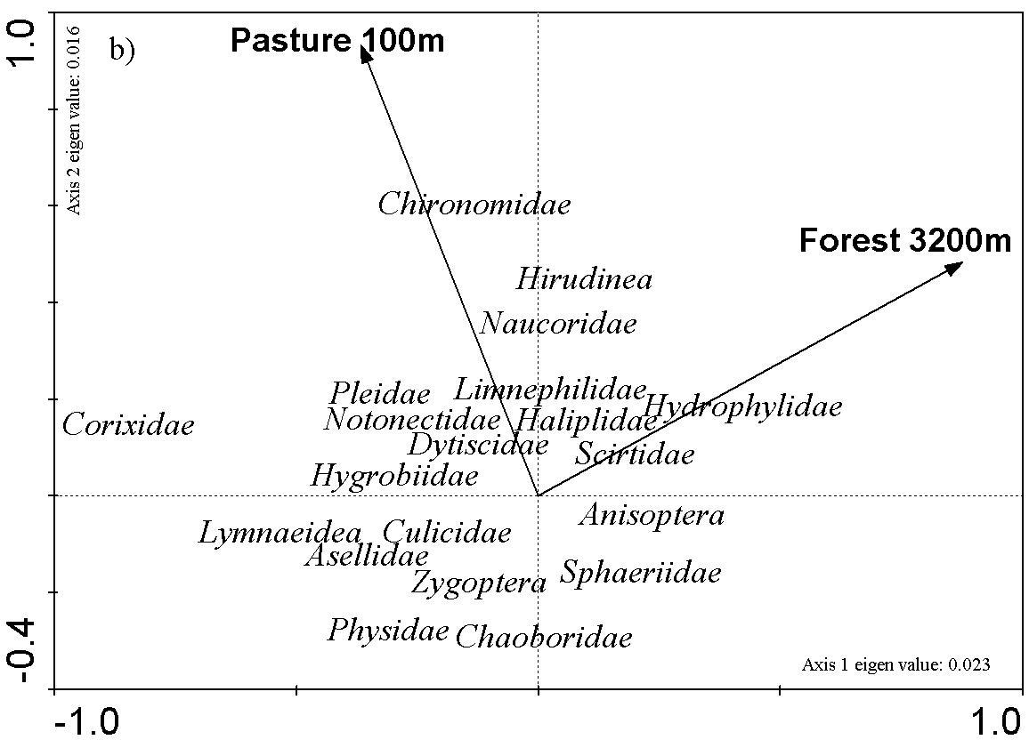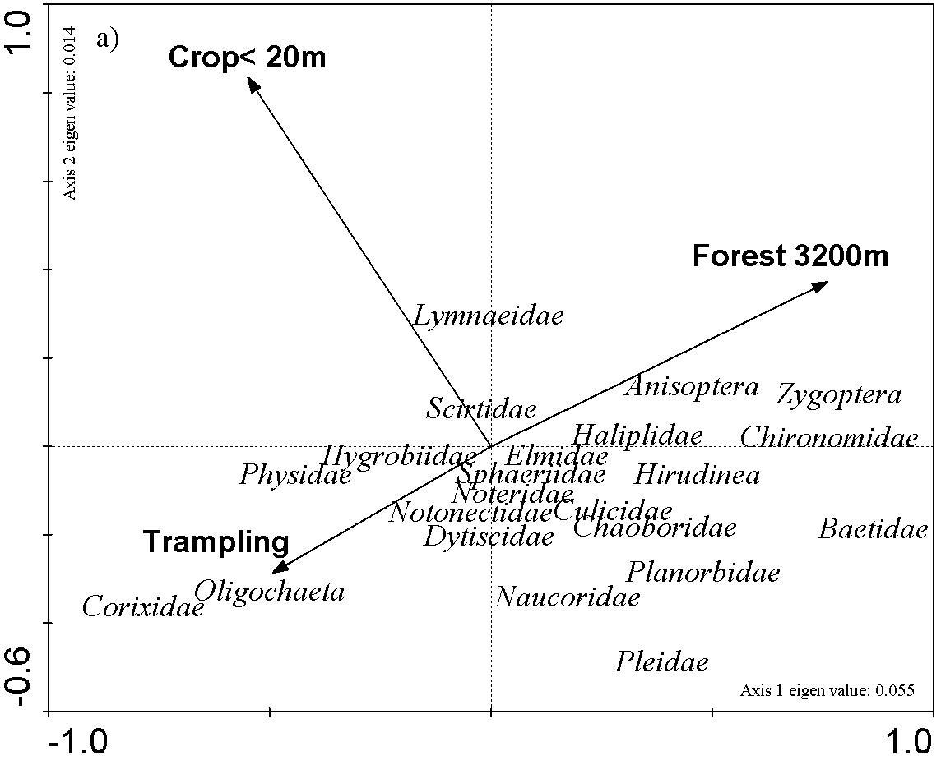
Figure 3.8. RDA ordination of selected land-use variables and taxa in 2003 (a) and in 2004 (b) (only taxa with fit of at least 1% are shown).

3.7.2.2 Land use and diversity
Multiple regression with land-use variables indicated that crop adjacent to the pond (<10 and 20m) had negative effect in both years. Trampling also showed negative correlation with Shannon Wiener diversity index but only in 2003. Similarly urban settlements had negative effect in 100m. Forest in the vicinity of the ponds (100m) exerted positive influence on rarity based index. (Table 3.13)

Table 3.13. Multiple regression of diversity and land-use variables selected by forward stepwise selection (numbers between brackets are the regression coefficients). TR- taxon richness, H’- Shannon-Wiener index, RBI- rarity based index
Diversity variables | Year 2003 | Year 2004
TR | Crop < 20 m (-0.28), p=0.019 | no significant result
H’ | Trampling (-0.25), p=0.010;  Urban 100m (-0.34), p=0.013 | Crop < 10 m (-0.28), p=0.021
RBI | Forest 100m (0.24), p=0.02 | Forest 100m (0.23), p=0.021

3.7.2.3 Pool characteristics and community composition
Macroinvertebrate communities were strongly influenced by the percentage cover and the growth type of vegetation (floating, submerged) (Fig. 3.9). In 2003 the vegetation cover (p=0.002), submerged vegetation (p=0.002) and the water transparency (snell) (p=0.008) explained 45.7 % of variation. Decaying organic matter (plmat), chlorophyll concentration and sandy sediment were still important pond characteristics this year and contributed 17.14% of the total variance. Using Fitted Generalized Linear Model several taxa had significant positive correlation with the vegetation coverage, submerged vegetation and transparency and negative correlation with chlorophyll concentration. These taxa were: Hirudinea, Halipidae, Baetidae, Pleidae, Anisoptera and Zygoptera. In contract Corixidae showed significant negative correlation with vegetation coverage (B=-0.71, p<0.01) transparency (B=-1.32, p=0.001) and positive relationship with chlorophyll concentration (B=0.51, p=0.01).
Fish, shade, pH, and two types of aquatic vegetation form structured the macroinvertebrate community in 2004. These five variables explained 45.4 % of the total variation. 22.7 % of the variation was explained by the floating and submerged vegetation, which strongly correlated with the % of vegetation cover. Similar taxa were influenced positively by the two types of vegetation form then by the vegetation cover in 2003. Lymnaeidae, Baetidae, Naucoridae, Pleidae, Anispotera, Zygoptera belonged to this group. Presence of fish correlated positively with the density of Lymnaeidae (B=0.55, p=0.02), Physidae (B=0.009,p=0.04) and negatively with Dytiscidae (B=-0.5, p<0.001) and Corixidae (B=-0.43, p=0.037).

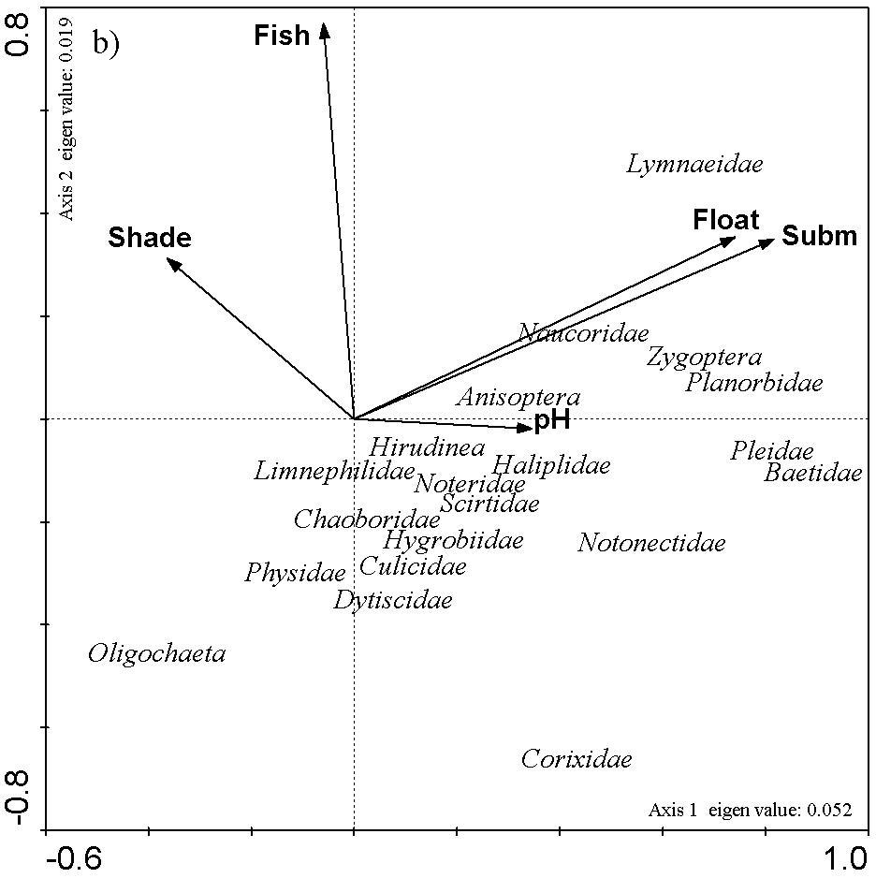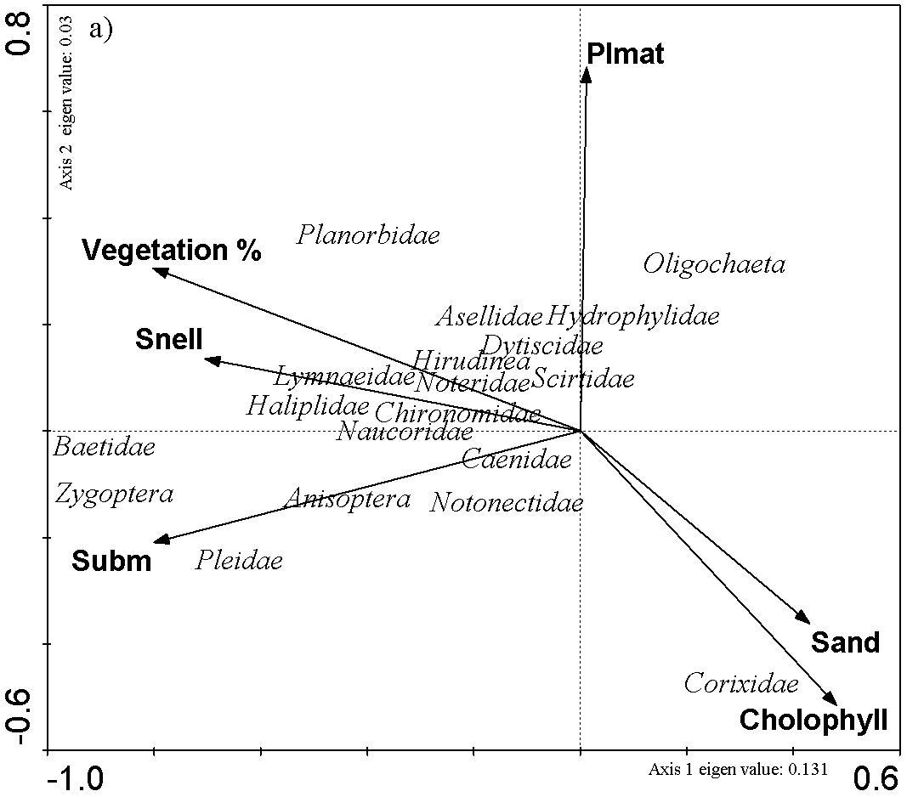
Figure 3.9. RDA biplot of macroinvertebrate data and the forward-selected significant pond characteristics in 2003 (a) and 2004 (b). Taxa with fit more then 1% are plotted.

3.7.2.4 Pool characteristics and diversity
Vegetation coverage and transparency had a positive influence on the diversity of macroinvertebrates in both years. Additionally presence of fish, high chlorophyll and NO₃⁻ concentration influenced the diversity negatively and submerged vegetation exerted positive effect in 2004 (Table 3.14).

Table 3.14. Multiple regression of diversity metrics and forward-selected pool characteristics (numbers between brackets are the regression coefficients).
Diversity variables | Year 2003 | Year 2004
Taxon richness | % Veg (0.39), p<0.001  Sneller depth (0.23), p= 0.022  Plmat (-0.19), p=0.041 | Fish (-0.23), p=0.041  Subm (0.26), p=0.023
H’ | % Veg (0.21), p=0.041  Snell (0.21), p= 0.046 | Chl (-0.33), p=0.002  NO₃⁻ (-0.34), p<0.001  Fish (-0.3), p=0.003  %Veg (0.23), p=0.017
RBI | % Veg (0.23), p=0.03  Sneller depth (0.21), p= 0.029 | Fish (-0.24), p=0.036  Subm (0.27), p=0.014

3.7.3 Discussion
Macroinvestebrate communities were strongly influenced by local land use. Presence of crop in the vicinity of the ponds had negative effect on Heteroptera and Ephemeroptera and also influenced significantly the total macroinvertebrate diversity. Pesticides and herbicides are commonly used in agriculture. Since ponds are relatively small, they may easily be contaminated by downwind drift or accidental overspraying. Macroinvertebrate communities can be directly affected or through the vegetation alteration by the use of herbicides. Apart of the significant effect of agricultural land trampling by cattle exerted negative effect on macroinvertebrate diversity however positively influenced the presence of a Heteroptera family (Corixidae). This family also correlated positively with the pasture 100 m in 2004 indicating that species of this family has preference to habitats intensively used by cattle. Forest in 100m had positive influence on the diversity of macroinvertebrates probably providing habitats for some adult forms. Large scale forest might influence the adults of some taxa although this contradict to the findings of Petersen et al (2004) who showed in stream habitat that adult Ephemeroptera use only 20m each side of a stream. A seasonal shift was detected in the importance of land use. In 2003 summer crop was one of the variable structuring the macroinvertebrate community while during spring (2004) the presence of pasture became an influential land use probably due to the less intense agricultural activities in early spring.
Among the local pond characteristics not only the percent of the vegetation coverage but also the different growth forms of vegetation types had the largest impact structuring the macroinvertebrate community. Number of individuals, total taxa, and numbers of several species was shown by Jeffries (1993) to increase with increased complexity of submerged macrophytes. In the present study several taxa were associated with vegetation and high water transparency in both years. In 2003 the same taxa were negatively affected by the high chlorophyll concentration. During spring when phytoplankton was present in lower density other factors influenced the macroinvertebrate community. Fish was another variable altering the community structure and had negative effect on diversity during spring. This is in concordance with the general theory. Fish prey upon macroinvertebartes and disturb sediment and such as impacting the macroinvertebrate community negatively. Though contradicts some other results. Gee et al (1997) found no evidence that stocking with fish influences the total number of species of either macrophytes or macroinvertebrates in pond. pH also can be important in a habitat use and Friday (1987) showed strong effect of pH on macroinvertebrate community composition. In the present study pH was also statistically selected to explain part of the macroinvertebrate variation in 2004 but correlation was found only with Lymneidae. This may be due to the fact that the variation of pH was low among the sampled ponds.
Several misconception of pond management exist including the belief that maintaining open water by the physical removal of aquatic vegetation, silt and trees shading the water surface is vitally important for all ponds (Biggs et al. 1994). In most instances, the physical alteration of an existing pond is unnecessary and the most important factor is to ensure that water quality is maintained by the protection of the surrounding catchment (Wood et al. 2003). Maurizio et al. (2004) demonstrated the environmental value of a 6 m wide buffer strip in protecting water quality, as it abated all the agrochemicals in the shallow groundwater flow. Our results support the idea that landscape management in the vicinity of the ponds have the largest impact on macroinvertebrate communities and diversity. Local pond management has to focus on the improvement of vegetation structure and coverage, elimination of fish and the improvement of water quality to prevent algal bloom.

3.8 Amphibia, by D. Bauwens, T. De Bie, H. Hampel and D. Ercken

3.8.1 Results
Rana "esculenta" is denoted a species complex that consists of Rana lessonae, R. ridibunda and R. esculenta since it is very difficult to distinguish the adults of these three species in the field and impossible to distinguish the larvae. The different species were found in varying frequencies, roughly reflecting their commonness in Belgium (Table 3.15).

Table 3.15. Frequencies (absolute and relative) of occurrence of different amphibian species in the sampled ponds.
species | Bufo bufo | Rana ‘esculenta‘ | R. temporaria | R. arvalis | Triturus alpestris | T. cristatus | T. vulgaris/ helveticus
# ponds | 13 | 75 | 38 | 2 | 36 | 14 | 67
%ponds | 10 | 60 | 30 | 2 | 29 | 11 | 53

For the four most frequently encountered species, we compared pond characteristics and land use variables (within a radius of 200 m) between ponds that were occupied by the species and ponds where the species was not found. Results of these univariate tests (t-tests, Chi²-tests) are summarized in Table 3.16.

Table 3.16. Summary of univariate comparisons between ponds where amphibian species were either present or absent. “>”: significantly (α = 0,05) higher value in ponds where species is present; “ < “:significantly (α = 0,05) lower value in ponds where species is absent; “ = “: no significant difference.
Variable | R. "esculenta" | R. temporaria | T. alpestris | T. vulgaris/ helveticus
Sneller depth | > | = | = | =
pH | = | = | = | =
PCA ION | < | = | = | <
Submerged veg. | > | = | = | >
Emerged veg. | > | = | = | >
Floating veg. | = | = | = | >
% Veg. coverage | > | = | = | >
Silt layer | < | = | = | <
Surface | > | = | = | =
Max depth | < | = | = | =
% Shade | = | = | = | =
Fish | = | = | < | =
Trampling | = | = | = | =
Cattle | = | = | = | =
Manure | = | = | = | =
Fenced | = | = | = | =
Crop | < | = | = | =
Forest | > | = | = | =
Pasture | = | = | = | =
Urban | = | = | = | =

3.8.2 Discussion
Only ponds inhabited by R. “esculenta” and T. vulgaris/helveticus exhibited differences with ponds where these species were not found. These were also the species that were most frequently encountered during the survey.
Ponds with R. “esculenta” were more transparent, contained more aquatic vegetation, were larger and deeper, had less silt on their bottom, had lower scores for ion-related variables and had more forest and less crop in their immediate surroundings than ponds where members of this species complex were absent.
Ponds with T. vulgaris/helveticus contained more aquatic vegetation, had less silt on their bottom, had lower scores for ion-related variables than ponds where members of these species were not encountered.
These results coincide reasonably well with results obtained by other studies (e.g., Dorn and Brandl 1991; Fasola 1993; Strijbosch 1979).

3.9 Fish, by S.N.M. Mandiki, V. Gillardin, T. De Bie, D. Ercken, H. Hampel and P. Kestemont

3.9.1 Results
The results from the two consecutive years of field investigations showed that the Belgian water pools were characterized by a poor ichtyofauna whatever the level of the agricultural land use (Table 3.17). Few fish species were present in 38 pools out of the 99 sites during the summer of 2003. In most of the sampled pools, only one species was usually present. Moreover, the number of fish was too low to establish any population structure. Fish were quantified in only 24 water pools and the number of fish per 10 anode immersions ranged between 3 and 49, except for the false harlequin Pseudorasbora parva (n = 101) and the rudd Scardinius erythrophthalmus (n = 177) in two extensive pools. Native and exotic species represented 62% and 38% of the ichtyofauna, respectively; the exotic species were found higher in agricultural areas (64%) than in natural ones (36%) indicating the interest of farmers to the management of water pools by an eventual restocking. The most frequent species were the three-spined stickleback Gasterosteus aculeatus (occurrence = 39%), followed by the goldfish Carassius auratus (occurrence = 29%), the roach Rutilus rutilus (occurrence = 13%) and the false harlequin (occurrence =13%). The proportions of native fish species, such as the three-spined stickleback and roach were higher in agricultural areas than in natural ones (Table 3.17).
During the spring of 2004 no population typology could be established. In most of the pools, 2 to 28 fish were caught per 10 anode immersions, except for Pingutius pingutius (n = 84 - 101) in three pools located in agricultural areas, three-spined stickleback (n = 83) in a natural pool and goldfish (n = 50) in one intensive pool. The most frequent species were Pingutius pingutius, followed by Rutilus rutilus and Carassius spp. Native species such as Rutilus rutilus were found equally in intensive areas and extensive ones as well as in natural pools, indicating no deleterious anthropogenic pollution on the poor ichtyofauna of the Belgian ponds, as observed during summer 2003.

Table 3.17. Fish presence and proportions (%) of different fish species sampled during summer 2003 and spring 2004
Species (2003/2004) | Presence (%) | Intensive (%) | Extensive (%) | Natural (%)
Gasterosteus aculeatus | 39/8 | 30/0 | 30/50 | 40/50
Carrasius auratus | 29/8 | 54/50 | 28/25 | 18/25
Carrasius gibelio | 0/14 | 0/29 | 0/71 | 0/0
Rutilus rutilus | 13/16 | 60/50 | 20/25 | 20/25
Pungitius pungitius | 0/33 | 0/38 | 0/38 | 0/24
Pseudorasbora parva | 13/14 | 50/40 | 25/20 | 25/40
Umbra pygmaea | 5/4 | 0/0 | 50/50 | 50/50
Cyprinus carpio | 8/2 | 0/0 | 0/0 | 100/
Lepomis gibbosus | 5/6 | 0/0 | 50/50 | 50/50
Tinca tinca | 5/0 | 50/0 | 50/0 | 0/0
Ameirus melas | 5/0 | 0/0 | 50/0 | 50/0
Salmo trutta | 3/2
Scardinius erythrophtalmus | 3/2
Misgurnus fossilis | 3/0
Esox lucius | 3/0
Abramis brama | 0/2

3.9.2 Discussion
Correlations were calculated between the presence and number of fish and with heavy metal loads in order to speculate on the poor abundance of fish in the pool habitats. No relationships could be established between heavy metal load and the presence or absence of fish regardless the type of the pond. Indeed, for all heavy metals analysed in water (Cu, Zn, Pb, Cd, Sn and Hg) no significant differences were found between pools colonised by fish and those without. Moreover, the number of fish was not related to the level of heavy metals in water as shown by low and non-significant coefficients of correlation, except for a high, but non-significant value, for Cu (R₂ = 0.33). It is also likely that the low abundance of fish could not be related to the pollution stress of pesticides. No any type of triazine was detected in the investigated pools. Moreover only one pool had a high atrazine level (72 µg/L) where no fish was found and four pools contained atrazine and its metabolites (see WP9).
The overall results indicated that the low abundance of fish communities in the investigated pools cannot be explained by an eventual pollution stress related to agricultural practices, such as the release pesticides, but may indicate a low management level due to the lack of interest in the pond habitats. The low occurrence and abundance of fish species in the Belgian ponds restrict the possibility to select for a fish sentinel species.

3.10 Macrophytes, by L. Van Hecke

3.10.1 Method
In general, 2981 separate plant fragments could be identified (about 95% of all collected material). Identification of reputed genera, such as Callitriche and Ranunculus subgenus Batrachium, is only possible when the material is sampled under optimal conditions and when the important diagnostic are present. Far more material was collected during the spring campaign than during the summer campaign (respectively 2132 and 850 units), what might create a lack of balance between both subgroups. Moreover some plants could only be identified with certainty at the species-level during one of the seasons (spring or summer). Extrapolation of identifications over the two seasons was done only when not dealing with annuals and when no doubt was possible.

3.10.2 Results
Within the summer-group 150 taxa where identified (inclusive some only at the genus-level), 262 taxa (id.) within the spring-group and 287 within the mix of both groups. Considering only the taxa that were typical for pond habitats then the groups respectively counted 113 (summer), 132 (spring) and 147 (summer + spring) taxa. When selecting only the real hydrophytes, then the differences between the groups diminish almost completely with 33 taxa for the summer-group, 35 taxa for the spring-group and 40 taxa for the summer + spring-group. So the differences between the summer and spring groups in the amount of specimens and the number of identified taxa were provoked mostly by the sampling of less important, not relevant taxa during the spring campaign.
The maximum numbers of macrophytes (hydrophytes + helophytes) were sampled in VbBegIn (19 taxa) and VbBegNa (19 taxa) during the summer-campaign, in WvBlaEx (32 taxa) during the spring-campaign and in OvLedNa (35 taxa), VbBegNa and WvBlaEx (both 34 taxa) over both seasons combined.
In general very few specific rare plants were present in the pools. Based on the macrophytic composition it can be supposed that the pools WvBlaEx, LiBilEx, VbBegIn and VbBegEx have been submitted to the introduction of alien species.

Chapter 4. Assessment of genetic diversity of selected model groups (WP 4)

Genetic diversity is the first level of biodiversity and determines flexibility of the population inhabiting a specific habitat in response to environmental change. This chapter aimed to assess if genetic diversity and taxon diversity are maintained by similar mechanisms. Therefore, genetic diversity was related to a number of selected variables which were associated with local and regional characteristics of the ponds. The selected variables used in the analysis are shown to be very important in determining taxon diversity (see Chapter 3). Additionally, genetic diversity was related to taxon diversity, and verified whether both levels of diversity are positively correlated.

4.1 Cladocera, by G. Louette, A. Hulsmans, K. De Gelas, and L. De Meester

4.1.1 Material and Methods
The genetic diversity of two cladoceran zooplankton species (Daphnia magna and Daphnia pulex) was investigated. Both species are frequently observed in Flemish water bodies (Louette et al. under review), and several studies have been performed on their genetic structure in the past (Michels et al. 2003; De Gelas 2004).
For D. magna, 10 different populations were included, scattered over 6 sites in Belgium (Fig. 4.1 a). These sites were Knokke (WvKnoEx, WvKnoIn, WvKnoNa), Blankenberge (WvUitEx, WvUitIn), Damme (WvDamNa), Diksmuide (WvBlaEx, WvBlaIn), Ploegsteert (HnPloIn), and Oud-Turnhout (AnOudIn). For D. pulex, 11 different populations were analyzed, distributed over 10 sites in Belgium (Fig. 4.1 b). These sited included Hasselt (LiHasIn), Nobressart (LxNobIn), Villers-le-Bouillet (LgVlbEx), Villers-sur-Semois (LxVssEx, LxVssNa), Waillet (NaWaiEx), Lede (OvLedNa), Begijnendijk (VbBegEx), Halle (VbHalNa), Zoutleeuw (VbZouIn), and Ieper (WvIepIn).

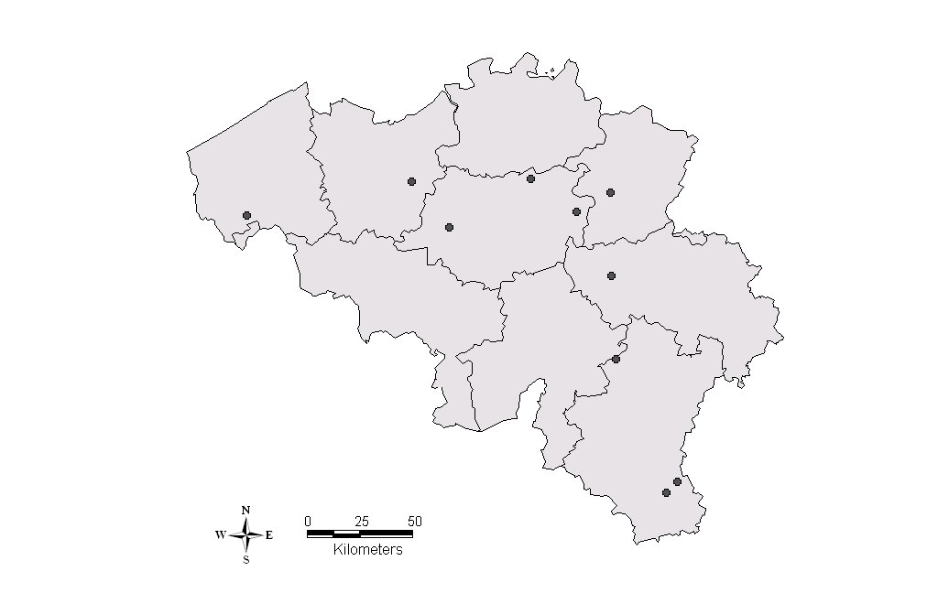
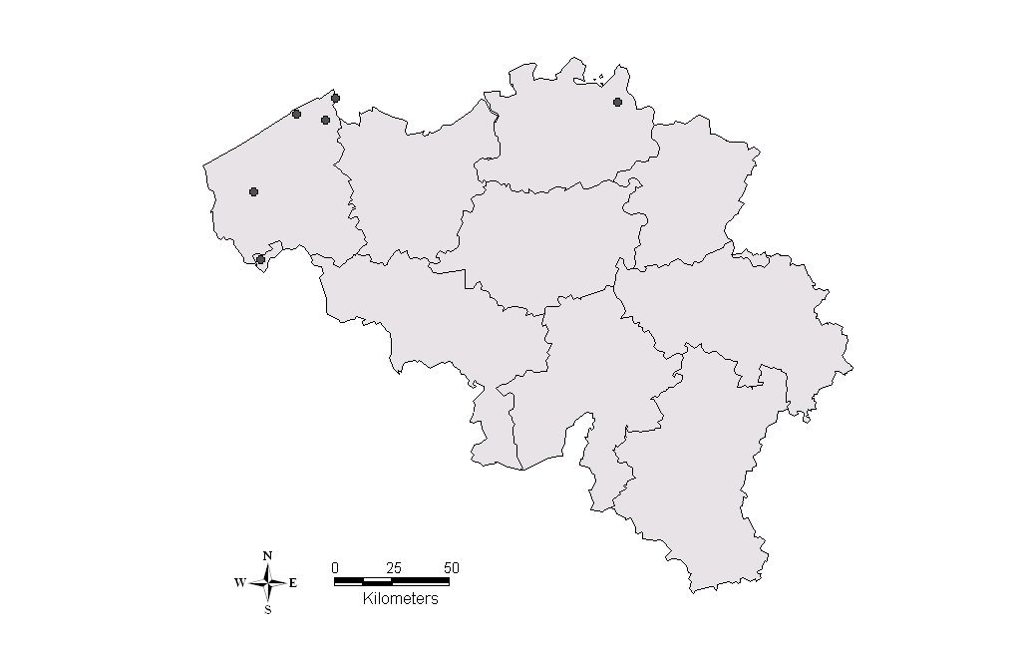
a) b)
Figure 4.1. Geographic location of the different sites where cladoceran zooplankton populations were collected for genetic analysis a) D. magna b) D. pulex. In a number of sites more than one population was analyzed.

Individuals were collected during the sampling campaign of 2004.
In the laboratory, microsatellite analysis was performed on 40 individuals per population. For D. magna, the populations were analyzed for 4 polymorphic loci, being Dma12 (7 alleles), Dma35 (2 alleles), Dma11 (9 alleles), and Dma3R (4 alleles). In the case of D. pulex, the populations were analyzed for 6 polymorphic loci, being Dp183 (3 alleles), Dp496 (5 alleles), Dp502 (3 alleles), Dp339 (6 alleles), Dp525alt (2 alleles), and Dpu7 (2 alleles).
Genotyping of the individuals resulted in data on the allele and multilocus genotype frequencies of the populations. Genetic diversity was determined by two different indices: the number of multilocus genotypes (MLG), and the multilocus genotype Simpson diversity (MLGD). Both measures were calculated using the software tool HWCLON (Vanoverbeke unpublished data).
Correlation analyses were run for genetic diversity and a number of selected variables related to local and regional characteristics of the ponds. These variables were selected, as they are important determining taxon diversity (see WP 3). Variables of local characteristics that were included in our analysis were vegetation (% of submerged macrophytes) and water transparency (Sneller depth in cm); both variables reflect the ecological quality of the ponds. Variables of regional characteristics that were included in our analysis were land use (the presence or absence of crops within a 20 m range) and isolation (the surface area in m² of water bodies within a radius of 5 km of the focal pond). Land use has been shown to strongly affect the ecological quality of ponds, and may indirectly be responsible for patterns in genetic diversity through the addition of nutrients or pesticides (pollution load). Isolation of the habitat may influence genetic diversity through dispersal limitation. Furthermore, we verified if genetic diversity was positively correlated with taxon diversity. Taxon diversity was determined by two indices: cladoceran zooplankton Shannon-Wiener diversity, and the scores of the first PCA axis of the multi-group (macroscopic animal taxa) Shannon-Wiener diversity.
In order to detect patterns of isolation by distance, genetic distance (allelic differentiation) was calculated among all pairs of populations by F_{ST}, using the method of Weir and Cockerham (1984). Geographic distance (km) was determined by the Euclidian distance among all pairs of populations. A Mantel test was used to detect a significant relationship, applying the software program GENETIX (Belkhir et al. 2002).

4.1.2 Results and Discussion

4.1.2.1 Genetic diversity within populations
The genetic diversity of cyclic parthenogenetic populations (e.g. cladocerans) is dependent of a number of local and regional factors. Local factors, such as population size, length of the growing season, and the strength of selection may all determine the genetic diversity level (De Gelas 2004). It is expected that genetic diversity is higher in populations, which have a higher population size. Population size is on one hand determined by the surface area of the habitat, and on the other hand by the time of existence of the population in the habitat. Both surface area and age lead to a larger resting egg bank, which on its side results in more unique multilocus genotypes hatching at the start of the growing season. As all populations harbor more or less the same type of habitats (farmland ponds with a similar surface area), and the age of the investigated ponds could not be estimated univocally, these variables were not included in the analysis. The length of the growing season may also have an important impact on the genetic diversity. Permanent populations undergo a longer period of selection than intermittent populations, and as a result have a lower genetic diversity. As all populations were sampled at the same moment, we assume that they were all present in the habitat for the same time interval (assuming intermittent populations).
The strength of selection is another determining factor, and is dependent on different kinds of environmental pressures (e.g. ecological quality of the habitat). One may expect that in good-quality habitats (diverse niche availability, low nutrient and pesticide loads) more multilocus genotypes can co-exist, due to lower competitive interactions or less strong selection forces towards (often few) resistant multilocus genotypes (Bachiorri et al. 1991). However, our analyses did not confirm any of these expected patterns. No significant relationship was observed between the genetic diversity (MLG and MLGD) of D. pulex populations and variables related to local characteristics (MLG and vegetation: r² = 0.01, p = 0.76; MLGD and vegetation: r² = 0.01, p = 0.98; MLG and water transparency: r² = 0.21, p = 0.16; MLGD and water transparency: r² = 0.20, p = 0.16) (Fig. 4.2).
Figure 4.2. Relationship between the genetic diversity (MLG and MLGD) of D. pulex populations and variables related to local characteristics of the ponds (vegetation and water transparency).

Regional factors, such as land use and isolation may also determine diversity levels. Land use may indirectly affect the ecological quality of the habitat by the influx of nutrients and pesticides (see higher). We detected no significant difference in genetic diversity of D. pulex populations for the variable land use (ANOVA; MLG and land use: p = 0.76; MLGD and land use: p = 0.91) (Fig. 4.3 upper). Isolation of a population may on first sight result in a lower genetic diversity due to dispersal limitation. This may certainly be the case for organisms displaying poor dispersal capacities, but cladoceran zooplankton are known to colonize newly created habitats on a time scale of a few months (Louette and De Meester 2005). Isolation may thus not be a good characteristic for determining genetic diversity patterns in mature Daphnia populations. Certainly, if the frequently occurring persistent founder effects, found in this type of organisms, may influence genetic diversity (see further). As expected, no significant relationship between genetic diversity of D. pulex populations and isolation was observed (MLG and isolation: r² = 0.02, p = 0.72; MLGD and isolation: r² = 0.04, p = 0.59) (Fig. 4.3 lower).
Figure 4.3. Average value of relationship between the genetic diversity (MLG and MLGD) of D. pulex populations and variables related to regional characteristics of the ponds (land use and isolation).

Finally, we integrated both levels of diversity, and related genetic diversity of D. pulex populations with taxon diversity. However, our analysis failed to detect any positive relationship (MLG and cladoceran diversity: r² = 0.06, p = 0.48; MLGD and cladoceran diversity: r² = 0.02, p = 0.67; MLG and multi-group diversity: r² = 0.12, p = 0.51; MLGD and multi-group diversity: r² = 0.16, p = 0.43) (Fig. 4.4).
Figure 4.4. Relationship between the genetic diversity (MLG and MLGD) of D. pulex populations and taxon diversity (cladoceran and multi-group).

To summarize, no significant relationships could be found between the genetic diversity of D. pulex and D. magna and a selection of key pond characteristics. This may indicate that other variables than the ones investigated by us are important in determining genetic diversity, or that the underlying patterns were not detected because of the relatively low number of populations analyzed in our study. Further, and more extensive, research will hopefully reveal which factors determine genetic diversity of the Daphnia populations in the ponds.

4.1.2.2 Genetic diversity among populations
The genetic diversity among populations was investigated by the relation between the pair wise genetic distance and geographic distance (isolation by distance patterns). No such pattern was detected for any species (D. magna and D. pulex) on the spatial scale of Belgium (Fig. 4.5).
Figure 4.5. Relationship between the pair wise genetic distance and geographic distance of the Daphnia populations (D. magna on the left, Mantel test: r = 0.30, p = 0.26; D. pulex on the right, Mantel test: r = 0.23, p = 0.12).

As cladoceran zooplankton have high dispersal capacities (Louette and De Meester 2005), it is likely that individuals may reach all habitats, thereby having the potential to homogenize the allele pool. Paradoxically, it is observed that cyclic parthenogenetic populations, harboring (often small) habitats in very close proximity of each other, display a high genetic differentiation. This may be attributed to their ability to rapidly increase their population size, leading to persistent founder effects (Boileau et al. 1992), and even to monopolization effects when populations locally adapt (De Meester et al. 2002). This may result in the unsuccessful settlement of immigrating individuals in resident populations (Louette et al. submitted). Both the high dispersal abilities of the Daphnia species, and the persistent founder effects often observed in the populations, may lead to the disruption of such clear isolation by distance patterns. On a larger spatial scale (e.g. Europe), where geographic boundaries prevent dispersal among regions, the isolation by distance may be more likely to be detected (De Gelas 2004).

4.2 Anostraca, by G. Louette, A. Hulsmans, K. De Gelas and L. Brendonck

The intensive field survey revealed no (relict) populations of anostracans in Belgium. It is known that anostracan populations are very rarely found, and the most recent findings in Flanders date back from many decades (Brendonck 1989). However, in Wallonia some populations of Chirocephalus diaphanus were recently detected in the region of Hamois (Loneux and Walravens 1998). Another population of this species is currently present in Vijlen in adjacent Limburg (The Netherlands) (Paulssen 2000).

4.3 Amphibians, by I. Schon, H. Vrijders, A. Maes, D. Bauwens, B. Goddeeris and K. Martens

4.3.1 Material and Methods
Triturus alpestris was collected from 17 sampling sites covering at least three different ponds in each Flemish province. In the laboratory DNA extractions were conducted with the Qiagen DNeasy kit from 33 individuals. Because intraspecific genetic variability was expected to be high, PCR amplification and direct, automatic sequencing were used to screen the mitochondrial regions 12S and 16S. Primers for these applications were developed from available sequences in Genbank.
Small amounts of tissues were collected from 5 specimens of Hyla aborea from three different populations of the province of Limburg (Maasmechelen, Diepenbeek, Zonhoven). In order to compare past and present patterns of genetic diversity, an additional 22 samples from old and preserved collections were also investigated. These came from three populations in the province of Limburg and two from the province of Antwerp. All were collected between 1939 and 1950. From both recent and historic samples, DNA was extracted following the optimized conditions from the pilot study. 10 additional DNA extractions from the Dutch Limburg region were included in the subsequent analyses to increase the sample size of recent populations. Genetic diversities were expected to be low therefore microsatellites were the genetic target region in this species. These are the fastest evolving parts of nuclear DNA and are commonly used for studies on conservation biology and population genetics. Thirteen published primers for microsatellites in H. arborea (Arens et al., 2006) were tested and optimized. Especially the amplifications from old samples required extensive adaptations of the PCR protocols. In total, 4 primers amplified microsatellites from both recent and old samples, whereas an additional two only amplified DNA from recent samples.

4.3.2 Results, Discussion
The pilot studies showed that as little as half a square centimetre of tissue is sufficient for subsequent PCR amplification and sequence analyses. This means that sampling from living amphibians is feasible without disrupting the natural population structures.
The intraspecific genetic diversity of Flemish Triturus alpestris populations was low. Only a single substitution was found in the sequenced 450bp of 16S and the 350bp of 12S, respectively (Maes, 2004). On a larger geographic scale, T. alpestris from Flanderen were shown to be genetically very distant to a population from Germany (sequence data from Genbank) with more than 5% sequence divergence in 16S (loc. cit.). Whether changes in the rate of molecular evolution, historic bottlenecks (through glaciations) or more recent founder effects (through habitat fragmentation) are the explanation for this puzzling result will require additional analyses. The obtained sequences could be used to reconstruct the evolutionary history of the genus Triturus and verify the taxonomic position of T. alpestris (Maes, 2004), which is still debated in current literature.
The successful screening of Hyla aborea from museum collections demonstrates that comparisons between past and present patterns of genetic diversity can be achieved. This has important implications for nature conservation and valorises extant natural history collections. The microsatellite data from H. aborea indicate a loss of genetic diversity and heterozygosity in recent Belgian and Dutch populations (Vrijders, 2006). Certain alleles from two microsatellite loci are limited to historic populations. F-statistics did not (yet) confirm statistically significant genetic differences between populations. This might be owing to the limited sample set, because differences between populations in this species appear to be large when compared to other Amphibia (indicating limited gene flow). Additional screening of individuals from both recent and historic populations is needed to further confirm this hypothesis.

4.3.3 Conclusions
Conservation genetic research on Belgian Amphibia should continue. The analyses of T. alpestris and H. aborea will be expanded as described above. Two additional species will be included in the genetic screening, namely Triturus cristatus and Alytes obstetricans. This will allow us to test whether the observed low levels of genetic diversity are a common pattern for the majority of Belgian amphibian. Such data are a prerequisite for developing knowledge-based species conservation and protection.

Chapter 5. Assessment of taxon diversity using resting propagule banks (WP 5)

by

T. De Bie, S. Declerck, L. De Meester and Luc Brendonck

Many aquatic organisms produce resting eggs that accumulate in the sediments forming resting propagule banks. Analysing taxon composition of the resting propagule bank may provide an efficient way to assess diversity of a given taxonomic group, since resting egg banks integrate variation in space (integrate taxa over the whole habitat) and time (integrate seasonal variation). A methodology has been developed to assess diversity in zooplankton using resting egg banks through hatching experiments (Vandekerkhove et al. 2005). This approach has proven very promising for shallow lakes. In this project the technique was tested on a subset of selected ponds. This chapter is focused on the dormancy of cladocerans.

5.1 Methods
Sediment samples were collected in all 126 ponds in January and February 2004, during the refractory period of the dormant eggs. At each sampling station 20 sediment samples were collected with a handcorer (5.2 cm diameter, 1 m height). Sampling was organized such that disturbance of the bottom surface was minimal. The samples consisted of the upper 3 cm of each sediment core. Immediately after collection, the samples were stored at 4° C until processing. On a subset of 45 randomly selected MANSCAPE-ponds, resting eggs were isolated from the sediment by means of the Onbé (1978) – Marcus (1990) sugar flotation method. The isolated eggs were incubated in 2-L aquaria filled with diluted ADAM medium (200 µS cm⁻¹, Kluttgen et al., 1994) at stimulated spring conditions (15°C, long day photoperiod: 16 hours light day⁻¹). Cladoceran hatchlings were removed at 3-d intervals during a period of 30 days, identified to genus level and transferred to 50 mL jars filled with dechlorized water. Once these hatchlings reached a morphologically identifiable stage, they were preserved and identified to species level using the key of Flössner (2000). The hatching method was evaluated by comparing the species richness and species identity of the hatchling assemblages with that of active community samples.

5.2 Results

5.2.1 Descriptive results
Figure 5.1 shows that there was a high variation in number of dormant eggs found in the sediment of the selected ponds. The average number of ephippia (i.e. protecting structure that contained the resting egg(s)) per g dry sediment was 2.35. No significant relation between the density and pond characteristics were found.

Figure. 5.1. Density of ephippia after isolation from the sediment with the Onbé-Marcus method.

5.2.2 Comparison with results obtained from shallow lakes and young ponds
The resting egg abundance and hatching efficiency of the selected ponds were compared with those obtained in 94 lakes by Vandekerkhove et al. (2005a) and with 24 one year old man-made ponds studied by Vandekerkhove et al. (2005b). Figure 5.2 shows that young ponds contain higher density of resting eggs than lakes and older ponds. The hatching success however was highest in lakes, while ponds and young ponds showed hatching efficiencies lower than 250 individuals/kg sediment.

Figure 5.2. Left: box plot of the density of resting eggs in the sediment of ponds, lakes and in one-year old ponds. Right: box plot of the hatching efficiency obtained from the isolated resting eggs. (Lines correspond with the median, boxes with quartiles, error bars with 10th-90th percentiles and points with outliers).

5.2.3 Resting egg bank versus active community
Cladoceran species richness was determined from both the active community sample and the hatchling assemblage. To allow comparison of richness data between both methods the data needed to be standardized and normalized (see Vandekerhove et al. 2005 for method). From Figure 5.3 it is clear that the majority of ponds hatchlings contained a higher fraction of the species.

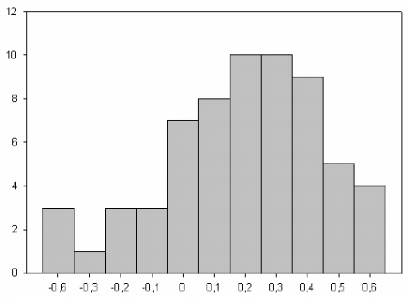
Number of ponds
egg bank – active community

Figure 5.3. Frequency distribution of normalized species richness of the hatchling assemblages and the normalized active community species richness.

5.3 Discussion
The results showed that the analysis of resting egg banks (REB) can be useful to estimate cladoceran diversity. If the analysis of REB is used in combination with the analysis of the active community, than we can have an idea not only about the diversity that is present at a given moment but also about the potential diversity that is hidden in the sediment and that can take part of the active community if local conditions are favourable.
In the present study species richness found in REB was higher than species richness found in the active community. This may be explained by the fact that the studied resting egg community consisted of a pooled sample of the upper sediment layers (3 cm) that integrates resting eggs produced during more than one growing season and probably more than one year. The distribution of resting eggs is also partially homogenized by re-suspension events mediated by wind, benthic organisms or trampling by cattle. The active community represented only individuals captured on two single sampling occasions. Therefore REB’s were potentially richer than the active community that was characterized by often high, but variable, species turnover rates (Arnott et al. 1999).
The comparison between REB from the selected MANSCAPE-ponds with those from lakes and from young-aged ponds showed interesting outcomes. While the abundance of eggs was higher in young ponds than in the other habitats, the hatching was relatively low. Several studies suggested that young egg banks may already have considerable ecological and evolutionary implications, although they have little direct impact on the population dynamics of the next growing season (Hairston et al. 1999; Brendonck and De Meester 2003). The high densities of dormant eggs in the young ponds was striking but can probably be explained by a low degree of sedimentation due to a lack of available organic material or by the lack of a well developed benthic assemblage. Many benthic species are generalist scavengers and therefore may include dormant eggs in their diet (e.g. amphipods: Cárceres and Hairston 1998). Additionally, benthic species like freshwater annelids and chironomids larvae can enhance bioturbation and rapidly bury dormant eggs under several centimetres of sediment, where they are deprived of hatching cues like light and oxygen. The presence of a well developed benthic community in older lakes and ponds can thus result in a significant loss of eggs from the system. The fact that the number of hatchlings from small ponds was relatively low in comparison with those of lakes can be explained as a bet-hedging strategy (Philippi and Seger 1989). In a bet-hedging strategy during a given growing season, only a fraction of the viable dormant eggs that are capable of hatching will hatch and this guarantees the survival in temporal and highly dynamic habitats like ponds. Small ponds are more unpredictable than large lakes and therefore it was expected that hatching fractions are lower.
Because of their isolation and small size, ponds are very heterogeneous systems. This was also reflected in the high variation in density of resting eggs between the selected MANSCAPE-ponds. Conservation practices (e.g. regularly clearing out the ponds) and land use practices (e.g. trampling by cattle) can seriously impact the structure of the resting egg bank and in this way also the zooplankton community. Further research on the effects of management history on diversity patterns of zooplankton and other groups is therefore recommended.

Chapter 6. Quantifying the regional context (WP 7)

by

T. De Bie, S. Declerck, L. De Meester, S. Keyers and L. Brendonck

This chapter comprises the results that involves the characterisation of the regional context. For all ponds and pond clusters, a number of regional characteristics were quantified using GIS-applications: topographical, hydrographical and land use data. To assess the effect of the degree of connectivity or isolation on regional species richness, the number and surface area of surrounding water bodies was estimated. Neighbouring water bodies may be of importance because they provide a reservoir of organisms from which ponds may be colonized.

6.1 Methods

6.1.1 Land use
Land use cover variables were assessed at seven different spatial scales. The percentage cover of land use types was estimated for circular areas with centre at the location of the ponds and a radius ranging from 50 m over 100, 200, 400, 800, and 1600 m to a maximum of 3200 m (corresponding to total surface areas of 0.008, 0.03, 0.125, 0.5, 2, 8, and 32 km2, respectively) (Fig. 6.1). The land use types discerned were (1) crop land, (2) meadows and pastures, (3) forest and (4) urban areas. Coverage data were obtained through the application of the GIS software package ArcView GIS 3.2a (ESRI, Inc.). For the Flemish territory, we used topographical raster maps of the National Geographic Institute (1978-1993; scale: 1/10,000) and the land use coverage database of Flanders (2001; resolution: 15 m). For the Walloon region, topographical and land use data were derived from the PICC (Projet Informatique de Cartographie Continue; 1995-2000; scale: 1/1000) and from the soil occupation database of the Walloon region (Direction de l’Observatoire de l’Biotope et de la Géomatique du Ministère de la Région Walonne; 1988-1989; 1/50.000), respectively. In addition, a visual assessment was made of the nearby crop land presence independently from the GIS-dataset. This was done in the field at the time of sampling by reporting the presence or absence of crop land within concentric circles of 10, 20 and 100 m around the pond. Trampling by cattle was assessed using a simple score system (none, low, intermediate, high or very high degree of trampling of the pond edges; TRAMPLING).

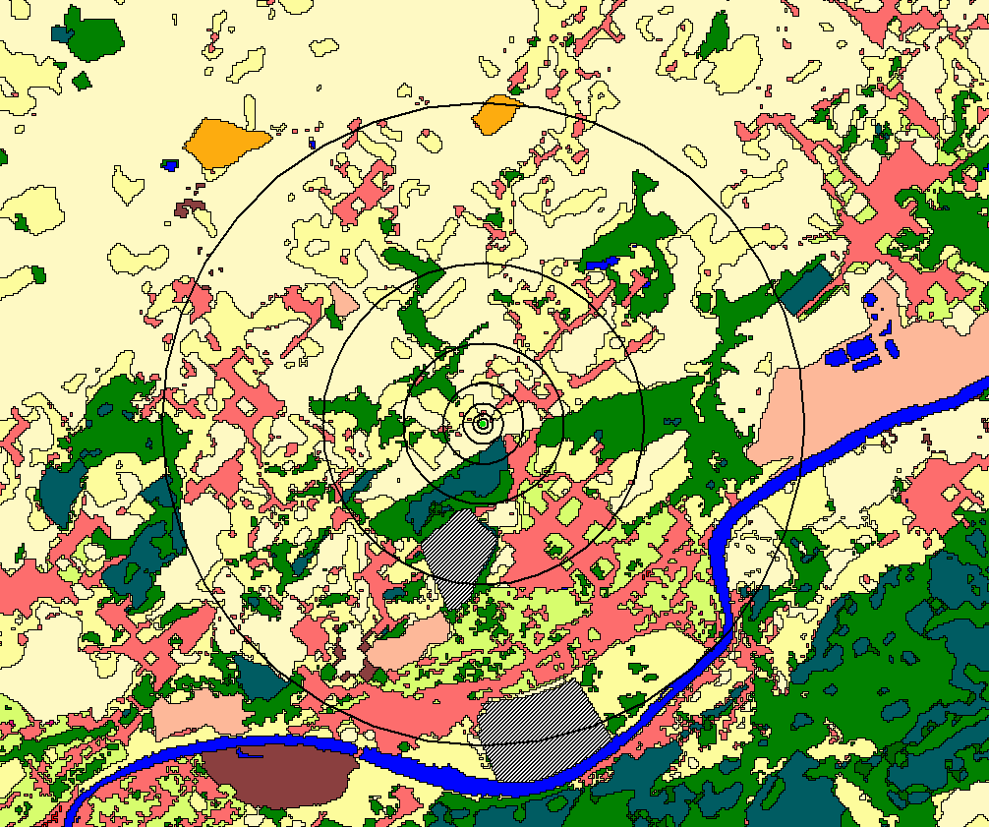

Figure 6.1. Land use data was estimated for circular areas with center at the location of the ponds and a radius ranging from 50 m over 100, 200, 400, 800, and 1600 m to a maximum of 3200 m (corresponding to total surface areas of 0.008, 0.03, 0.125, 0.5, 2, 8, and 32 km2, respectively).

6.1.2 Degree of connectivity
To estimate the degree of connectivity between water bodies within each cluster, the number of standing and running water bodies was counted and their total surface area and length (in case of linear water bodies) was determined inside a circular region with a diameter of five km. The centre of the circular area was positioned in the midpoint between the three selected ponds. The number and surface area of standing water bodies were estimated using topographical maps. In addition recent aerial photographs were used (Flanders: 2000, Walloon region: 2003), because a large number of small water bodies were not indicated on the topographical maps. The number and length of running waters like ditches, streams and rivers were determined using the hydrograpical atlas (Flanders: Vlaamse Hydrografische Atlas 2000; Walloon region: Réseau Hydrographique). As each region is represented by three study sites, regional species richness was estimated as the sum of all species in the three studied ponds. Standardized PCA-analysis on the entire group of organisms indicated a high degree of association in gamma richness among the groups (Fig. 6.4). Therefore we choose to analyse the summarizing PCA-scores of the first principal component axis in function of the degree of connectivity.

6.2 Results

6.2.1 Degree of connectivity
Lentic water bodies smaller than 200m² were most abundant in the selected regions (Fig. 6.2).
Figure 6.2. Left: Average number of water body types inside the selected regions of 20 km² (pool < 200m²; 200m² < pond < 2ha; lake > 2ha). Right: Average of the total surface area of each water body type inside the selected regions. Error bars denote SE.

Based on the calculated densities on average 3,1 pool/km², 2.1 pond/km³ and 0.2 lakes/km² were found. The dominant type of lotic waters was small non-navigable watercourses (category 2) (Fig. 6.3).

Figure 6.3. Average length of watercourses in Flanders. (category 0: navigable watercourses; category 1-3: non-navigable watercourses, the number is based on jurisdiction and category 6: non-classified watercourses, including ditches). Error bars denote SE.

According to a PCA (Fig. 6.4, left) regional species richness of all groups tends to be correlated with each other.

Figure 6.4. Left: Biplot of PCA on the gamma richness (represented as the sum of the three selected ponds in the 42 clusters) for different taxonomical groups. Right: Relationship between the total length of the watercourses and the first axis of the ‘gamma diversity PCA’.

To investigate if regional species richness was related with the measured connectivity variables an RDA analysis with the connectivity variables was performed. A forward selection procedure only revealed a significant effect of total length of small non-navigable lotic watercourses (total length of category 2) (25.7%, F: 8.3; p: 0.002). The correlation with the first axis of the ‘gamma diversity PCA and the total length of the watercourses is represented in Figure 6.4 (right). A correlation matrix between each group separately (Table 6.1) showed a positive relation between the regional species richness of amphibians and fish with the total surface area of lentic water bodies. No other relations were found between number or surface area of lentic water bodies with the studied groups.

Table 6.1. Correlation matrix showing significant results between the different variables of connectivity and gamma richness of each of the studied groups.
 | Length watercourse  cat. 0 | Length watercourse cat. 2 | Length all watercourses | Tot surface area lentic water bodies
Phytoplankton | r=0.53  p=0.04
Coleoptera |  | r=0.73  p=0.002
Heteroptera |  | r=0.58  p=0.02
Mollusca |  | r=0.58  p=0.02
Aquatic Vegetation |  | r=0.57  p=0.02 | r=0.60  p=0.01
Fish |  |  |  | r=0.51  p=0.01
Amphibia |  |  |  | r=0.32  p=0.04

6.3 Discussion
The total number of ponds in Belgium is not known. Estimations based on maps, aerial pictures or field surveys are often biased towards larger ponds because a large proportion of small and naturally ephemeral ponds, that hold water for a few months or even weeks, are overlooked. The average density of ponds and pools per km² is relatively high compared with estimations in Wales and England (Wood 2003). This is partly an artefact because we determined the number of ponds in the adjacent region of our 42 selected clusters, dry regions are therefore automatically excluded. Nevertheless, the clusters were well distributed over almost entire Belgium (Fig. 6.1) and therefore we could say that small water bodies are often very numerous.
A high degree of correlation was found between the regional species richness of the different groups that were examined in this study. This means that regions that are rich for one taxonomical group also tend to be rich for other groups. Of all connectivity variables, total length of non-navigable watercourses was best explaining this pattern of regional richness. This could indicate that lotic and linear water bodies are important dispersal routes, connecting species rich with species poor sites. Streams and rivers are often more permanent than ponds and they can cover an area that is much larger than most standing water bodies. On the one hand, lotic water bodies can act as a source of species that can occur and develop viable populations in both lentic as lotic systems. On the other hand, lotic water bodies can form ideal dispersal routes and facilitate dispersal from one lentic water body to an other for a number of species. Lentic water bodies are isolated, island-like habitats, separated by inhospitable terrestrial landscape. Dispersal between habitats may be achieved by active or passive dispersal over land or in connected systems via aquatic connections between ponds (Van de Meutter 2006). Our results indicate that these lotic water bodies are not only important for slow dispersers (like Mollusca) or passive dispersers (like phytoplankton) but also for active (flying) dispersers as Coleoptera and Hemiptera. We should however remark that due to limitations in recording, the explanatory power of small systems could have been decreased. The gamma richness of amphibians was positively correlated with the total surface area of standing water bodies, the natural habitat type of these animals. It is remarkable that also the gamma richness of fish was positively correlated with the total surface area of standing water bodies and not with lotic water bodies. This can be caused by the heterogeneity between ponds and lakes, each containing a different set of fishes, while lotic water bodies are more homogenous.

Chapter 7. Assessment of trematode parasite loads (WP 8) (Bertrand Losson and Saadia Larsi- University of Liege)

by

S. Larsi and B. Losson

Fasciola hepatica can represent a serious threat for cattle and may have economical effect. Numerous ponds were used as drinking water for cattle and such as assessment of parasite load was essential. Density of trematode parasites was evaluated using a combined approch based on the study of the intermediate host. As the epidemiology of trematode infections depends heavily on the climatic conditions, these measures were carried out during two consecutive years.

7.1 Methods

7.1.1 Detection of Fasciola hepatica infection from snails sampled in the ponds

7.1.1.1 DNA extraction
The snails shells were crushed and removed. DNA from snails was extracted according to the phenol-chloroform method. Two steps were followed: in the first, an equal volume of phenol-chloroform-isoamyl alcohol (25/24/1) was used, the phases were separated by centrifugation; in the second, the aqueous phase was mixed with an equal volume of chloroform-isoamyl alcohol. Another centrifugation was performed. The aqueous phase finally obtained was precipitated with 1/10 volume of 3M sodium acetate and 2.5 volume of absolute ethanol cooled at –20°C, and refrigerated at –20°C for 1h. The pellet obtained after centrifugation was washed in 75% ethanol, centrifuged at 4°C, and air-dried. The precipitated DNA was redissolved in a small volume of TE buffer. DNA was stored at –20°.

7.1.1.2 DNA analyses of snail samples
DNA was analyzed using PCR and Southern blot techniques.
In each technique one positive control (DNA from adult Fasciola hepatica), and one negative control (DNA from uninfected snails) are included.
DNA of Fasciola hepatica specific clones were amplified by PCR using specific primers.
For the detection of infected snails by Southern blot technique, a specific repetitive probe of Fasciola hepatica was used. DNA extracted from snails was excised by digestion with a restriction enzyme and DNA fragments were separated by agarose gel electrophoresis. DNA fragments were transferred from the gel to a nylon membrane. The membrane was prepared in prehybridization solution and the radiolabeled probe. DNA of Fasciola hepatica was added in the solution for overnight hybridization. Hybridizing clones were identified by autoradiography.

7.1.2 Laboratory infection of snails to verify the vectorial capacity of Galba truncatula and Radix peregra
Experiment was carried out to verify the vectorial capacity of Galba truncatula and Radix peregra under laboratory conditions. These two species were selected since they are common species of snails in Belgium. The capacity of both species was confirmed using microscopical and molecular techniques.
The eggs of Fasciola hepatica were poured in a falcon and put in an incubator 22°C for 14 days for embryonation. The emergence of miracidia was induced by cooling on an ice bath and lighting. Eggs hatched within 1 hour. For collecting the miracidia, they were transferred to a small opaque Earlen mayer with a small window at the top. A source of light was placed behind that. Miracidia were gathering at the window level. The counting of miracidia was performed in a Petri dish under a binocular microscope. Snails were infected with five miracidia each. The infected snails were used as a positive control for the presence of Fasciola hepatica. As a negative control, Lymnaea stagnalis DNA was used.

7.2 Results and discussion
With PCR technique presence of specific DNA of Fasciola hepatica were detected in the snails from 8 pools; 4 intensive, 3 extensive and 1 natural. Two pools were already infected during summer 2003. The results with the Southern blot technique were similar to those with the PCR. These results indicate very low infection of ponds by Fasciola hepatica.
The low infection of snails by F. hepatica may be explained first by the very dry weather conditions in 2003 since the life cycle of F. hepatica relies on the presence of water. Furthermore as the case of the most vectorai diseases the level of infection in the vector(s) is low; however one infected vector has a high potential for transmission.

Chapter 8. Assessing anthropogenic stress: pollution loads (WP 9)

by

S.N.M. Mandiki, V. Gillardin, L. André, J.-P. Thomé, T. De Bie, D. Ercken, H. Hampel and Patrick Kestemont

8.1 Methods
Sediment samples were taken from the upper sediment layer during the zoobenthos sampling at eight point units. They were handled in plastic bottles, dried at 60°C during 48 hours, and thereafter calcimined at 650°C. Then, they were acidified (HClO₄–HF–HNO₃) at 110°C over night before being evaporated and stored in 5%HNO₃ solutions. Lyophilised mollusc samples were directly acidified (H₂0₂ – HNO₃) and stored in acidified solutions. Mineral solutions were assayed for Cu, Zn, Pb, Cd and Sn by mass spectrometric methods using a HR-ICP-MS integrated system. For Hg analyses in water samples, glass bottles were acid cleaned (1% HNO₃) and filtration of water was performed as soon as possible with appropriate filtration equipment pre-treated for trace metal analysis to avoid any sources of contamination.
PCBs levels were determined in snail homogenates by a high performance gaz chromatographic method. Briefly, the homogenate sample was lyophilised before a first lipid extraction by an accelerated solvent extractor. Then, the lyophilised extract was purified by a first acid cleaning-up to eliminate all the organic matters and a second florisil cleaning-up for the most polar molecules. The amount of total PCBs in the purified extract was determined by chromatography and the different PCB isoforms were separated in accordance to the temperature increment.
Two-way ANOVA was used to compare the heavy metal load in the two years and in the pools with different land use intensity.

8.2 Results and discussion

8.2.1 Heavy metal and PCBs pollution loads
In order to determine an eventual stress pollution related to heavy metals, four matrixes namely water, suspended materials, sediment and molluscs (Lymnaea species) from each investigated pool were assayed for Cd, Sn, Zn, Cu, Pb and Hg. PCBs traces congeners were also tested in molluscs which were supposed to be one of the potential aquatic sentinels in the pool habitats.

8.2.1.1 Heavy metals in water
Results concerning the levels of heavy metals in water are summarized in Table 8.1. During the two consecutive years of investigation, a total of 181 water samples were assayed. Belgian pools were characterised by a low level of heavy metals, values being in all clusters about 100 times lower than those commonly measured in the surface water of Belgium and elsewhere (MRW - DGRNE, 1999 - 2001). Indeed, according to the latter authors, reference indices of heavy metals in river water for aquaculture of sensitive fish were established at the following levels (µg/L): Hg: 0.05; Pb: 30.0; Cu: 10.0; Zn: 4.0. Hg load in water was evaluated on a total of 107 samples, and as for other heavy metals, the level was lower as compared to other surface water bodies, except for an elevated level in only one natural pool (533 ng/L). Except for Cu, values for the heavy metals increased between the two years, being higher during spring 2004 than during summer 2003. In general, absolute values obtained during spring of 2004 were 2 to 8 times higher than during summer 2003 due, perhaps, to a more rainy weather regime in 2004 allowing a higher metal flow through the investigated pools. This increase induced a relatively high accumulation of Cd, Cu and Zn in some pools located in Antwerp and West-Vlanderen areas; as well as Pb or Sn in some pools located in Liége, West-Vlanderen, Luxembourg and Vlaams-Brabant provinces. Nevertheless, these discharges were equally found in pools located in natural areas or that impacted by agricultural management. In this regard, statistical analyses showed no significant differences between natural, extensive and intensive pools for each of the investigated metal and for the two consecutive years, indicating a limited deleterious anthropogenic impact on the pool environment.

Table 8.1. Concentrations (ppb) of heavy metals (Cu, Sn, Zn, Cd, Pb and Hg) in water sampled from different types pools (natural, extensive and intensive) in Belgium during summer 2003 and spring 2004.
* Hg dis = dissolved Hg (ng/L) assayed only during spring 2004. Except for Cu, values were higher during spring 2004 than during summer 2003 but they did not differ between the type of pools.
Type of pool /year | Cd | Sn | Pb | Cu | Zn | Hg dis*
Natural  2003  2004  Extensive  2003  2004  Intensive  2003  2004 | 0.07 ± 0.10  0.29 ± 0.63  0.13 ± 0.34  0.23 ± 0.55  0.06 ± 0.07  0.09 ± 0.09 | 0.04 ± 0.03  0.10 ± 0.13  0.03 ± 0.02  0.19 ± 0.48  0.03 ± 0.01  0.10 ± 0.15 | 1.68 ± 3.61  2.31 ± 4.18  0.55 ± 0.88  3.14 ± 9.53  0.73 ± 1.48  1.52 ± 2.92 | 4.75 ± 4.50  4.40 ± 8.25  4.54 ± 4.19  2.90 ± 2.29  3.14 ± 1.76  2.06 ± 0.98 | 10.66 ± 12.5  63.41 ± 43.6  12.85 ± 22.8  48.22 ± 26.5  6.74 ± 8.3  44.80 ± 19.9 | -  6.52 ± 4.31  -  7.46 ± 6.15  -  5.84 ± 4.47

8.2.1.2 Heavy metals in suspended matter and in sediment
As expected, levels of heavy metals were higher in suspended materials (Fig. 8.1 left) and sediment (Fig. 8.1 right) than in water matrix but values were still lower than those found in river sediments, as stated above. A high variability independent of the land use level was observed for Pb, Cu and especially for Zn in suspended materials (Zn = 876 ± 1559, 379 ± 426, 432 ± 493 ppb in natural, extensive and intensive pools, respectively) and sediment (Zn = 164 ± 89, 185 ± 124, 128 ± 78 ppm in natural, extensive and intensive pools, respectively). For suspended materials, a high accumulation of Sn (< 1000 ppb) were detected in 12 pools of the 91 sampled assayed, the highest discharge (8238 ppb) was observed in a natural pool of West-Vlanderen (WvOosNa) for an unknown reason. These high accumulations were not confirmed in sediment sampled during spring 2004 but few samples were assayed to ensure such finding. As for water samples, any significant differences between natural, extensive and intensive pools were calculated for each metal, both for suspended materials and sediment samples, indicating no significant pollution load in the investigated pools.

Figure 8.1. Concentrations of heavy metals (Cd, Sn, Pb and Cu) in suspended materials sampled in Belgian water pools during summer 2003 (left) and in sediment sampled during spring 2004 (right). Means did not significantly differ in the two years.

8.2.1.3 Heavy metals in snails
As sentinel organisms, snails were tested for the same heavy metal accumulation (Table 8.2 and Fig. 8.2). Unfortunately, they were present in only 12% of pools (12/99) sampled during summer 2003 and 24% (30/125) of the pools sampled during spring 2004. Except for lower values of Sn (< 0.1 ppm) during spring 2004, levels of heavy metals were comparable between the two-sampling seasons regardless the type of pools. As for other matrices, values for Cu and especially for Zn varied greatly among the pools but not between the type of pools (Zn = 194 ± 64, 203 ± 63, 164 ± 39 ppm for natural, extensive and intensive pools, respectively). No significant differences were calculated between the type of pools, except for a lower level of Pb in natural pools of Luxembourg, Limburg and Vlaams Brandt clusters. The concentrations of all heavy metals measured in snails were lower compared to levels described in some sentinel fish species sampled previously in some Belgian rivers and streams (Bervoets and Blust 2003), and confirmed the low level of heavy metal pollution in water from the Belgian pools, as stated above.

Table 8.2. Concentrations (ppm/dry matter) of heavy metals and PCBs (ppb/g lipids) in snails collected in Belgian pools during summer season of 2003. For PCBs, values are mean groups for the sum of 7 and 24 trace congeners, respectively.
Type of pool | Cd | Sn | Pb | Cu | Zn | PCBs
Natural  Extensive and Intensive | 0.90 ± 0.64  1.52 ± 1.66 | 14 ± 15  34 ± 16 | 1.2 ±1.04  2.2 ± 1.4 | 10.1 ± 6.6  31.4 ± 20 | 100 ± 22  103 ± 55 | 208/272  368/399

8.2.1.4 PCB’s in snails
The snail samples were also assayed for PCBs and the results showed no significant accumulation of PCBs in any investigated pool (Table 8.2 and Fig. 8.2). No congener could be detected in the samples, and for most of the pools only 2 to 9 congeners were present at low levels. The amount of 24 congeners was low, ranging from 0.7-381 ppb. A relatively high level of PCBs was detected only in 4 pools located either in agricultural areas (Vlaams Brabant: 734-1275 ppb, Liege: 719-2023 ppb) or in natural ones (Luxembourg: 751-1153 ppb). Overall values were comparable between pools regardless the level of land use indicating that the presence of PCBs was not directly related to the agricultural management.

Figure 8.2. Heavy metal concentrations (Cd, Pb, and Cu in ppm/dry matter) and PCBs (ppb/g lipids) in snails collected during spring 2004. Mean groups did not significantly differ.

The results concerning levels of heavy metals in water, suspended materials, sediment and snails, as well as level of PCBs did not show a high threshold load imposing a obvious stress pollution in the pools representative of the Belgian bio-geographical areas whatever the land use level. Nevertheless, snail samples, as sentinel organisms, were not sufficiently abundant to ascertain to any eventual stress response related to chronic exposure of heavy metal or PCBs at low levels in water and sediment from the investigated pools.

8.2.2 Pesticide loads in water
Triazines (atrazine, simazine, propazine, etc) and their metabolites (methylatrazine etc.) are considered as the most spread herbicides in the environment by agricultural practices. Analyses of these compounds were performed on a total of 89 and 88 water samples collected during summer 2003 and spring 2004, respectively in all Belgian provinces as for heavy metals. From all sampled pools, only atrazine and some metabolites were detected in seven pools (Table 8.3). The levels of triazines in these pools were lower than those reported from surface water in Belgium (MRW - DGRNE, 2004 - 2005) except a high level in one intensive pool in Vlaams Brabant (VbBeeIn: 72.3 µg/L). Three clusters were found with high pesticide level during the two consecutive years.The seven positive pools were located in agricultural areas (in Vlaams Brabant {Vb}, West-Vlaanderen {Wv} and Luxembourg {Lx}, Liège {Lg}). None were located in natural areas, indicating, to some extent, an impact of agricultural practices.

Table 8.3. Concentrations (µg/L) of atrazine and metabolites in water sampled from different types of pools in Belgium during summer 2003 and spring 2004
Pool Code | Atrazine | Deisopropylatrazine | Desethylatrazine
Summer 2003  VbBeeIn  VbTwEx  VbTwIn  WvBlaIn  LgHenIn  Spring 2004  VbTwIn  WvBlaIn  LgHenEx  LxVssIn | 72.3  5.6  13.7  0.6  0.9  1.4  0.6  0.7  0.5 | 4.0  1.0  0.7  0  0  0.2  0  0  0 | 7.7  0.6  2.4  0  0.7  0.3  0  0  0

The results concerning the level of triazines in water did not show a high threshold load susceptible to induce a significant pollution stress but the results point out the possibility of a release of pesticides by agricultural management even if low values were observed. Long-term effects of such low concentrations on sedentary organisms in water pools are not yet elucidated.

Chapter 9. Assessment of ecosystem architecture and trophic structure typology for small water bodies – Integrated data analyses (WP 6 - WP 10)

by

S. Declerck, T. De Bie, H. Hampel, L. De Meester, W. Vyverman, J. Van Wichelen, K. Vandergucht, B. Goddeeris, , D. Ercken, L. Denis, L. Vanhecke, L. Brendonck, K. Van Der Gucht, W. Vyverman and K. Martens

The major objective of the present chapter is to present the results of some data analyses that integrate the extensive information that was obtained for the many different organism groups. Detailed analyses on the relationship between ecologically relevant pond characteristics can be found in Chapter 2 whereas community structure and diversity for each of the studied organism groups is given in Chapter 3. This chapter highlights some major tendencies that were detected for the taxon diversity (richness) and community composition of multiple aquatic organism groups, and the relation of these communities with pond characteristics (physico-chemical and morphometric variables), geographic patterns and surrounding agricultural land use.

9.1 Results

9.1.1 Patterns of association in taxon richness among multiple organism groups
An approach in the analysis of biodiversity patterns is to evaluate in how far and according to which patterns multiple organism groups show a tendency towards congruence in their taxon richness (richness concordance). Such patterns were explored by applying standardized PCA-analysis and ordinary product moment correlation analysis on the taxon richness estimates of all of the investigated organism groups. The PCA-analysis was performed on standardized data because we wanted to give equal weight to each of the organism groups. The results of this PCA-analysis are given in Figure 9.1. From this plot we see that specific subsets of organism groups tended to display quite strong patterns of concordance in taxon richness. The first PCA axis represented one major gradient of taxon diversity for many macroscopic animal groups, and was strongly correlated with species richness in beetles (Coleoptera), in bugs (Heteroptera), in insect groups that are no beetles or bugs (Ephemeroptera, Trichoptera, Chaoboridae) and in mollusks. Furthermore, this gradient was also strongly correlated with the number of macro-invertebrate families (excluding insects and mollusks). The first PCA-axis can thus be considered as a good surrogate variable reflecting species richness of many animal groups (Fig. 9.2). Taxon richness in planktonic organism groups (like genus richness in phytoplankton and species richness in cladocerans) tended to be largely independent from the first gradient and was strongly associated with the second PCA axis. Species richness in chironomids and benthic diatoms showed no correlations with taxon richness in other aquatic organism groups.

Figure 9.1. Biplot of the first two axes of a standardized PCA-analysis (the ‘Diversity PCA’) performed on the taxon richness estimates of the different organism groups studied (summer 2003). Circles represent ponds, arrows represent the loadings of richness variables.

9.1.2 Associations between multi-group gradients of taxon diversity and pool characteristics, land use and spatial variables
Several pool characteristics were significantly correlated to Diversity PCA1. The variables that showed the strongest associations with this gradient were variables related to the cover by vegetation (percentage cover by submerged vegetation (p<0.001) and emergent vegetation (p < 0.05)) and by variables related to vegetation structure and complexity (like number of vegetation growth types, of dominant plant genera, or the Shannon-Wiener index calculated on the percentage cover of different vegetation types; all p-values < 0.001). The two latter vegetation complexity variables contributed to the diversity gradient independently of vegetation cover, as their effects remained significant upon inclusion of vegetation cover variables as co-variables (P-values < 0.05). All associations between vegetation cover or complexity related variables with the diversity gradient were always positive.

Figure 9.2. The relationship between the taxon richness of different organism groups (S) and the first axis of the ‘Diversity PCA’.

Water transparency, chlorophyll a and total phosphorus were the only other pool characteristics that were significantly correlated to the diversity gradient. Water transparency was positively (p < 0.01) and total phosphorus was negatively (p < 0.05) correlated to the diversity gradient. Morphometric variables (e.g., surface area, depth, volume or perimeter) were not correlated to the diversity gradient, whereas a significantly negative association was discovered between diversity PCA1 and sandy soil (p <0.001). No spatial patterns in the diversity PCA1 was detected.
Crop presence/absence within a radius of 20m of the pond was negatively associated with macroscopic animal diversity (p<0.05). Trampling had a marginally significant negative effect on this diversity gradient.
Many of the variables that were significantly associated to the diversity PCA1 were to some extent also correlated to each other (multicollinearity). We therefore did an effort to identify a set of variables that had the highest unique contribution to the explanation of the diversity PCA1. This was done by the construction and statistical testing of a multiple regression model of which the variables had been selected by a forward selection procedure. From this procedure, it appeared that the variables submerged vegetation cover, vegetation complexity (measured as the Shannon-Wiener of vegetation types) and sandy soil formed together the most parsimonious regression model. The model explained about 29.7% of the variation (p < 0.001). Vegetation related variables (percentage cover and vegetation complexity) together uniquely explained about 63% of the variation, whereas sand explained only 22%. In addition, both variables groups shared about 15% of the explained variation. There were no other variables (e.g., land use, physico-chemical or morphometric variables) that significantly explained additional unexplained variation.

9.1.3 Patterns in community composition of organism groups typical of ponds: the relative importance of pond characteristics, land use and geographic patterns
For each of the investigated organism groups we investigated which of the explanatory variables were best in explaining community composition using canonical correspondence analysis (CCA). More specifically, for each type of explanatory variables (e.g., pond characteristics, land use variables and spatial variables) a most parsimonious model of variables was constructed. We then proceeded by assessing the relative contribution of the selected pond variables and the selected land use variables to community composition applying variation partitioning (Lepš and Šmilauer 2004). Finally, in order to test the robustness of the former analysis upon accounting for spatial patterns, this exercise was repeated by also incorporating the spatial variables in the variation partitioning (Borcard et al. 1992).

9.3.1.1 Pond characteristics
The results of the variation partitioning are presented in Figure 9.3. All organism groups were very significantly explained by one or a set of pond characteristics. The number of contributing pond variables was variable and depended of the identity of the organism group (two in coleopterans, three in heteropterans, phytoplankton and benthic diatoms and six in zooplankton). Phytoplankton and benthic diatoms were mainly explained by physico-chemical variables and their most parsimonious models contained no biotic or morphometric variables. The models of all other organism groups contained only one biotic variable, being the percentage coverage by vegetation (or another vegetation related variable like the number of vegetation growth types in coleopterans). One exception to this formed the zooplankton communities, to which also fish and phytoplankton biomass (chlorophyll a) formed a significant unique contribution. Morphometric variables were only taken up in the models of three organism groups: heteropterans, chironomids and zooplankton). Water transparency was the most important physical variables, often upon taking into account the vegetation effect (cf. heteropterans, chironomids, zooplankton and benthic diatoms). The ‘Ion’ variable (a summary variable of all ion variables derived from a standardized PCA) was the most important water chemistry related variable, contributing to the models of three groups (zooplankton, phytoplankton and benthic diatoms). In some groups, however, water hardness explained more variation that the Ion variable (cf. coleopterans and mollusks), or still contributed significantly to the model even upon accounting for Ions (benthic diatoms). Sulphates and chlorides were significantly associated with part of the variation in mollusk communities.

9.3.1.2 Land use
Intensity of trampling by cattle was related to community structure in four of the investigated organism groups (heteropterans, zooplankton, phytoplankton and benthic diatoms). Furthermore, four organism groups showed a significant association with the share of crops in the surrounding land, although the corresponding spatial scales varied: coleopterans and heteropterans responded to crops on very small spatial scale in the immediate vicinity of the pond (<20m), whereas mollusks and benthic diatoms showed some associations with crops on the scale of 16 to 32km² areas. Four organism groups (coleopterans, chironomids, zooplankton and benthic diatoms) also showed associations with forest, all on a scale of 32km². In addition, heteropterans also seemed to be affected by the amount of trees surrounding the ponds (measures as degree of shade on the pond).
All organism groups were significantly associated to at least on land use variable, although in mollusks, phytoplankton and benthic diatoms these effects turned insignificant when correcting for the effects of pond characteristics.

9.3.1.3 Spatial patterns
With the exception of phytoplankton, all organism groups showed a spatial pattern in their community composition. With the exception of zooplankton, the spatial patterns of the majority of the organism groups were relatively simple. Latitudinal gradients (Y or derived variables, like Y² and Y³) were more prevalent and important than longitudinal gradients and significantly contributed to the models of zooplankton, mollusks, coleopterans, heteropterans and benthic diatoms. Longitudinal gradients were only evident for zooplankton, chironomids and benthic diatoms.

9.2 Discussion
The high degree of concordance that was found for the taxon richness in a subset of the investigated organism groups (e.g., ‘macroscopic’ animal groups like coleopterans, heteropterans, other insect species, amphibians), contrasts with the findings of earlier studies on freshwater organisms in lakes and rivers (Heino et al. 2003; Declerck et al. 2005), where no strong evidence for among-group associations were found. This difference with other studies may be the result of a difference in the identity of the studied groups, or the fact that pools differ in this from rivers and lakes, or because richness of macroscopic animal groups was estimated on the basis of a standardized sampling effort rather than of a standardized number of investigated individuals per sample (rarefaction).
The fact that the diversity of a set of animal groups tends to follow the same major gradient has important implications. First, it suggests that the diversity in these groups is driven by quite similar processes. For example, the gradient was related to characteristics of the vegetation (e.g., cover and complexity) and several forms of land use. This strongly suggests that management should be concerned with the maintenance of rich and varied water plant vegetations and the remediation of influences from the surrounding land use. Second, the finding of a common diversity gradient opens a lot of perspectives for the development of cost-efficient indicators for animal biodiversity in ponds. In our dataset, heteropteran taxon richness, for example, tended to be well correlated with the diversity of most macroscopic animal groups and may therefore be a potentially suitable indicator group for the overall biodiversity of the considered groups. This finding should, however, be validated with independent datasets. It should also be recognized that diversity in several other organism groups (e.g. benthic diatoms, chironomids, the planktonic components) did not follow that same diversity gradient and can, therefore, not be represented by the same indicator.
The animal diversity gradient in taxon richness revealed significant associations with land use practices, mainly with the presence of crop land in the immediate vicinity of the ponds and to a lesser extent with the degree of trampling. The ‘effect’ of land use on this multi-group richness gradient, however, turned insignificant upon accounting for pond characteristics. This indicates that direct effects (for example through insecticide inputs) and indirect effects (through affecting pond vegetation) of land use on animal diversity can not be disentangled statistically. Crop land and trampling have been shown to affect the turbidity status and vegetations in ponds (Declerck et al. in press; Chapter 2). Land use effects may therefore act on pond diversity indirectly through effects on pond characteristics, although the possibility of direct effects can of course not be excluded.

Figure 9.3. Results of variation partitioning on CCA analysis for each of the major organism groups studied. Total inertia: total of community variation. PC: pond characteristics; LU: land use variables; SPATIAL: spatial model. Common: variation that is commonly explained by variables in the model.

Chapter 10. Ecological assays of impact of selected pollutants on model organisms (WP 11)

by

S.N.M. Mandiki, V. Gillardin, L. Spano, S. Flamant, F. Masroor and P. Kestemont

10.1 Effects of PCBs on antioxidant systems of developing Xenopus laevis
Many amphibian populations are declining in a number of geographical areas. The causes are unknown, but there is evidence of a potential role of xenobiotic (Carey and Bryant 1995). Organochlorine compounds, including PCBs, accumulate in wildlife tissues and are associated with developmental problems in Amphibians which are potentially exposed to those toxicants via several routes (Gutleb et al. 2000). PCBs are known as teratogens and embryotoxicants. Oxidative stress following the production of reactive oxygen species has been postulated to play a role in the toxic manifestations of PCBs, including embryolethality and teratogenicity (Hilscherova et al. 2003). Indeed, normal embryonic development requires a balance between production of reactive oxygen species ROS and the protective capacity of antioxidative systems. In this study, possible mechanism(s) of PCBs toxicity were investigated that could lead to oxidative stress in amphibian larvae.

10.1.1 Methods
A modified FETAX assay (Frog Embryo Teratogenesis Assay for Xenopus) was used to investigate the embryotoxic effects of PCBs. The FETAX assay consists the evaluation of teratological effects (pattern and frequency of specific malformations, mortality,...) induced by different concentrations of toxicants. The test was conducted on larvae 48 hpf (hours post-hatching) during 72 h and repeated 4 times with larvae coming from different couple of adult frogs. The impact of PCBs on antioxidant systems and protein expression profiles was also studied.

10.1.1.1 Animals, breeding and housing
All experiments were performed in laboratory conditions. Adults were maintained in aquaria with water at 22 ± 1°C and are fed twice weekly. Xenopus laevis embryos were obtained by injecting male and female adult frogs with human chorionic gonadotropin (Sigma, St Louis, MO). Embryos were then staged and selected prior to contamination.

10.1.1.2 FETAX settings
Larvae were maintained in FETAX buffer prior to contamination. After scoring, groups of 20 to 40 larvae without visible malformation were placed in 200 ml dishes with 100 ml of different contamination solutions (0; 100µg/l; 1000µg/l; 10000µg/l AROCLOR 1254 and DMSO control). All experiments were repeated five times in triplicate. During the FETAX exposure period of 72h, the dishes were kept at 23 ± 1 °C, the exposure media was replenished every day and dead animals were removed and counted. After 72h, larvae samples were fixed. They were then scored for developmental anomalies, body length and body weight.

10.1.1.3 Oxidative stress indicators
Lipid peroxidation LPO and total glutathione GSH were evaluated for non-enzymatic indicators, and Superoxide Dismutase SOD, Catalase, Glutathione -s- transferase GST, Glutathione Reductase GR and Glutathione Peroxidase GPx activities for enzymatic indicators. The amount of enzymes breakdown products was evaluated by spectrophotometric methods (Fatima et al., 2000; Mockett et al., 2002). The measured activities were normalized with the protein content of each sample. Protein content in supernatants was determined by the Lowry method (Lowry et al. 1951).

10.1.1.4 Proteomic assay: 2D – DIGE
The proteomic approach was developed to understand how PCBs act at the protein level. Two-dimensional electrophoresis method consists in separating proteins inside 2D – polyacrylamide gels. The first dimension step is an isoelectric focusing (IEF;pH gradient 4-7), which separates proteins according to their isoelectric points (pI). The second dimension, SDS-polyacrylamide gel electrophoresis (SDS-PAGE, 12.5% polyacrylamide), separates proteins according to their molecular weights. At the end of the separation, different species are detected as spots at different positions in the gels. These spots are stained by fluorescence. Fluorescence 2-D difference in gel electrophoresis (2D-DIGE) uses molecular weight- and pI-matched, spectrally resolvable dyes (Cy2, Cy3 and Cy5) to label protein samples prior to 2-D electrophoresis. Different dyes were used to separately labelled proteins isolated from DMSO control group and PCBs 1000µg/l treated group inside the same gel (4 replicates from different samples groups). The gels were scanned using Typhoon 9400 imagers and were analysed by IDeCyder software. Afterwards, by statistical analysis (t-student test), proteins of interest (p < 0.001) were defined.

Results and discussion

10.1.2.1 FETAX and Oxidative stress indicators
Average survival rate was high for the first four conditions; i.e.: 93% for blank control, 91% for DMSO control, 93% for 100µg/L and 90% for 1000µg/L. However, survival rate for the 10000 µg/L - treated larvae was only 29 ± 38%. This mortality rate can be explained by the fact that 10000µg/L is probably higher than the LC50 dose for young Xenopus laevis larvae. PCBs exposure at high doses induced a significant (p < 0.05) decrease in growth rate as evidenced by a reduction in final body weight for the 1000µg/L -treated (4.3 ± 0.5 mg) and 10000µg/L -treated (3.8 ± 0.14) groups. Concerning the oxidative stress indicators, only GST activity showed a significant (p < 0.05) variation when exposed to 1000µg/L of PCBs with average value of 2233 ± 452 nmol CDNB/min /mg prot compared to 1357 ± 289 nmol CDNB/min /mg prot for control group. For the other indicators tested (LPO, SOD, CAT, GPx, GR and GSH level) no significant variations were found, suggesting a minor effect of PCBs on oxidative system after short acute contamination.

10.1.2.2 Proteomic assay: 2D – DIGE
Comparison of total homogenates of 1000µg/L PCBs treated larvae versus control DMSO on IEF pH range 4-7 revealed out of 1884 spots detectable, and 71 were significantly (p < 0.01) different (Fig. 10.1). Therefore, these spots were selected for visual verification. Of the 71 selected spots, 55 proteins were confirmed to show a truly differential expression in both DMSO control and contaminated group; some of these proteins are over-expressed in the PCBs condition while others are under-expressed. These selected proteins are in process for identification by Mass Spectrometry. They will provide useful information to correlate with various pathways of the stress response in X. laevis and other aquatic organisms even if higher doses than those found in the environment were used.
Figure 10.1. 2D – DIGE gel (IEF 4-7; polyacrylamide 12.5%) showing 71 proteins with significantly (p < 0.01) differential expression. Spots surrounded are the confirmed proteins.

10.2 Growth and oxidative stress parameters in young tadpoles of Xenopus laevis and Rana temporaria exposed to atrazine
Amphibian populations may be considered as sentinel species for environmental pollution since they are present in a lot of fresh water bodies including water pools. As a decline is globally observed in such populations many studies have been focussed on the eventual deleterious impact of pesticides including atrazine, inducing endocrine disruptive mechanisms in amphibians, and thereby failure in reproductive performances (Sanderson et al. 2000; Murphy et al. 2005). Oxidative mechanisms, which may also be disturbed while exposed to xenobiotic compounds, have received little attention. Therefore, this experiment was conducted to study whether atrazine exposure during the early larval stage affects oxidative system of tadpoles from two frog species: African clawed frog Xenopus laevis and European frog Rana temporaria.

10.2.1 Methods
Rana temporaria was chosen because this species is one of the most common frogs in Belgium, and thereby may be considered as one of the indicative sentinel organisms for agricultural influence. This species was compared to Xenopus laevis, as a much known eco-toxicological model. Rana temporaria tadpoles originated from wild frog populations in a natural pool near Butchenbach (Eastern Belgium) during the spawning time in April. Eggs were collected at the time of hatching, and young tadpoles were kept in small aquaria in an indoor facility at environmental temperature (12 – 14°C). They were exposed to atrazine 24 hours after hatching, and different concentrations were compared in triplicate groups of 30 young tadpoles each: 0, 10, 70, 100, 300 and 1000µg/L of FETAX medium culture (Frog Embryo Teratogenesis Assay Xenopus). The culture medium was changed every 2 or 3 days. Tadpoles were fed daily with a commercial feed containing spiruline algae. Growth was evaluated two weeks after contamination and 9 tadpoles per treatment were sampled for the evaluation of antioxidant and oxidant enzyme activities (catalase CAT, superoxide dismutase SOD, lipid peroxidation LPO, etc). After stunning on ice, the tadpole samples were plunged in liquid nitrogen and stored at –80°C. Xenopus laevis young tadpoles were obtained from a captive couple of frogs induced for final gonad maturation, reproductive behaviour and spawning by an injection of hCG (human Chorionic Gonadotropin). Atrazine exposure started 24 hours post-hatching under the same conditions as those described for R. temporaria except for a comparison of three concentrations: 10, 70 and 300µg/L of FETAX medium culture. Tadpole samples were carried out at 7, 15 and 30 days of the atrazine exposure for oxidative stress evaluation but growth was followed at each sampling date.

10.2.2 Results and discussion
Atrazine exposure did not affect growth and survival for any species 15 days after contamination. Body weight varied between 88 to 128 mg for Rana temporaria and 285 to 359 mg for Xenopus laevis. These results in concordance with the previous finding that atrazine exposure at doses ranging from 1 to 25µg/L do not affect growth parameters and metamorphosis in X. laevis (Carr et al. 2003). This may indicate that atrazine exposure has no deleterious effect on the endocrine control of growth. This is likely for sex steroid hormones, which are involved in the growth control, and our previous experiment demonstrated that atrazine exposure at 100µg/L had no substantial deleterious effect on steroidogenesis both in males and females of goldfish (Spano et al. 2004). The levels of antioxidant and oxidative enzyme activities revealed that atrazine exposure did not induce any oxidative stress impact in both frog populations. No changes were detected in the antioxidant enzyme activities like in the catalase activity on day 15 for R. temporaria and between days 7 to 30 for X. laevis. Exception was an increase at 70µg/L however this increase was not confirmed at the higher doses of 100µg/L (Fig. 10.2). The same was observed for oxidative enzyme activities, such as lipid peroxidation activity for the two species.

Figure 10.2. Catalase activity (U/mg prot) in R. temporaria and X. laevis 15 to 30 days after atrazine exposure. Means with different subscripted letters are significantly different (a –b).

The results of the two present studies indicated that atrazine and PCBs would be of a minor importance in affecting oxidative capacities in tadpoles of both investigated species. Potential effects of atrazine on oxidative systems previously have not been investigated but it has been recently reported that some pollutant such as PCBs and DDT can induce a significant oxidative stress response in aquatic organisms (Ferreira et al. 2005). It was also demonstrated that a mixture of agricultural pesticides could induce multiple dysfunctions, such as a decrease in retinoid acid inducing alteration in the immune system of some frog species (Christin et al. 2004; Bérubé et al. 2005).

10.3 Effects of herbicide mixture on endocrine-immune systems of goldfish
No important accumulation of triazine herbicides was observed in the Belgian pools regardless the land use level or the eco-geographic location (See Chapter 8). Nevertheless, in three of the 88 water pools examined during spring 2003 high concentration of atrazine was detected ranging from 14 – 73 μg/l. Therefore, in a previous study the effects of low and high levels of atrazine doses on gonad development and physiological status in adult goldfish were examined. This study demonstrated an elevated atresia rate of oocytes in ovaries exposed to high atrazine concentration (1000µg/ml) but did not show clear evidence of vitellogenin (VTG) induction as a consequence of exposure to these herbicide doses (Spano et al. 2004). Few studies have been developed to understand the more subtle potential endocrine-immunological effects of chronic low-level exposure to mixtures of chemicals in aquatic organisms. The exact relationships between combined effects of pollutants and host disease in aquatic organisms remain elusive. Hence this experiment focuses on the identification of changes that can be detectable at lower concentrations comparable to that present in our environment, as well as to the identification of the synergistic effects of agricultural chemical mixtures on endocrine and immune systems and disease resistance in goldfish juveniles, Carassius auratus, which is one of the most frequent species identified in the Belgian pools.

10.3.1 Methods
A mixture of herbicides composed by atrazine, simazine, diuron and isoproturon (ASDI) was selected at a maximal concentration of 100µg/L on the basis of reported levels of these herbicides present in ground and surface water of Belgium (Ministère de la Région Wallonne, 2004 - 2005). A control group of ongrowing juvenile goldfish were compared to treated fish in six replicates of 20 fish per 100L-tank. Fish were sampled on 0, 4, 8 and 12 weeks for oxidative enzymes (catalase and superoxide dismutase in liver, spleen and head kidney), immune stress response (superoxide anion production by spleen or head kidney macrophages, serum lysozyme activity, antibody production and immunoglobulin IgM) and endocrine disruptor biomarkers (aromatase activity AA and vitellogenin induction VTG). After 12 weeks of pesticide exposure, control and treated groups were subjected to a bacterial challenge by Aeromonas salmonicida to test the modulation in immune status and disease resistance. Mortality was observed ten days after intra-peritoneal injection of different doses of bacteria (3.5 x 102 to 3.5 x 107 CFU/fish). Superoxide radicals and serum lyzosyme activity were assayed by spectrophotometric methods, IgM and VTG by ELISA, and AA by radioimmunoassay. Antibody production titre was measured by serum agglutination against sheep red blood cells (SRBCs) 11 days after each sampling period.

10.3.2 Results and discussion

10.3.2.1 Endocrine disruption response
Aromatase activity, which is responsible for the switch of androgen steroids to estrogens, did not differ after 12 weeks of herbicide mixture exposure both in males and females goldfish (Fig. 10.3). This result in concordance with our previous finding that atrazine exposure at 100µg/L has no effect on sex steroid dynamics (Spano et al. 2004). Moreover, the results of the present study showed that herbicide mixture exposure did not affect vitellogenin synthesis neither in males nor in females (Fig. 10.3) as already observed after atrazine exposure in the previous study (Chapter 10.2). Together, the results of the present study confirms the previous finding that that atrazine or herbicide mixture at low concentrations in water does not cause estrogenic response comparable to oestrogen compounds in aquatic organisms (Hecker et al. 2005).

Figure 10.3. Changes in brain aromatase activity (fmol/mg prot min) and plasma vitellogenin (VTG µg/ml) level in goldfish exposed to herbicide mixture (ASDI) during 12 weeks.

10.3.2.2 Immunological response
Exposure of goldfish to contaminated water tanks by a 100 μg of ASDI/L enhanced the superoxide production from both head kidney and spleen macrophages (21-37%). The increase in anion radicals was earlier in head kidney, until the 4th week (21%) to the 8th week (37%, p < 0.05) of exposure, while in spleen, such response was observed until the 8th week (21%) to the end of experiment. Production of anion radicals strengthens the phagocytosis capacity to contract pathogens but excess may induce cell damages. Thus, the present results indicated that ASDI exposure may enhance oxidative stress in the primary haemopoetic organs i.e. head kidney of Carassius auratus, though the kinetics of induction of such oxidative stress may be different between organs. Short-term exposure to pesticide mixture did not affect plasma lysozyme activity but afterwards values increased over the time of treatment, especially on the 8th week of exposure (p < 0.05)(Fig. 10.4).

Figure 10.4. Effect of exposure to herbicide mixture (ASDI) on plasma lysozyme activity (U/min/ml) and antibody production titre of goldfish.

These results indicated that ASDI treatment enhanced the sensitivity of fish to defence against the invading environmental pathogen. Lysozyme activity is greatly influenced by the severity and the type of stressors to which fish are exposed, and is one of the key factors for the integrity of the non-specific immune system in fish (Zelikoff 1998; Felvoden et al. 2003). Agglutination antibody titre against sheep red blood cells (SRBCs) revealed significant (p < 0.01) suppression in specific defence after four weeks of ASDI treatment (Fig. 10.4). This suppressive effect was sustained over the time of ASDI exposure even if mean groups did not differ. The suppression in immune defence was confirmed after 12 week of ASDI exposure by a reduced disease resistance in ASDI treated fish evidenced by a higher (p < 0.01) mortality rate (17 ± 10%) by the bacterial challenge as compared to control fish (2 ± 4%).
All immunological parameters showed that herbicide mixture at concentration found in the surface water environment of Belgium can alter some aspects of the immune defence in goldfish rending them more susceptible to certain pathogens. This suppressive effect by agricultural herbicide has been reported in other aquatic organisms in other countries, such as frogs in which a decrease in retinoid acid, a highly potent molecules associated with multiple dysfunctions was detected (Bérubé et al. 2005).

10.3. Conclusions
Results from eco-toxicological studies using immature sexually goldfish or young frog tadpoles showed that short-term exposure at low atrazine concentrations has no deleterious effects on endocrine and oxidative systems of aquatic organisms, while a mixture of the later with other herbicides at concentration (100µg/L) similar to those found in the environment induces a significant decrease in some immunological parameters after 8 weeks of exposure and a reduction in the disease resistance after 12 weeks of exposure. Hence, more eco-toxicological studies are recommended on living sedentary organisms in the Belgian pools to enable the eventual deleterious impact of pesticides even if their accumulation was not found high during our investigation period. The eco-toxicological results also showed that relevant multi-approach methodologies should be used to characterize the subtle pollution stress response at different physiological pathways of the aquatic organism.

Chapter 11 External dispersal and colonisation processes of model organisms (WP 12)

by

G. Louette, S. Declerck and L. De Meester

Community assembly is dependent of both regional and local factors (Shurin et al. 2000). While regional factors (dispersal) are most important during the early stage of community assembly, local factors (abiotic and biotic characteristics) become more important in structuring communities when they mature (Caley and Schluter 1997). This chapter presents the result of the colonization pattern of cladoceran zooplankton in a set of newly created ponds. The relative importance of regional and local factors in determining community structure was assessed. More specifically, the colonization rate, the sequence in which colonizing taxa enter the system and the accumulation of diversity in relation to time were investigated.

11.1 Materials and Methods

11.1.1 Study sites
The ponds studied are scattered over Flanders, and financially supported by local and regional governments. Numerous small ponds were being created in nature reserves and agricultural land. Twenty-five such newly constructed ponds, distributed over 13 different sites, were selected. Of the different sites, 7 sites contained 1 pond (Damme DA, Herentals HT, Kinrooi KI, Middelkerke MI, Maasmechelen MM, Oud-Heverlee OH, and Ternat TE), 5 sites contained two ponds (Bierbeek BI1-BI2, Heist-op-den-Berg HB1-HB2, Heers HE1-HE2, Kortessem KO1-KO2, and Maarkedal MA1-MA2), and one site contained 8 ponds (Tongeren T1-T8). Within a site, multiple ponds were located in each others immediate neighbourhood (within a distance of 100 m from each other) (Fig. 11.1). Three important criteria were employed for pond selection. First, all of the studied ponds were totally new and did not involve areas in which there was a pond, ditch or swamp before (as verified on recent and historical maps). Thus, the soil of the ponds contained no dormant egg bank. The ponds filled spontaneously by rain- and groundwater within two months after their creation (they were all created in late September). Secondly, all selected ponds were isolated from any other water body, in order that colonization could not occur by a (even temporary) direct connection, but had to occur through air. Finally, in order to be able to assess the role of regional characteristics (regional species richness), the ponds located in different sites throughout Flanders were selected.

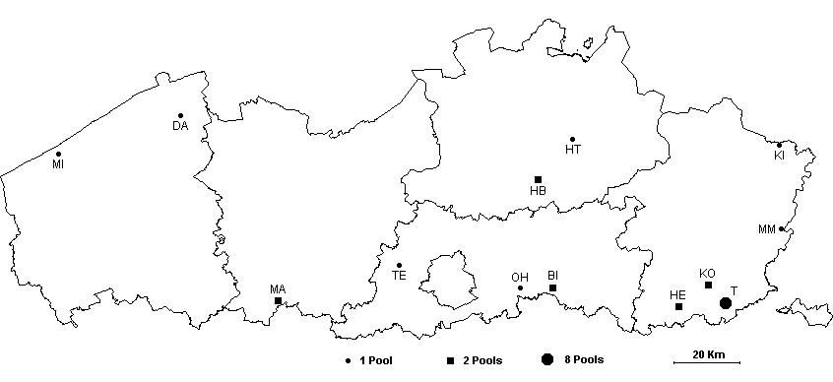

Figure 11.1. Geographic location of the 25 studied, newly constructed ponds on the map of Flanders.

11.1.2 Sampling
Sampling of all newly created ponds was performed bimonthly during three consecutive years, using the sampling protocol (Chapter 1). Additionally the occurrence of species in the regional species pool was assessed. To do so, we sampled in the immediate neighbourhood (area with a radius of 3 km around each new pond) on average 10 (se 1) standing water bodies of different types (ditches, canals, pools, ponds, and lakes) during the summer period.

11.1.3 Data analysis
For each year, alpha, beta and gamma diversity of cladoceran zooplankton were estimated following the methods described by Lande (1996). We calculated these diversity measures for each of the 6 sites that contained at least 2 ponds. In the case of the site with 8 ponds (site T), calculations were based on two randomly selected ponds. For each individual pond in each year, the total number of cladoceran species was determined that were detected during this year (i.e. cumulative species richness within a year). Alpha diversity (local species richness) was then calculated as the average of these richness estimates for the ponds occurring in a same site. Gamma diversity (overall richness) was calculated as the total number of species that was detected in a pair of ponds within each site, whereas beta diversity (richness not found in an average sample) was calculated as the difference between gamma and alpha diversity.
With the dataset of 12 spatially independent randomly selected ponds (MI was omitted from this analysis), consistent shifts in the cladoceran zooplankton communities were tested for over years with canonical correspondence analysis (CCA) (ter Braak and Smilauer 2002). Two datasets were used for this analysis: the species lists (presence-absence data of species on year basis) and the biomass data. To avoid temporal pseudo-replication the species biomass data were averaged over months within years. All biomass data were log (x+1) transformed, and species that were present in less than 10% of the ponds were left out of the analysis.
In analogy to the analysis of the species data, a redundancy analysis (RDA) was performed to test for consistent changes in the set of environmental variables through time.

11.2 Results and Discussion

11.2.1 Colonization rate and sequence of colonizing taxa
Newly created ponds were very rapidly (after a few months) colonized by cladoceran zooplankton, and a continuous and gradual increase in the average number of species was observed in the first year (r² = 0.99, p < 0.001) (Fig. 11.2 left). During the first year, a total of 20 cladoceran zooplankton species were detected in the set of 25 newly created ponds. Strikingly, daphniids (Ceriodaphnia spp., Daphnia spp., Simocephalus vetulus and Scapholeberis mucronata) represented almost 50% of the colonization events. This bias is even more pronounced during the first 6 months of the study, when more than 50% of the colonization events involved Daphnia species. With the exception of Chydorus sphaericus, chydorid and macrothricid species tended only to be present in the second half of the study, and none became very widespread. Overall, C. sphaericus, S. vetulus and Daphnia obtusa were observed in most of the ponds, with D. obtusa appearing in the active populations earlier than the other two species. In ponds where D. obtusa was able to establish a population, the species was found already after 5 months (median value), for C. sphaericus and S. vetulus, the first observation was after the eighth and tenth month, respectively.
The regional survey, involving the analysis of summer communities of a total of 135 water bodies, yielded a total of 50 cladoceran species. All species observed in the newly created ponds were also observed in the immediate region (3 km) of the ponds. There is a marginal positive linear relation between local and regional species richness (r² = 0.27, p = 0.07) (Fig. 11.2 right). Of the 19 species that were found to be common in the regional survey (occurring in more than 50% of the studied sites), 6 were not observed in any of the newly created ponds. Other common species in regional species pools, such as Ceriodaphnia pulchella and Bosmina longirostris, were only found sporadically in the newly created ponds.
Figure 11.2. Cumulative number of cladoceran species (average of all 25 ponds) observed in the ponds during the first year (left). Relationship between the regional (within 3 km) and mean local cladoceran zooplankton species richness. Local species richness is determined as the cumulative number of species (with the average of all new ponds located within a site) observed in the first year (right).

11.2.2 Diversity and community composition patterns
During the first year, on average 4.2 cladoceran zooplankton species were observed in the newly created ponds. Furthermore, no increase in alpha and gamma diversity (average 5.9 species) was detected over the three-year period (Fig. 11.3).

Figure 11.3. Changes in alpha, beta, and gamma diversity over time (averages over the 6 sites with 2 selected ponds).

This may indicate a rapid saturation of the cladoceran zooplankton communities. However, long-lasting effects of dispersal limitation can form an alternative explanation. Results of a joint study by De Bie et al. (unpublished data), demonstrate that older (> 15 years old) pond habitats (sharing similar environmental characteristics, i.e. few macrophytes and no fish) harbor a significant higher amount of species than the communities of our study. Second, results of an establishment success experiment demonstrated that when dispersal limitation was artificially neutralized, immigrant species could still settle successfully in treatments which resembled the resident communities of newly created ponds (Louette et al. 2006).
Beta diversity among ponds within sites was low and did not change over time. This can be attributed to the fact that a large part of the community is always represented by the three abundant species (D. obtusa, C. sphaericus and S. vetulus). Hence, differences in beta diversity were originating through the irregular appearance of other species.
Figure 11.4. Change over time in the average biomass share (%), for the three most commonly observed cladoceran zooplankton species.

CCA analysis revealed a significant effect of pond age on year averages of the cladoceran biomass data (F = 1.54, p < 0.05), but not on species lists (F = 1.00, p = 0.57). The significant age effect was mainly due to shifts in the biomass composition of ponds. In the first year upon creation, cladoceran community biomass in ponds tended to be dominated by D. obtusa (Fig. 11.4). During the second and third year the absolute biomass of D. obtusa remained unchanged, whereas the relative biomass was significantly lower than in the first year (p < 0.05). This was due to an increase in the population biomass of C. sphaericus and S. vetulus between year 1 and year 2 (p < 0.05). The biomass of other species was on average much lower. C. sphaericus and S. vetulus were present during longer periods in the second and third year compared to the first year. The change in community composition may be explained by differences in arrival time (or establishment success) among species (see higher), rather than induced by changes in environmental variables (the RDA analysis indicated no changes in these variables over the three-year period).

Chapter 12. INTERNAL COLONIZATION PROCESSES: ASSESSMENT OF EGG BANK DYNAMICS (WP 13)

by

G. Louette and J. Vandekerckhove

In addition to colonization occurring from external sources (regional habitats) in newly created habitats, internal sources (resting egg bank) may also influence community structure (starting after the first growing season). In order to track this process it is necessary to quantify the assembly of the resting egg bank in these newly created ponds. Furthermore, the study focused on what extent hatching of resting eggs contributed to the composition of communities in the field.

12.1 Materials and Methods

12.1.1 Assembly of resting egg bank
The resting egg banks of the newly created ponds were sampled after 6 months and after 1 year of pond existence (see Chapter 11 for details on the study sites). Sampling of the sediment followed the protocol (Chapter 1). In the laboratory, dormant eggs were isolated from each sediment sample, applying the sugar flotation method (Vandekerkhove et al. 2005). Isolated eggs were counted and assigned to morphotypes. The results were then compared with data on the bimonthly samplings of the active communities in the newly created ponds.

12.1.2 Internal colonization
Three newly created ponds (BI1, BI2, and OH) were selected out of the set of 25 ponds. Sediment samples were taken at weekly intervals (4 times) during the month of April, when the ponds were more than one year old. Samples were incubated in the laboratory, and hatching of Daphnia species was monitored during three days. All Daphnia individuals hatching in these three days were induced to hatch in the field.

12.2 Results and Discussion

12.2.1 Assembly of resting egg bank
In all but one of the ponds, a cladoceran zooplankton egg bank started to assemble within the first year (Fig. 12.1). Up to 10,000 dormant eggs were found per square meter (average: 1,700 eggs/m²; range: 59 to 10,041 eggs/m2), mainly originating from Daphnia species, Chydorus sphaericus and Simocephalus vetulus. Of all 99 cladoceran zooplankton populations were detected in the active community samples after one year, 46% were also retrieved from the egg bank. The likelihood for a species to be detected through egg bank analysis was strongly determined by its density and period of persistence in the water column. Dormant eggs of large populations (> 10 ind./l) that were present for multiple months were much easier to detect than dormant eggs of small populations (< 10 ind./l) that were only observed once (85% versus 16% of populations with detectable dormant egg banks, respectively). Because of the strong correlation between abundance and permanence of populations in the study systems (r = 0.46, p < 0.0001), we could not disentangle their effects on the detectability of the dormant eggs.

Figure 12.1. Frequency distribution showing the number of ponds with one to eight species found in the active community samples (upper), and in the dormant egg bank samples collected 6 and 12 months after creation of the ponds (lower).

Furthermore, the analysis of the dormant egg bank failed to detect several species that were present in the active communities. In some ponds, populations that reached high densities and remained present for a longer period were absent in the egg bank samples, while populations that were only occasionally observed in the water column did produce a detectable amount of resting eggs. This suggests that the accuracy of the egg bank method to assess cladoceran species richness and composition was limited because of the variability among populations in their allocation of energy to the production of resting eggs. Contrarily, a dormant egg was found of species that was not detected in the corresponding active community in two ponds. Either these eggs were produced by populations that reached only low densities (< 1 ind./l), so that they were unlikely to be detected in the active community, or they entered the sediment directly after dispersal from another habitat.
The presence of many thousands of eggs in the sediment suggests that young egg banks may already have considerable ecological (maintenance of species richness, priority effects) and evolutionary implications (maintenance of genetic diversity, founder effects) (Hairston et al. 1999, Brendonck and De Meester 2003). Yet, these results suggest that the direct numerical impact of spring-time hatching on the dynamics of active populations is likely to be limited in the young ponds. Indeed, mature egg banks typically hold 103 to 106 eggs per m² (Hairston 1996) and even then emergence has only occasionally a direct impact on the seasonal dynamics (Cáceres 1998).

12.2.2 Internal colonization
No Daphnia specimens were observed which were induced to hatch in the field, emerging from the sediment. This absence of hatching may on the one hand be explained by the low impact that hatching has on the dynamics of active populations in young populations (see above), or the month of April is not an important hatching month for the Daphnia species occurring in the ponds. This may certainly be the case for the most dominant Daphnia species in the newly created habitats (D. obtusa), as this species is mainly a winter species (Flössner 2000). For other Daphnia species (e.g. Daphnia magna), the month of April has been shown to be a key month in hatching from the sediment (Moreau et al. unpublished data).

Chapter 13. guidelines for sustainable and integrated management of ponds and pools in Belgium (WP 14): EXECUTIVE MANAGEMENT SUMMARY

by

K. Martens, T. De Bie, H. Hampel, L. De Meester, W. Vyverman, J. Van Wichelen, K. Vandergucht, B. Goddeeris, D. Bauwens, D. Ercken, L. Denis, L. Vanhecke, G. Louette, I. Schon, L. Brendonck, K. Van Der Gucht, W. Vyverman, S. Larsi, B. Losson, S.N.M. Mandiki, V. Gillardin, P. Kestemont and S. Declerck.

13.1 Rationale

- Ponds are still present in large numbers (Wood et al. 2003; De Bie et al., 2008), hold an important fraction of aquatic biodiversity, and include more rare species, than any other non-marine aquatic habitat (Oertli et al 2002; Céréghino et al. 2008). It has been shown that, for certain groups of organisms and within landscapes (e.g. Flanders), ponds can collectively represent a higher (gamma) diversity than lakes or rivers (Biggs et al., 1994; De Bie et al., 2008). The loss of small freshwater bodies will cause a direct reduction in the connectivity among remaining populations and can significantly reduce numbers of organisms (Gibbs, 1993; Semlitsch & Bodie, 1998).
- In addition, there is a high variability between ponds (Gee et al., 1997; Williams et al., 2003) and it is likely that two small ponds would together support more species than a single large pond. This high beta diversity is confirmed by the MANSCAPE results (De Bie et al. in prep).
- It is relatively easy to manage ponds at local scales. Ponds have a small catchment area compared to lakes and rivers (Davies et al., 2008) and land use (crop fields) in the close surrounding of the pond appears to determine the quality of the pond (Declerck et al., 2006). This means that even in strongly fragmented landscapes dominated with crops, ponds can have relatively high ecological value depending on the type of land use in their immediate vicinity.
- As ponds are common elements of most landscapes, and since the biodiversity of ponds is high as well as exceptional, it will be possible to promote biodiversity conservation and management as a whole, using ponds as model systems (De Meester et al., 2005).
- Since most ponds are in agricultural areas, it is vital that different sectors are respected when it comes to management of ponds: agricultural, nature conservation, recreational,…

13.2 Summary of main management-related Manscape results

- Local drivers of biodiversity: presence/ absence of fish and macrophyte cover are sledgehammer drivers of aquatic biodiversity in ponds (e.g. De Bie et al. submitted). Turbidity and sediment quality (sludge) are also important. Both are highly affected by presence of cattle (trampling).
- Regional drivers of biodiversity include land use, effects are sometimes visible up to hundreds of meters. However, in general, local factors are more important drivers than regional ones. This facilitates management in highly fragmented landscapes such as agricultural areas in Belgium.
- MANSCAPE confirms earlier results on high beta- and gamma-diversity amongst ponds.
- Older ponds might have higher biodiversity levels than new ponds. Optimal source allocation between creation of new ponds and maintenance of old ponds will dependent on (1) rates at which the diversity and structure of aquatic communities is established in new ponds and (2) the degree to which species of new pond communities represent unique assemblages with high nature value (Louette et al., in revision; De Bie et al., in prep.) The zooplankton species set reported from recent ponds appeared to be common in older ponds, whereas many species of old ponds remained undetected in recent ponds. Therefore, old ponds might be source populations for new ponds.
- Incidence of parasites potentially harmful for cattle (example: liver fluke Fasciola hepatica) in the studied ponds in Belgium is very low.
- Pesticide load is very low in the Belgian ponds, regardless of the land use, but heavy metals in areas under intensive anthropogenic activities should be monitored.

13.3 Recommondations

- It is strongly recommended to continue programs creating new ponds in a variety of landscapes. Since old ponds might have accumulated higher alpha biodiversity levels with time, pond conservation management schemes will have to allocate resources among the creation of new ponds and the maintenance of old pond systems.
- Such pond creation programs should ideally be paralled by studies on (a) colonisation processes in various circumstances, (b) studies on socio-economic appraisal of ponds, (c) organisation of biodiversity within ponds.
- Given the high beta diversity between ponds, it is recommended (a) that management be organised at the level of pond complexes, (b) that new ponds be created in clusters (this will also be cheaper), (c) that different types (surface, depth,..) be created within the clusters (eg crested newt can only survive in deep ponds, ), (d) that new ponds be created near existing wetlands (this gives quickest results).
- Given the high gamma-diversity, it is recommended to look for the optimal number of ponds needed in landscapes to obtain maximal biodiversity. Pond management should have a regional (landscape) dimension. Field surveys of biodiversity at landscape dimension should also incorporate multiple organism groups simultaneously, because optimal schemes can depend on the choice of the target group.
- Local management techniques (1): given the importance of the 4 most important local drivers of biodiversity identified by MANSCAPE (see above: fish, macrophytes, sediment quality, turbidity), it is recommended that in a given cluster of ponds, at least a number of them have limited access to cattle This should NOT mean that cattle should be totally excluded from pond access. On the contrary, the MANSCAPE results on parasite distribution offer a first indication that natural ponds might be safer than presently perceived.
- Local management techniques (2): for the same reason, it is important to prevent the filling in of ponds and to improve sediment quality using appropriate management techniques, like the removal of sludge. It is recommended that the effect of various management techniques on ponds are investigated in situ, using field experiments.
- Regional management techniques (1): for regional management of ponds and pond clusters, interdisciplinary stake holder committees should be maintained. Meetings of such committees should discuss all sectorial interests.
- Regional management techniques (2): land use should be evaluated prior to deciding where to dig new pond clusters. MANSCAPE demonstrated that certain types of land use (eg certain types of plantations) are more detrimental in proximity of ponds than others (see above). Nevertheless, because of the high relevance of local factors, pond biodiversity can probably still largely maintain its integrity even in agricultural landscapes.
- Regional management techniques (3): A compensation scheme for land owners / end users should be drafted, based on socio-economic evaluation of valuation (perception) of ponds by stakeholders.

REFERENCES

Arens P., Bugter R., van t’ Westende W., Zollinger R., Stronks J., Vos C.C. and Smulders M.J.M. 2006. Micro satellite variation and population structure of a recovering Tree frog (Hyla arborea L.) metapopulation. Conservation Genetics, (in press).

Arnott S.E., Yan N.D., Magnuson J.J. and Frost T.M. 1999. Interannual variability and species turnover of crustacean zooplankton in Shiled lakes. Canadian Journal of Fisheries and aquatic Sciences 56: 162-172.

Bachiorri A., Rossi V., Bonacina C. and Menozzi P. 1991. Enzymatic variability of a colonizing population of Daphnia obtusa Kurz (Crustacea, Cladocera) in Lake Orta (Italy). Verhandlungen der Internationalen Vereinigung für Theoretische und Angewandte Limnologie 24: 2813-2815.

Belkhir K., Borsa P., Chikhi L., Raufaste N. and Bonhomme F. 2002. GENETIX, logiciel sous Windows pour la génétique des populations. Laboratoire Génome, Populations, Interactions, CNRS UMR 5000, Université de Montpellier II, Montpellier (France).

Bérubé V.E., Boily M.H., DeBlois C., Nathalie Dassylva N. and Spear P.A. 2005. Plasma retinoid profile in bullfrogs, Rana catesbeiana, in relation to agricultural intensity of sub-watersheds in the Yamaska River drainage basin, Québec, Canada. Aquatic Toxicology 71: 109-120.

Bervoets L. and Blust R. 2003. Metal concentrations in water, sediment and gudgeon (Gobio gobio) from a pollution gradient: relationship with fish condition factor. Environmental Pollution 126: 9-19.

Biggs J., Corfield A., Walker D., Whitfield M. and Williams P. 1994. New approaches to the management of ponds. British Wildlife 5: 273–87.

Boileau M.G., Hebert P.D.N. and Schwartz S.S. 1992. Non-equilibrium gene frequency divergence: persistent founder effects in natural populations. Journal of Evolutionary Biology 5: 25-39.

Bonnet, E. and Van de Peer, Y. 2002. Zt: a software tool for simple and partial Mantel tests. Journal of statistical Software. 7: 1-12.

Borcard D., Legendre P. and Drapeau P. 1992. Partialling out the spatial component of ecological variation. Ecology 73: 1045-1055.

Borin M., Bigon E., Zanin G. and Fava L. 2004. Performance of a narrow buffer strip in abating agricultural pollutants in the shallow subsurface water flux. Environmental Pollution 131: 313-321.

Brendonck L. 1989. A review of the phyllopods (Crustacea: Anostraca, Notostraca, Conchostraca) of the Belgian fauna. In: Invertebrates of Belgium, Wouters K. and Baert L. (eds.), Royal Belgian Institute of Natural Sciences, Brussels pp. 129-135.

Brendonck L. and De Meester L. 2003. Egg banks in freshwater zooplankton: evolutionary and ecological archives in the sediment. Hydrobiologia 491: 65-84.

Brendonck L., De Meester L. and Hairston N.G. Jr. 1998. Evolutionary and Ecological Aspects of Crustacean Diapause. Archiv fur Hydrobiologie (Special Issues) 52:561.

Cabana G. and Rasmussen J.B. 1996. Proceedings of the National Academy of Sciences of the United States of America, 93(20):10844-10847.

Cáceres C.E. 1998. Interspecific variation in the abundance, production, and emergence of Daphnia diapausing eggs. Ecology 79: 1699-1710.

Cáceres C.E., Hairston N. G. Jr. 1998. Benthic-pelagic coupling in planktonic crustaceans: the role of the benthos. Arch. Hydrobiol. Spec. Issues. Advances in Limnology 52: 163-174.

Caley M.J. and Schluter D. 1997. The relationship between local and regional diversity. Ecology 78: 70-80.

Carey C. and Bryant C.J. 1995. Possible interrelations among environmental toxicants, amphibian development, and decline of amphibian populations. Environmental Health Perspectives. 103 (4): 13-7.

Carr J.A., Gentles A., Smith E.E., Goleman W.L., Urquidi L.J., Thuett K., Kendall R. J., Spanò L., Tyler C.R., Van Aerle R., Devos P., Mandiki S.N.M., Silvestre F., Jean-Pierre Thomé J.P. and Kestemont P. 2004. Effects of atrazine on sex steroid dynamics, plasma vitellogenin concentration and gonad development in adult goldfish (Carassius auratus). Aquatic Toxicology 66: 369-379.

Casper, S.J. and Kraus H.D. 1980. Süsswasserflora von Mitteleuropa, 23. Pteridophyta und Anthophyta, 1. Teil: Lycopodiaceae bis Orchidaceae. Gustav Fisher, Jena pp. 1-403.

Christin M.S., Ménard L., Gendron A.D., Ruby S., Cyr D., Marcogliese D.J., Rollins-Smith L. and Fournier M. 2004. Effects of agricultural pesticides on the immune system of Xenopus laevis and Rana pipiens. Aquatic Toxicology 67: 33-43.

Crowder L.B. and Cooper W.E. 1982. Habitat structural complexity and the interaction between bleugills and theri prey. Ecology 63(6): 1802-1813.

Cyr H. 1998. How does the vertical distribution of chlorophyll vary in littoral sediments of small lakes? Freshwater Biology 40 (1): 25-40.

Davies B. R., Biggs J., Williams P.J., Lee J.T., Thompson S. 2008. A comparison of the catchment sizes of rivers, streams, ponds, ditches and lakes: implications for protecting aquatic biodiversity in an agricultural landscape. Hydrobiologia 597: 7-17.

De Bie T., Declerck S., Martens K., De Meester L., Brendonck L., 2007. A comparative analysis of cladoceran communities from different water body types: patterns in community composition and diversity. Hydrobiologia 597: 19-27.

Declerck S., De Bie T., Ercken D., Hampel H., Schrijvers S., Van Wichelen J., Gillard V., Mandiki R., Losson B, Bauwens D., Keijers S., Vyverman W., Goddeeris B., De Meester L., Brendonck L. and Martens K. 2006. Ecological characteristics of small farmland ponds: associations with land-use practices at multiple spatial scales. Biological Conservation 131: 523-532.

Declerck S., Vandekerkhove J., Johansson L., Muylaert K., Conde-Porcuna J.M., Van der Gucht K., Martinez C.P., Lauridsen T., Schwenk K., Zwart G., Rommens W., Lopez-Ramos J., Jeppesen E., Vyverman W., Brendonck L. and De Meester L. 2005. Multi-group biodiversity in shallow lakes along gradients of phosphorus and water plant cover. Ecology 86: 1905-1915.

De Gelas K. 2004. The genetic structure of cyclical parthenogens: Daphnia magna in Europe as a model. PhD, K.U. Leuven, Belgium.

De Meester L., Declerck S., Stoks R., Louette G., Van de Meutter F., De Bie T., Michels E., Brendonck L. 2005. Ponds and pools as model systems in conservation biology, ecology and evolutionary biology. Aquatic Conserv: Marine and Freshwater Ecosystems 15: 715–725.

De Meester L., Gómez A., Okamura B. and Schwenk K. 2002. The Monopolization Hypothesis and the dispersal – gene flow paradox in aquatic organisms. Acta Oecologica 23: 121-135.

Denys L. 2006. Calibration of littoral diatoms to water chemistry in standing fresh waters (Flanders, lower Belgium): inference models for historical sediment assemblages. Journal of Paleolimnology 35. in press.

Dorn P. and Brandl R. 1991. Die Habitatnische der 'Wasserfrosches' in Nordbayern. Spixiana 14: 213-228.

Drost M.B.P., Cuppen H.P.J.J, Van Nieukerken E.J. and Schreijer M. 1992. De waterkevers van Nederland. Uitgeverij K.N.N.V., Utrecht, Nederland.

Edington J.M. and Hildrew A.G. 1995. Caseless caddis larvae of the British Isles. Freshwater Biological Association N 53 pp. 134.

Elliott J. M., Humpesch U.H. and Macan T.T. 1988. Larvae of the British Ephemeroptera: A key with Ecological notes. Freshwater Biological Association N 49 pp. 145.

Fasola, M. 1993. Resource partitioning by three species of newts during their aquatic phase. Ecography 16: 73-81.

Fatima M., Ahmad I., Athar M. and Raisuddin S. 2000. Polluant-induced over-activation of phagocytes is concomitantly associated with peroxidative damage in fish tissues. Aquatic Toxicology 49: 243-250.

Ferreira M., Moradas-Ferreira P. and Reis-Henriques M.A. 2005. Oxidative stress biomarkers in two resident species, mullet (Mugel cephalus) and flounder (Platichthys flesus) site in river Douro Estuary, Portugal. Aqautic Toxicology 71: 39-48.

Fevolden S.E., Roed K.H. and Fjaslestad K. 2003. A combined salt and confinement stress enhances mortality in rainbow trout (Oncorhynchus mykiss) selected for high stress responsiveness. Aquaculture 216: 67-76.

Flössner D. 2000. Die Haplopoda und Cladocera (ohne Bosminidae) Mitteleuropas. Backhuys Publishers, Leiden, The Netherlands.

Friday L. 1987. The diversity of macroinvertebrate and macrophyte communities in ponds. Freshwater Biology 18: 87-104.

Gee J.H.R., Smith B.D., Lee K.M. and Griffiths S.W. 1997. The ecological basis of freshwater pond management for biodiversity. Aquatic Conservation: Marine and Freshwater Ecosystems 7: 91-104.

Gibbs J.P. 1993. Importance of small wetlands for the persistence of local populations of wetland-associated animals. Wetlands 13: 25-31.

Glöer P. and Meier-Brook C. 1994. Deutscher Jugendbund für Naturbeobachtung, Hambourg, pp 136.

Gutleb A.C., Appelman J., Bronkhorst M., Van den Berg J.H.J. and Murk A.J. 2000. Effects of oral exposure to polychlorinated biphenyls (PCBs) on the development and metamorphosis of two amphibian species (Xenopus laevis and Rana temporaria). The Science of the Total Environment 262: 147-157.

Hairston N.G. 1996. Zooplankton egg banks as biotic reservoirs in changing environments. Limnology and Oceanography 41: 1087-1092.

Hairston N.G., Lampert W., Cáceres C.E., Holtmeier C.L., Weider L.J., Gaedke U., Fischer J.M., Fox J.A. and Post D.M. 1999. Lake ecosystems – Rapid evolution revealed by dormant eggs. Nature 401: 446-446.

Hambright K.D. and Zohary T. 2000. Phytoplankton species diversity control through competitive exclusion and physical disturbances. Limnology and Oceanography 45 (1): 110-122.

Haslam S., Sinker Ch. and Wolseley P. 1975. British Water Plants. Field Studies 4: 243-351.

Havel J.E., Eisenbacher E.M. and Black A.A. 2000. Diversity of crustacean zooplankton in riparian wetlands: colonization and egg banks. Aquatic Ecology 34: 63 – 76.

Hayes T.B., Collins A., Lee M., Mendoza M., Noriega N., Stuart A.A. and Vonk A. 2002. Hermaphroditic, demasculinized frogs after exposure to the herbicide atrazine at low ecologically relevant doses. Proceedings of the national Academy of Sciences of the USA 99(8): 5476–5480.

Hecker M., Kim W.J., Park J.W., Murphy M.B., Villeneuve D., Coady K.K., Jones P.D., Solomon K.R., Van Der Kraak G., Carr J.A., Smith E.E., Preez L., Kendall R.J. and Giesy J.P. 2005. Plasma concentrations of estradiol and testosterone, gondal aromatase activity and ultrastructure of the testis in Xenopus laevis exposed to estradiol or atrazine. Aquatic Toxicology 72: 383-396.

Heino J., Muotka T. and Paavola R. 2003. Determinants of macro-invertebrate diversity in headwater streams: regional and local influences. Journal of animal Ecology 72:425-434.

Hilscherova K., Blankenship A.L., Nie M., Coady K.K., Upham B.L., Trosko J.E. and Giesy J.P. 2003. Oxidative stress in liver and brain of hatchling chicken (Gallus domesticus) following in ovo injection with TCDD. Comparative Biochemistry and Physiology Part C 136: 29-45.

Interlandi S.J. and Kilham S.S. 2001. Limiting resources and the regulation of diversity in phytoplankton communities. Ecology 82 (5): 1270-1282.

Jeffries M. 1993. Invertebrate colonisation of artificial pondweeds of differing fractal dimension? Oikos 67: 142-148.

Jermy A.C., Chater A.O. and David R.W. 1982. Sedges of the Britisch Isles. BSBI Handbook No 1. Botanical society of the British Isles, London, pp 268.

John D.M., Whitton B.A. and Brook A.J. 2002. The Freshwater Algal Flora of the British Isles. Cambridge University Press, Cambridge, pp 720.

Keith P. and Allardi J. 2001. Atlas des poissons d'eau douce de France. Patrimoines Naturels 47: pp 387. Publications Scientifiques du M.N.H.N., Paris.

Klausnitzer B. 1996. Käfer im und am Wasser. Spektrum Akademischer Verlag, Heidelberg, Germany.

Kluttgen B., Dulmer U., Engels M. and Ratte H.T. 1994. ADAM, an artificial fresh-water for the culture of zooplankton. Water Research 28: 743-746.

Krammer K. 1997a. Die cymbelloiden Diatomeen. Eine Monographie der weltweit bekannten Taxa. Teil 1. Algemeines und Encyonema Part. Bibliotheca Diatomologica 36: 1-382.

Krammer K. 1997b. Die cymbelloiden Diatomeen. Eine Monographie der weltweit bekannten Taxa. Teil 2. Encyonema part., Encyonopsis and Cymbellopsis. Bibliotheca Diatomologica 37: 1-469.

Krammer K. 2000. Diatoms of Europe. Vol. 1. The genus Pinnularia. A.R.G. Gantner Verlag K.G., Ruggel, pp 703.

Krammer, K. 2002. Diatoms of Europe. Vol. 3. Cymbella. Gantner Verlag, Ruggel, pp 584.

Krammer, K. 2003. Diatoms of Europe. Vol. 4. Cymbopleura, Delicata, Navicymbula, Gomphocymbellopsis, Afrocymbella. Gantner Verlag, Ruggel, pp 530.

Lande R. 1996. Statistics and partitioning of species diversity, and similarity among multiple communities. Oikos 76: 5-13.

Lange-Bertalot H. and Moser G. 1994. Brachysira. Monographie der Gattung. Bibliotheca Diatomologica 29: 1-212.

Lange-Bertalot H. 2001. Diatoms of Europe. Vol. 2. Navicula sensu stricto, 10 genera separated from Navicula sensu lato, Frustulia. Gantner Verlag, Ruggel, pp526.

Lange-Bertalot H., Cavacini P., Tagliaventi N. and Alfinito S. 2003. Diatoms of Sardinia. Rare and 76 new species in rock pools and other ephemeral waters. Iconographia Diatomologica 12: 1- 438.

Lepš J. and Šmilauer T. 2003. Multivariate analysis of ecological data using CANOCO. Cambridge University Press, Cambridge, UK.

Loneux M. and Walravens E. 1998. Observation récente de Chirocephalus diaphanus (Prévost, in Jurin, 1820) en Belgique: appel aux naturalistes. Les Naturalistes Belges 79: 9-14.

Louette G. and De Meester L. 2005. High dispersal capacity of cladoceran zooplankton in newly founded communities. Ecology 86: 353-359.

Louette G., De Meester L., Declerck S. In revision. Assembly of zooplankton communities in newly created ponds. Freshwater Biology.

Louette G., Vander Elst M. and De Meester L. 2006. Establishment success in young cladoceran communities: An experimental test. Limnology and Oceanography 51: 1021-1030.

Lowry O.H., Rosbrough A.L., Farr A.L. and Randall R.J. 1951. Protein measurement with Folin phenol reagent. Journal of Biology 64: 95-102.

Maes A. 2004. Genetische variabiliteit van salamanderpopulaties in Vlaanderen: toepassing en conservatie. Scriptie voorgelegd tot het behalen van de graad van licentiaat Biologie, Universiteit Gent, 85 pp.

Marcus N.H. 1990. Calanoid copepod, cladoceran, and rotifer eggs in sea bottom sediments of northern Californian coastal waters: identification, occurrence and hatching. Marine Biology 105: 413-418.

Michels E., Audenaert E., Ortells R. and De Meester L. 2003. Population genetic structure of three pond-inhabiting Daphnia species on a regional scale (Flanders, Belgium). Freshwater Biology 48: 1825-1839.

Ministère de la Région Wallonne, DGRNE, 1999 – 2001. Système d’évaluation de la qualité de l’eau des cours d’eau. Rapports SEQ-EAU, unpublished reports.

Ministère de la Région Wallonne, DGRNE, 2004 – 2005. Tableau de bord de l’environnement wallon. Belbeuck Claude, MRW – DGRNE, Namur – Belgium.

Mockett R.J., Bayne A.C., Sohal B.H. and Sohal R.S., 2002. Biochemical assay of superoxide dismutase activity in drosophila. Methods in Enzymology 349: 287-292.

Moller Pillot, H and Krebs, B. 1981. Concept van een overzicht van de oekologie van Chironomidelarven in Nederland. (unpublished report).

Moller Pillot, H. 1984a. De larven van de Nederlandse Chironomidae (Diptera) 1A – Inleiding , Tanypodinae & Chironomini. Nationaal Natuurhistorisch Museum – Leiden.

Moller Pillot, H. 1984b. De larven van de Nederlandse Chironomidae (Diptera) 1B – Orthocladiini sensu lato. Nationaal Natuurhistorisch Museum – Leiden.

Moller Pillot, H. and Buskens, R. 1990. De larven van de Nederlandse Chironomidae (Diptera) 1C – Autoekologie en verspreiding. Nationaal Natuurhistorisch Museum – Leiden.

Murphy M.B., Hecke M.K.K., Coady A.R., Tompsett P.D. J., Du Preez L.H., Everson, K.R., Carr S. J.A., Smith E.E., Kendall R.J., Van Der Kraak G. and GiesyJ.P. (in press). Atrazine concentrations, gonadal gross morphology and histology in ranid frogs collected in Michigan agricultural areas. Aquatic Toxicology.

Muylaert K., Van der Gucht K., Vloemans N., De Meester L., Gillis M. and Vyverman W. 2002. Relationship between bacterial community composition and bottom-up versus top-down variables in four eutrophic shallow lakes. Applied and Environmental Microbiology 68: 4740-4750.

Oertli B., Auderset J.D., Castella E., Juge R., Cambin D. and Lachavanne J.-B. 2002. Does size matter? The relationship between pond area and biodiversity. Biological Conservation 104: 59–70.

Oertli B., Biggs J., Cereghino R., Grillas P., Joly P. and Lachavanne J.-B. 2005. Conservation and monitoring of pond biodiversity: Introduction. Aquatic Conservation: Marine and Freshwater Ecosystems 15: 535-540.

Onbé T. 1978. Sugar flotation method for sorting the resting eggs of marine cladocerans and copepods from sea-bottom sediments of Ise Bay and Uragami Inlet, Central Japan. Bulletin of the Japanese Society of Scientific Fisheries 44: pp 1411.

Paulssen L. 2000. De kieuwpootkreeft Chirocephalus diaphanus (Crustacea: Branchiopoda) ontdekt in Limburg. Natuurhistorisch Maandblad 89: 226-229.

Petersen I., Masters Z., Hildrew A.G. and Ormerod S.J. 2004. Dispersal of adult aquatic insects in catchments of differing land use. Journal of Applied Ecology 41: 934-950.

Philippi T. and Seger J. 1989. Hedging one’s evolutionary bets, revisited. Trends in Ecology and Evolution 2: 41-44.

Reynolds, C.S. 1984. Freshwater phytoplankton. Cambridge University Press, Cambridge, pp 384.

Ruttner-Kolisko A. 1974. Plankton Rotifers: Biology and Taxonomy (English translation of Die Binnengewisser, Vol. XXVI). Stuttgart pp 146.

Sanderson J.T., Seinen W., Giesy J.P. and Van Den Berg M. 2000. 2-Chloro-s-triazine herbicides induce aromatase (CYP 19) activity in H295R human adrenocortical carcinoma cells: a novel mechanism for estrogenicity. Toxicology 54: 121-127.

Sarnelle O. 2005. Daphnia as keystone predators: effects on phytoplankton diversity and grazing resistance. Journal of Plankton Research 27 (12): 1229-1238.

Savage A. A. 1989. Adults of the British aquatic Hemiptera Heteroptera: A key with Ecological notes. Freshwater Biological Association, 50, 173pp.

Scheffer M. 1998. Ecology of Shallow Lakes. Chapman and Hall, London, UK.

Scheffer M., Hosper S.H., Meijer M.L., Moss B. and Jeppesen J. 1993. Alternative equilibria in shallow lakes. Trends in Ecology and Evolution 8: 275-278.

Scheffer M., Rinaldi S., Gragnani A., Mur L.R. and Van Nes E.H. 1997. On the dominance of cyanobacteria in shallow turbid lakes. Ecology 78: 272-282.

Schönfelder I., Gelbrecht J., Schönfelder J. and Steinberg C.W. 2002. Relationships between littoral diatoms and their chemical environment in northeastern german lakes and rivers. Journal of Phycology 38: 66-82.

Semlitsch R.D., Bodie J.R. 1998. Are Small, Isolated Wetlands Expendable? Conservation Biology 12: 1129-1133.

Shurin J.B., Havel J.E., Leibold M.A. and Pinel-Alloul B. 2000. Local and regional zooplankton species richness: a scale-independent test for saturation. Ecology 81: 3062-3073.

Spanò L., Tyler C.R., Van Aerle R., Devos P., Mandiki S.N.M., Silvestre F., Thomé J.P. and Kestemont P. 2004. Effects of atrazine on sex steroid dynamics, plasma vitellogenin concentration and gonad development in adult goldfish (Carassius auratus). Aquatic Toxicology 66 : 369-379.

Strijbosch, H. 1979. Habitat selection of amphibians during their aquatic phase. Oikos 33: 636-372.

Tansley A.G. 1946. Introduction to Plant Ecology. Allen and Unwin, London.

ter Braak C.J.F. and Smilauer P. 2002. CANOCO for Windows. Biometris – Plant Research International, Wageningen, The Netherlands.

Tikkanen T. and Willén T. 1992. Växtplantonflora. Författarna Natur., Solna, pp 280.

Torgerson P. and Claxton J. 1998. Fasciolosis. In :Epidemiology and control, Dalton Cabi J.P. (eds.), Chapter 4. Cambridge, UK pp 113-149.

Vadeboncoeur Y., Jeppesen E., Vander Zanden M.J., Schierup H.H., Christoffersen K. and Lodge D.M. 2003. From Greenland to green lakes: Cultural eutrophication and the loss of benthic energy pathways in lakes. Limnology and Oceanography 48: 1408-1418.

Van de Meutter F., Stoks R. and De Meester L. 2006 Lotic dispersal of lentic macroinvertebrates. Ecography 29: 223-230.

Van der Gucht K., Vandekerckhove T., Vloemans N., Cousin S. and Muylaert K. 2005. Characterization of bacterial communities in four freshwater lakes differing in nutrient load and food web structure. FEMS Microbiolial Ecology 53: 205-220.

Van der Gucht K., Sabbe K., De Meester L., Vloemans N., Zwart G., Gillis M. and Vyverman W. 2001. Contrasting bacterioplankton community composition and seasonal dynamics in two neighbouring hypertrophic freshwater lakes. Environmental Microbiology 3: 680-690.

Vandekerkhove J., Declerck S., Brendonck L., Conde-Pocuna J.M., Jeppesen E., Johansson L.S., De Meester L. 2005a. Uncovering hidden species: hatching diapausing eggs for the analysis of cladoceran species richness. Limnology and Oceanography: Methods 3: 399-407.

Vandekerkhove J., Louette G., Brendonck L., De Meester L. 2005b. Development of cladoceran egg banks in new and isolated pools. Archiv für Hydrobiologie 162(3): 339-347.

Vrijders H. 2006. Bijdrage tot de kennis van de genetische variabiliteit van de boomkikker (Hyla arborea) in Vlaanderen. Scriptie voorgelegd tot het behalen van de graad van licentiaat Biologie, Universiteit Gent, pp 82.

Wallace I.D., Wallace B. and Philipson G. N. 1990. A key to the case-bearing caddis larvae of Britain and Ireland. Freshwater Biological Association, 51 pp 237.

Weir B.S. and Cockerham C.C. 1984. Estimating F-statistics for the analysis of population structure. Evolution 38: 1358-1370.

Werum M. and Lange–Bertalot H. 2004. Diatoms in springs from Central Europe and elsewhere under the influence of hydrogeology and anthropogenic impacts. Iconographia Diatomologica 13: 1-417.

Wiederholm, T. (ed.) 1983. Chironomidae of the Holarctic region: Keys and diagnoses, Part 1 – Larvae. Entomologica Scandinavica Supplement No.19 : 457 pp.

Williams P., Biggs J., Barr C.J., Cummins C.P., Gillespie M.K., Rich T.C.G., Baker A., Baker J., Beesley J., Corfield A., Dobson D., Culling A.S., Fox G., Howard D.C., Luursema K., Rich M., Samson D., Scott W.A., White R. and Whitfield M. 1998. Lowland Pond Survey 1996 Department of Environment, Transport and the Regions, London.

Williams P., Whitfield M., Biggs J., Bray S., Fox G., Nicolet P. and Sear D. 2003. Comparative biodiversity of rivers, streams, ditches and ponds in an agricultural landscape in Southern England. Biological Conservation 115: 329–341.

Wood P.J., Greenwood M.T., Agnew M.D. 2003. Pond biodiversity and habitat loss in the UK. Area 35: 206-216.

Wright S.W., Jeffrey S.W., Mantoura R.F.C., Llewellyn C.A., Bjørnland T., Repeta D. and Welschmeyer N. 1991. Improved HPLC method for the analysis of chlorophylls and carotenoids from marine phytoplankton. Marine Ecological Progress Series 77: 183-196.

Zelikoff J.T. 1998. Biomarkers of immunotoxicity in fish and other non-mammalian sentinel species: predictive value for mammals? Toxicology 129: 63-71.

Zwart G. Huismans R., van Agterveld M.P., Van de Peer Y., De Rijk P., Eenhoorn H., Muyzer G., Van Hannen E.J., Gons H.J. and Laanbroek H.J. 1998. Divergent members of the bacterial division Verrucomicrobiales in a temperate freshwater lake. FEMS Microbiolial Ecology 25: 159-169.
LIST OF AUTHORS AND THEIR AFFILIATIONS

